Design Brief: Design a hat that shows what you are thinking.

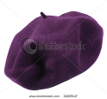
How are you feeling?
What are you doing?
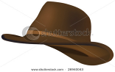

My Hat Design

Where are you?
What colours would you choose?


Draw a hat that you have seen.
How can you change the hat to suit your design idea?

The Final Design
Think about…….
Does your hat show what you are thinking?

Make a ‘washing line gallery’ to show how you planned your work.
You can use words and pictures.

How did you start the task? What did you do next? How did you move on?

