Unit 10

Reconstruction

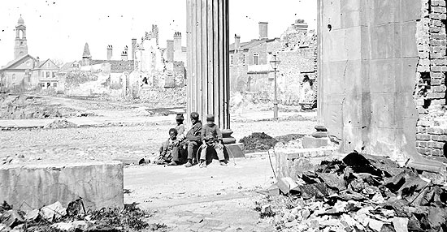
The end of the Civil War brought about a crucial turning point in American history and a moment of uncharted possibilities. It was also a time of unresolved conflicts. While former slaves exulted over freedom, the post war mood amongst ex-confederates was often as devastated as the southern landscape. The questions that the federal government faced in 1865 were unprecedented.

The end of the Civil War posed two important problems that had to be solved simultaneously; how to readmit the South to the Union and how to define the status of free blacks in American society. Intense political conflict dominated the immediate post war years between 1865 and 1877; the nation met these challenges in an era which came to be known as reconstruction.

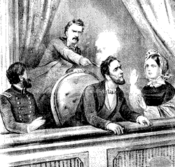
Conflict over Reconstruction began even before the war ended. In December 1863 President Abraham Lincoln issued the Proclamation of Amnesty and Reconstruction, which outlined a path by which each southern state could rejoin the Union. Lincoln proposed a lenient program of Reconstruction, which stemmed from his desire to heal the wounds of war as quickly as possible and put an end to animosity between North and South.

On April 14, 1865, days after the war ended, Lincoln was shot by Confederate sympathizer John Wilkes Booth. Lincoln's successor, Andrew Johnson, was an outspoken opponent of the rich slaveholders in the South, and as a Southern senator had refused to join the Confederacy, preferring to preserve the Union. Johnson said he intended to carry out Lincoln's Reconstruction policies, although unlike Lincoln, he believed that the South should be punished for its role in the war.
Presidential Reconstruction
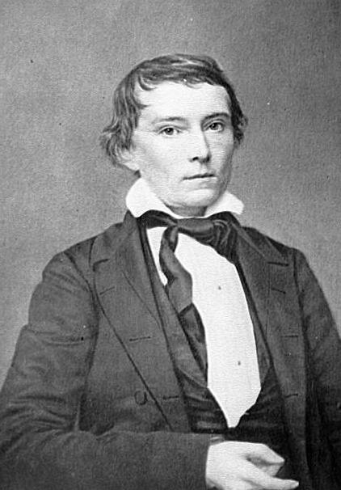
Once in office, Johnson adopted a more lenient policy than expected. By the end of 1865, Johnson had allowed Alabama, Florida, Georgia, Mississippi, North Carolina, South Carolina and Texas to create new civil governments that in effect restored the status quo ante bellum Confederate army officers and large planters assumed state offices. Former confederate congressmen and generals were elected to Congress. Georgia sent Alexander Stephens, the former Confederate vice president back to Washington as a senator.
Alexander Stevens

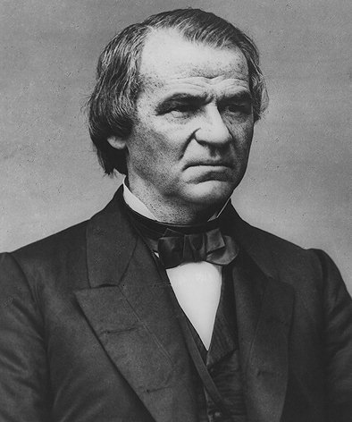
The Thirteenth Amendment to the American constitution had been passed in January 1865, prohibiting slavery in the United States. Johnson’s reconstruction plan insured that all states should accept to the amendment and guarantee freedmen some basic rights – they could marry, own property, make contracts, and testify in court against other blacks. But the southern states passed the ‘black codes’ which restricted freedman’s activities. Some codes established racial segregation in public places; most forbade racial inter marriage, jury service by blacks and court testimony against whites. The ‘black codes’ left freedmen no longer slaves, but not really liberated either.
Andrew Johnson

Congress V Johnson
Johnson’s reconstruction plans brought him in direct conflict with Congress. When Congress convened in December 1865 it refused to seat the delegates from the ex Confederate states and went on to establish a Joint Committee (House of Representatives and Senate) to dismantle the black codes.

Congress was divided into four blocks:
- Radical Republicans who pushed for a harsher program that would both punish the South and ensure that the newly freed black slaves would have total equality and the right to vote.
- Conservative Republicans who tended to favour the Johnson plan.
- Democrats who tended to favour more lenient policies toward the South, with limited federal intervention in the process.
- Moderate Republicans who were by far the largest congressional block, agreed with the radicals that Johnson’s plan was weak but thought that Northern voters would oppose black suffrage.

Unless the moderates and the radicals joined forces Johnson’s plan would prevail. Since none of the four groups had the two thirds majority required to overturn a presidential veto. Moderates were initially willing to accept Johnson's plan with only a few minor changes. Johnson refused their changes and succeeded in alienating moderate republicans who began to work with the radical republicans against him.
The Fourteenth Amendment
Once united the Republicans moved on to adopt the Fourteenth Amendment which defined citizenship to include all persons born or naturalized in the United States. It also undermined Johnson’s policy by ensuring proportional loss of congressional representation to any state that denied black suffrage and disqualified pre war officeholders who supported the Confederacy from state or national office.

Southern legislatures, except for Tennessee refused to ratify the amendment, and President Johnson denounced it. Republicans won a landslide victory in the congressional elections of 1866, winning almost two thirds of the House and four fifths of the Senate. They now believed that they had secured a mandate to overcome both southern and presidential resistance to their reconstruction policies.

Congressional Reconstruction
Congressional Reconstruction began with the Reconstruction Act of 1867, which invalidated the state governments formed under the Lincoln and Johnson plans. The act then went on to divide the Confederacy into five military districts and set forth strict requirements for readmission of ex-Confederate states to the Union. Congressional Reconstruction took effect in the spring of 1867, but it could not be enforced without military power. Johnson, as commander in chief attempted to hold back the congressional plan. Once again moderates and radicals joined forces to block Johnson from thwarting Reconstruction.

The Impeachment Crisis
The bitterness felt by the radicals towards the president reached its height with their attempt to impeach and convict him; this they believed would remove him as an obstacle to their Reconstruction policies. In early 1868, the House approved eleven charges of impeachment. Johnson’s trial began in the Senate in March 1868 and fascinated public attention for eleven weeks. Late in May 1868 the Senate voted against Johnson 35 to 19, one vote short of the two thirds majority required to convict
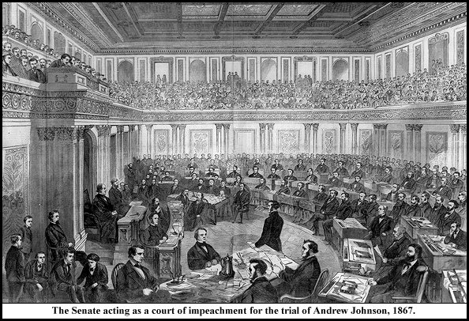

Impeachment Trial 1868

the president. But the anti-Johnson forces in Congress had achieved their aim; Andrew Johnson had no future as president. Radical Republicans, meanwhile, pursued their final major Reconstruction objective: to guarantee black males the vote.

The Fifteenth Amendment
Black suffrage was the linchpin of congressional Reconstruction. In 1869 Congress proposed the Fifteenth Amendment, which prohibited the denial of the vote by the states to any citizen on account of race, colour, or previous condition of servitude.

By the time the 15th Amendment was ratified in 1870, Congress could look back on five years of momentous change with three constitutional amendments. The 13th Amendment abolished slavery, the 14th affirmed the rights of federal citizens, and the 15th prohibited the denial of the vote on the basis of race. Congress had also readmitted the former Confederate states into the Union. But after 1868 congressional momentum slowed. And in 1869, when U.S. Grant became president, the fierce battle between Congress and the president came to an end.
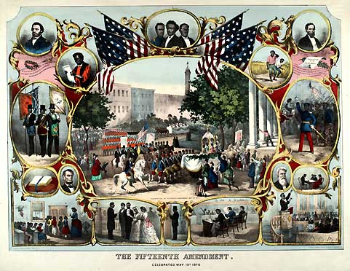
All images are from the US National Archives and are believed now to be out of copyright restriction.

