Unit 11

The Impact of the American Civil War

Emancipation
Emancipated slaves faced extreme difficulties and handicaps upon being freed. They had no property, tools or money and usually possessed inadequate skills to improve their standard of living. Only a very small minority had been trained as craftsmen, and more than 95% were illiterate. Nevertheless emancipation did give former slaves the right to own their own labour and a new sense of independence.
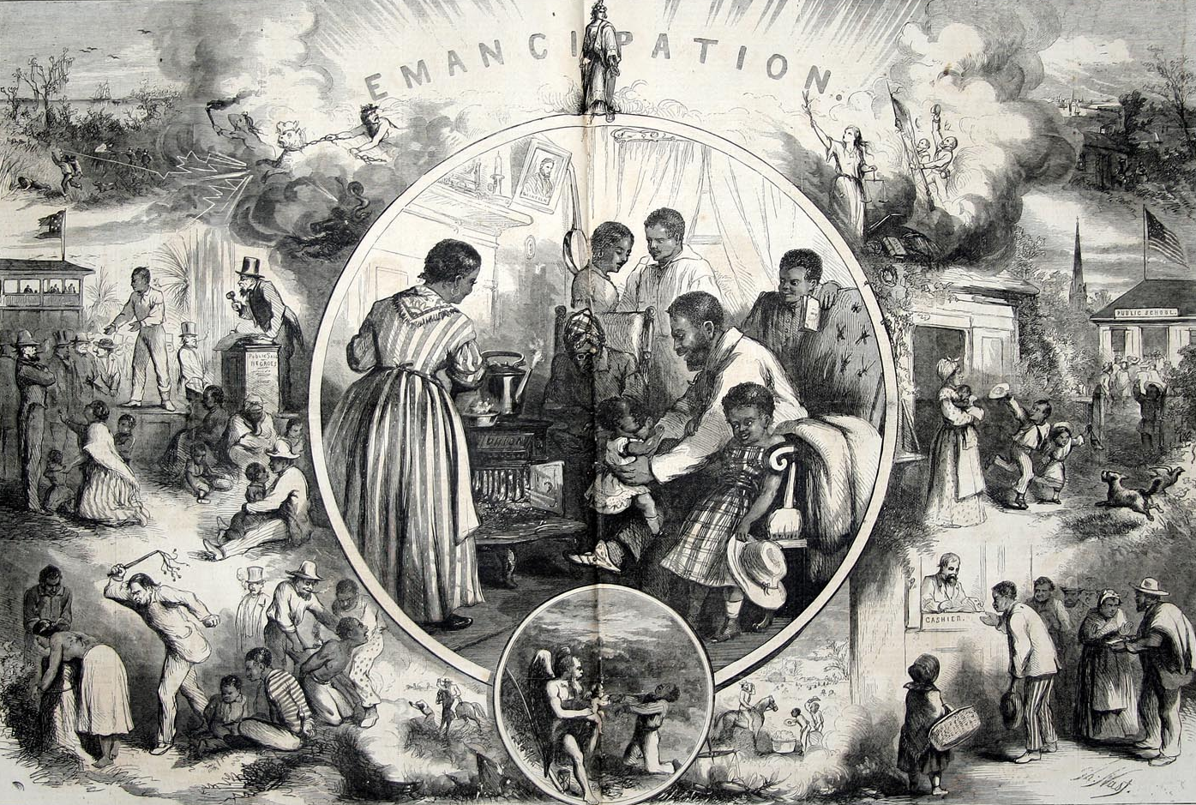
For the majority of former slaves, one of the greatest rights they had been granted through emancipation was mobility. Some moved out of the slave quarters and set up residence Emancipation created waves of migration within the former Confederacy. Large numbers left the countryside for towns and cities, traditional places of safety for blacks.

Black Institutions
The freed slaves’ desire for independence led to the post-war growth in black churches. In the late 1860s many blacks withdrew from white-run churches and formed their own. The African Methodist Episcopal church, founded in Philadelphia in the 1790s, gained thousands of new southern members. The black churches offered their congregation an opportunity take part in the service. They also provided relief, raised funds for schools and supported the Republican Party.

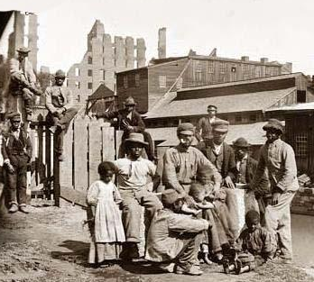
Black schools also played a crucial role for freedmen. The ex-slaves eagerly sought after literacy for themselves and their children. Following emancipation, blacks organised their own schools supervised by the Freedmen’s Bureau. The Freedmen’s Bureau and northern organizations like the American Missionary Association who helped to found Howard, Atlanta, Fisk University and Hampton Institute. But despite all these advances, black education remained limited. By the end of the Reconstruction period, more than 80 per cent of the black population remained illiterate. School segregation and segregation as well as on streetcars, steamboats, churches, trains, theatres and restaurants were taken for granted.

Freedmen and Landownership
For the majority of the newly freed slaves their sole ambition was to farm their own land. Indeed, to freed blacks everywhere, ‘forty acres and a mule’ was the dream that freed them from plantation labour, from white domination, and from cotton, the ‘slave crop’. But freedmen’s visions of landownership failed to materialize. By the end of Reconstruction, only a small minority of former slaves owned working farms. Without large scale land reform, the obstacles to black landownership remained insurmountable.
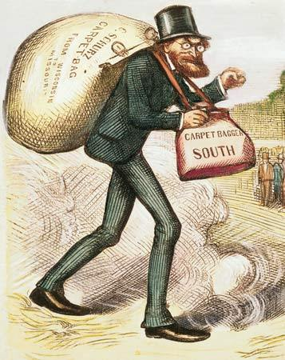
Carpetbaggers and Scalawags
The most important positions in southern state governments went to white Republicans, who were swiftly labelled as ‘carpetbaggers’ and ‘scalawags’ depending on where the individual was born. The name ‘carpetbaggers’ was used to describe northern opportunists who allegedly rushed South with their belongings in carpetbags to gain political power and money. The ‘scalawags’ were southern white Republicans, who were even more reviled in the South. Most ‘scalawags’ had opposed secession and had formed pro-Unionist majorities in the mountain areas of Georgia, Alabama and Tennessee.

Ku Klux Klan
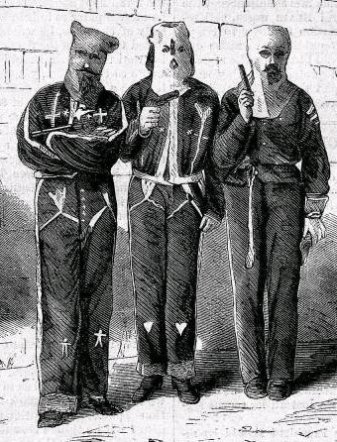
White southerners were very hostile to the new republican regimes imposed on them by Reconstruction because of their inclusion of blacks. White southerners had become so conditioned by slavery that they were unable to conceive of blacks as American citizens. In many places throughout the south the reaction to the new regime was one of violence.

The Ku Klux Klan (KKK) first organized in 1866 in Pulaski, Tennessee, as a social club with costumes and secret rituals common to fraternal organisations. Quickly the group turned from practical jokes to intimidation of both black and white Republicans who in their opinion were destroying their traditions and way of life. The group’s popularity grew rapidly throughout the south and similar groups such as the Louisiana Knights of the White Camellia formed imitating the actions of the KKK. Klansmen rode about the countryside hiding under masks and robes, issuing threats and violence.
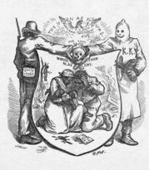
The Klansmen focused their terror on prominent Republicans, black and white. Although the majority of Klansmen were poor farmers and tradesmen, middle class whites – planters, merchants, doctors, ministers and lawyers – also joined and participated in its violence. Congress struck back with three Enforcement Acts (1870-71) to protect black voters. A mass prosecution of Klan members was pursued and in some counties habeas corpus was suspended. The program of federal enforcement broke the back of the Klan, and their actions declined steadily throughout the following years.

Conclusion
Emancipation certainly succeeded in reshaping the southern economy as former slaves sought new lives as free people and consequently created a completely new labour system. The North, meanwhile, careered headlong into an era of industrial growth, labour unrest and financial crisis. The importance of the ‘southern question’ to Northern politicians by the mid 1870s had disappeared. The federal government in Washington were ready to discard the reconstruction policies that Congress had imposed a decade before. Reconstruction finally collapsed in 1877 as the southern states returned to Democratic control.
All images are from the US National Archives and are believed now to be out of copyright restriction.

