Unit 2

Slavery & Antislavery Movements

Slavery
As both a symbol and reality, slavery became the most important difference between the North and the South from 1848 onwards. Southerners viewed it as a ‘peculiar institution’ that would come to play a crucial role not only in causing the civil war, but also in defining the ways in which it was fought, its goals and its meaning for post-war Americans.

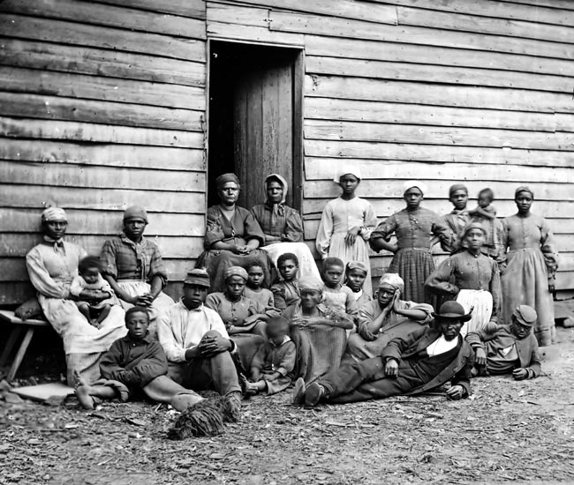
Plantation Slaves
The Slave Trade
Slaves stood at the bottom of the social hierarchy in America. The number of slaves in the United States had grown continuously from 698,000 in the first census held in 1790, to almost 4 million in the eighth census in 1860. The rise in the slave population occurred mainly through a natural increase, the rate of which was very similar to that of white Americans at the time. Following the 1808 Act outlawing the African slave trade it was expected that slavery would, in a few decades, become extinct but the expansion of the cotton belt with its need for cheap labour outstripped supply. Ending the importation of slaves only added to the value of those already in America. Prices for field slaves ranged between $300 and $400 in the 1790’s, rose to $1,500 - $2,000 in the 1850’s. Slaves with special skills cost even more.

With the prices of slaves increasing owners began improving the treatment of their now valuable property. ‘Massa was purty good,’ one ex-slave recalled later. ‘He treated us jus’ ‘bout like you would a good mule.’ Another said his owner ‘fed us reg’lar on good, ‘stantial food, jus’ like you’d tend to you dog, if you had a real good one’. Some owners hired waged workers, often Irish immigrants, for ditching and other dangerous work rather than risk the lives of the more valuable slaves.

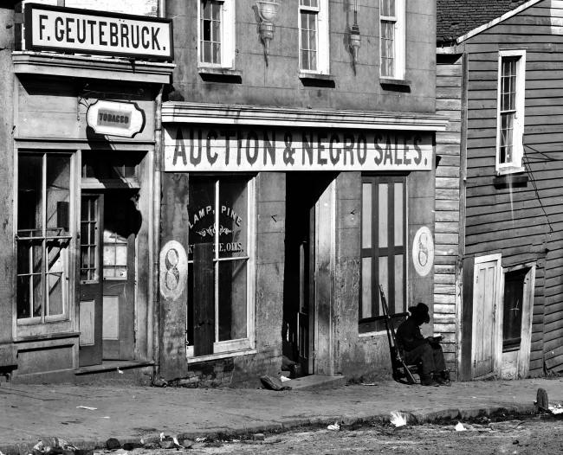
Every town of any size had public auctioneers and dealers willing to buy and sell slaves. The worst aspect of the slave trade was that it often led to splitting up families. Only Louisiana and Alabama (from 1852) forbade separating a child under ten from its mother, and no state forbade separation of husband from wife. Although historians have argued over the actual number of families that were split up in this way, the fear felt by the slaves was palpable.

A slave market in Atlanta Georgia

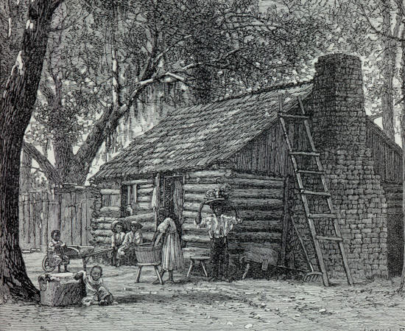
Plantation Slavery
The majority of southern slaves worked on cotton, tobacco or sugar plantations. The favoured jobs were those of household servants and skilled workers such as blacksmiths and carpenters, boatmen or cooks. Field hands were usually housed in one or two room wooden shacks with dirt floors and often without any windows.

A slave cabin
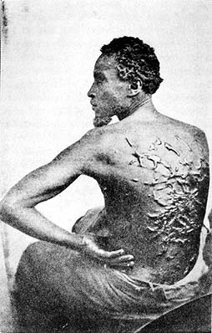
Field hands worked long hours from dawn to dusk. Very little protection was given to the slaves within the law. South Carolina’s limit of fifteen hours in winter and sixteen in summer exceeded the hours of daylight most of the year. The slave codes adopted in each state concerned themselves mainly with the owner’s interests and subjected the slaves not only to his governance but to surveillance by patrols of county militiamen, who struck fear into the slave quarters by abusing slaves found outside their plantations. Evidence suggests that a majority of both planters and small farmers used the whip, which the slave codes allowed. The difference between a good and a bad owner, according to one ex-slave, was the difference between one who did not ‘whip too much’ and one who ‘whipped till he’s bloodied you and blistered you.
A persecuted slave

If there was a melting pot in American history, the most effective was probably the one in which Africans from a variety of ethnic linguistic and tribal origins fused into a new community and a new culture as African Americans. Members of the slave community were bound together in helping and protecting one another, which in turn created a sense of cohesion and pride.

Antislavery Movements
Colonisation
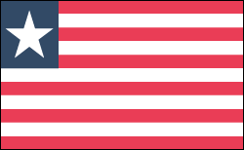
One of the fist antislavery societies to form in the United States was the American Colonization Society in 1817. The society proposed to return freed slaves to Africa. The movement had the support of prominent political figures such as James Madison, James Monroe, Henry Clay and Daniel Webster and it appealed to diverse opinions. Some saw the movement as a step towards emancipation, while others viewed the society as a way of maintaining slavery through getting rid of potentially problematic and difficult free blacks. In 1821 agents representing the society bought land in West Africa in order to create a new country. In 1822 freed slaves arrived from America, and twenty five years later the society relinquished control to the independent republic of Liberia. However, the colonization movement received very little support from either antislavery or proslavery elements. By 1860 only 15,000 blacks had migrated to Africa a minute number when compared to the amount of slave births. Liberian Flag

Abolitionism
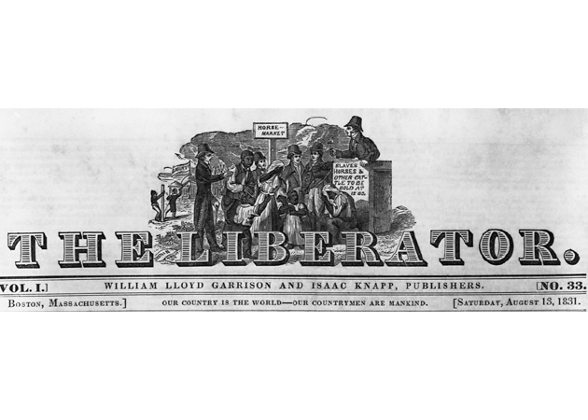
In the early 1830s the antislavery movement adopted a different approach. Its initial efforts to promote a gradual end to slavery by keeping out the institution from the territories gave way to demands for immediate abolition. In 1831, William Lloyd Garrison began publishing a new antislavery newspaper, The Liberator. The first issue of the paper renounced ‘…the popular but pernicious (evil) doctrine of gradual emancipation…Tell the mother to gradually extricate her babe from the fire into which it has fallen, but urge me not to use moderation in a cause like the present’ and he went on to promise: ‘I will be as harsh as truth, and as uncompromising as justice’.

Hatred and outrage intensified in the South towards what they perceived to be ‘Yankee meddling in Southern affairs’. The timing of Garrison’s newspaper was unfortunate as a few months later a slave rebellion took place in the south. Led by the slave Nat Turner the rebellion resulted in the deaths of nearly sixty whites. Large number of Southerners believed that Garrison should bare the blame for the insurrection, but there is no evidence that Turner had ever heard of the newspaper. Garrison argued that he had not a single subscriber in the South at the time.

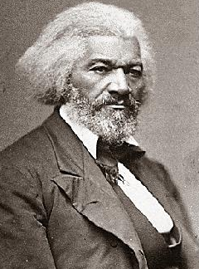
A period of organization followed these events. In 1832 Garrison and his followers set up the New England Anti-Slavery Society. In 1833 two wealthy New York merchants, Arthur and Lewis Tappan founded a similar group called the American Anti-Slavery Society. The society hoped to exploit the publicity given to the work of William Wilberforce in Britain which led parliament in 1883 to end slavery throughout the British Empire. Lecturers and organisers were sent out to speak in every available church and community hall. By the mid-1840s, the movement had some 1,300 local societies with total membership of 250,000.

Support for abolition came from the people attracted to other reform movements. Abolitionists tended to come from religious families that had been influenced by the revival movements of recent years. Among the abolitionist movements earliest supporters were free African Americans who lived in the Northern states. One of the most famous was Frederick Douglass, an escaped slave who earned enough money from lectures and writing to purchase his freedom. Frederick Douglass

By the 1840’s, abolitionism became a political as well as a moral crusade. Abolitionists had come to believe that the only way to destroy slavery was through political means. The two main political parties the Whigs and Democrats were not willing to be drawn into the issue. Consequently some abolitionists formed their own party, called the Liberty Party. This new party marked the birth of abolitionism as an organised force in national politics and would ultimately lead to civil war.

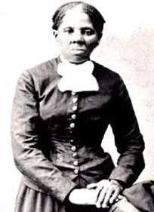
Underground Railroad
One element of slavery that was given a great deal of coverage during this period was the fugitive slaves. They were perceived by many in the south as having stolen themselves and as a result they provided a bad example for other slaves. Runaways were harshly punished. Fugitive slaves were assisted in escaping through the Underground Railroad which spirited African Americans northwards to freedom. Individuals like Harriet Tubman (known as ‘…the Moses of her people) dedicated their lives to working on the Underground Railroad. Railroad terms were used as code words: hiding places were called stations, and people like Tubman who aided slaves in their efforts to escape were often referred to as conductors.

The anti-slavery press publicized stories about the heroic escapes of fugitives from the gun-toting slave catchers and their bloodhounds. Abolitionists also quickly discovered that fugitive slaves made the most effective antislavery lecturers and their autobiographies (often ghost-written) became very popular. The organization of the underground railroad gave anti-slavery Northerners an opportunity to do something practical against slavery.
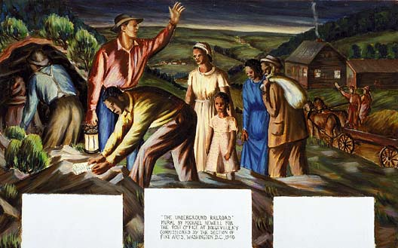

All images are from the US National Archives and are believed now to be out of copyright restriction.

