Unit 3
In-Depth Study 8
The Crisis of the American Republic, c.1848-1877
Question 1

Source A
I never would obey it. I had assisted thirty slaves to escape to Canada through the Underground Railroad over the last month. If the authorities wanted anything of me, my residence was at 39 Onondaga Street. I would admit that and they could take me and lock me up in the Penitentiary on the hill; but if they did such a foolish thing as that I had friends enough on Onondaga County to level it to the ground before the next morning. The slaves could no longer take control over what they could never imagine.
[From abolitionist reverend Luther Lee, pastor of the Wesleyan Methodist Church of New York, writing on the Fugitive Slave Act 1850]

Source B

That it shall be the duty of all marshals and deputy marshals to obey and execute all warrants and precepts issued under the provisions of this act, when to them directed; and should any marshal or deputy marshal refuse to receive such warrant, or other process, when tendered, or to use all proper means diligently to execute the same, he shall, on conviction thereof, be fined in the sum of one thousand dollars, to the use of such claimant, on the motion of such claimant, by the Circuit or District Court for the district of such marshal; and after arrest of such fugitive, by such marshal or his deputy, or whilst at any time in his custody under the provisions of this act, should such fugitive escape, whether with or without the assent of such marshal or his deputy, such marshal shall be liable, on his official bond, to be prosecuted for the benefit of such claimant, for the full value of the service or labour of said fugitive in the State, Territory, or District whence he escaped.

[From Section 5 of the Fugitive Slave Act, 1850]

Source C
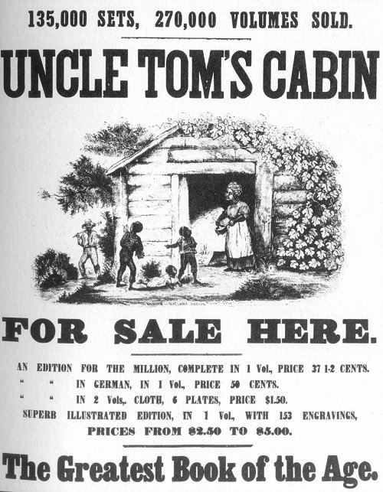

[A poster advertising the sale of Harriet Beecher Stowe’s novel, Uncle Tom’s Cabin (1853)]

Source D

I, John Brown, am now quite certain that the crimes of this guilty land will never be purged away but with blood. I had, as I now think, vainly flattered myself that without very much bloodshed it might be done.

[On the day of his execution firebrand abolitionist John Brown wrote
the above note to his wife (2 December 1859)]

Source E

Utterly convinced that he was carrying out God’s work, Brown led 19 men into Harpers Ferry. After gaining his major objective – he strangely sat back and waited while federal and Virginia troops rushed to the armoury. After US Marines stormed his position on the 18 October, 10 of Brown’s men lay dead and 4 more had been captures along with Brown. During the six week period between Brown’s capture and his execution on 2 December, sectional tensions reached new heights. Most of the South took on the appearance of an armed camp as militia units sprang to active duty and vigilante groups patrolled the countryside looking for suspicious people. For many in the North Brown was viewed as a hero.

[Dr. Elin Haf Griffiths, an academic historian, writing in a school text
book, The Causes of American Civil War (2007)]
- Study Source A. Use the source and your own knowledge to explain the meaning of the words “Underground Railway” in source A. (4)

- Study Sources A and B. Use the information in Sources A and B and your own knowledge to explain the importance of the Fugitive Slave Act of 1850. (8)

- Study Sources B and D. How reliable are these sources in explaining sectional tensions in America? (16)

- Study Sources D and E. How far does Source D support or contradict the interpretation of the impact of John Brown’s Raid given in Source E?
(20)

- How useful are these sources to an understanding of the causes and outbreak of the American Civil War to 1865? (32)

All images are from the US National Archives and are believed now to be out of copyright restriction.

