Unit 4

Events Leading to Sectional Conflict after 1848

1848
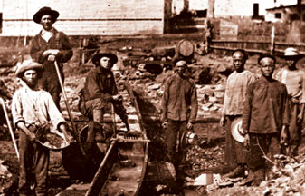
As the Mexican War drew to a close in 1848 the attention of the American public was drawn to the West. A new vast expanse of land which had recently been acquired from Mexico was waiting to be settled. Newspaper reports by journalists like Horace Greely the editor of the New York Tribune, encouraged Americans “…to go West young man and grow up with the country”. The discovery of gold in California in 1849 was just one sign of the untold wealth to be found in the west.

However, the West was also a cause of deepening concern. Southern states insisted on their rights to extend slavery into the new territories, while Northern states demanded an end to the expansion of the accursed institution. The survival of the ‘united’ states depended on how Americans resolved this volatile issue. During the decade of the 1850s, the slavery issue would put the Union to its most critical test.

The Compromise of 1850
As the calls for southern independence and states rights increased a troubled and divided Thirty First Congress assembled in Washington at the beginning of December 1849. The spotlight of the nation fell on the Senate, where a luminous cast enacted one of the great dramas of American politics, the Compromise of 1850. During this session extreme language, verbal attacks, fist fights and calls for duels replaced debate and discussion.

In January 1850, Henry Clay, the ‘Great Compromiser’ presented a set of resolutions to avoid disunion. Clay’s proposal went as follows:
- Let California enter the Union as a free state.
- Pass a strict fugitive slave law.
- Organise new territories in the South West without restriction to slavery.
- Abolish public slave auctions in the District of Columbia.
- Compensate Texas for losing New Mexico.
For ten weeks Clay’s measures were debated in an atmosphere of apprehension for the future of the nation. All the central characters in the sectional struggle took part in the debate – John Bell of Tennessee, Stephen A. Douglas of Illinois, Daniel Webster of Massachusetts and John C. Calhoun of South Carolina.

By far the most impressive of the contributors was Calhoun. Slumped in a chair, to weak to read his speech, in the weeks before his death, he attended every session of the Senate when it was read. He spoke of the development of abolitionism as a serious menace to the South and urged that if the Union was to be saved the causes of southern discontent should be removed. California’s admission as a free state, he warned, would justify secession.

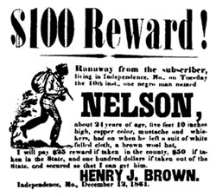
The Fugitive Slave Law
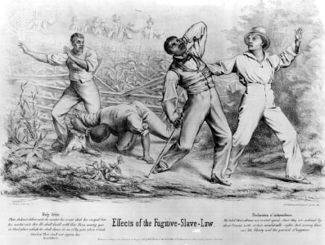
By far the most controversial measure in the Compromise of 1850 was the Fugitive Slave Act. The Fugitive Slave Law of 1850 made any Federal Marshal or other official who did not arrest an alleged runaway slave liable to a fine of $1,000. Law-enforcement officials everywhere now had to arrest anyone suspected of being a runaway slave on no more evidence than a sworn testimony of ownership. The suspected slave could not ask for a jury trial or testify on his or her own behalf. In addition, any person aiding a runaway slave by providing food or shelter was subject to six months' imprisonment and a $1,000 fine. Officers who captured a fugitive slave were entitled to a bonus for their work. Since any suspected slave was not eligible for a trial this led to many free blacks being conscripted into slavery as they had no rights in court and could not defend themselves against accusations. In fact the Fugitive Slave Law brought the issue home to anti-slavery citizens in the North, since it made them responsible for enforcing slavery. Even moderate abolitionists were now faced with the immediate choice of defying what they believed an unjust law or breaking with their own consciences.

Uncle Tom’s Cabin
The enactment of the Fugitive Slave Law created immense animosity and hostility in the North. Beneath a calm surface a volcano of Northern discontent rumbled. The wide spread popularity of Harriet Beecher Stowe’s novel Uncle Tom’s Cabin, both reflected and reinforced the strong feelings of guilt and loathing towards slavery felt in the North. Harriet Beecher Stowe said that she was moved to write the novel by the anguish she felt towards the way slaves were treated in the North and in the South by the Fugitive Slave Law. For nearly a year the story ran weekly in an anti-slavery newspaper, beginning in the spring of 1851, by the spring of 1852 the story was published in book form. Uncle Tom’s Cabin became an instant bestseller and provoked strong passionate feelings of revulsion in the North towards slavery and angry denial in the South. A decade after its publication, when Harriet Beecher Stowe was introduced to Abraham Lincoln, the President allegedly said: ‘So you’re the little woman who wrote the book that made this great war’.
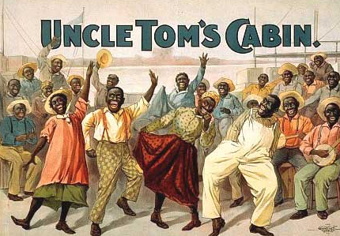

All images are from the US National Archives and are believed now to be out of copyright restriction.

