Unit 6

Secession and the start of the Civil War

Secession
Following Abraham Lincoln’s election victory, South Carolina’s state legislature began taking the lead towards seceding from the Union. A bill was immediately passed for the election of delegates to a state convention to consider braking away. Meeting on the 17 December 1860, the convention unanimously adopted an ordinance of secession. Encouraged by South Carolina’s brave example, seven states in the lower South seceded from the Union. They included Georgia, Florida, Alabama, Mississippi, Louisiana and Texas. Southern radicals had long preached that the Republican Party posed an immediate threat to the preservation of slavery and social peace in the South. Southern ‘fire-eaters’ (the most extreme pre-war Southern pro-slavery nationalists) argued that their honour, liberty and safety all demanded an immediate break from a Union headed by a sectionalised antislavery party that had not received a single electoral vote in the South.
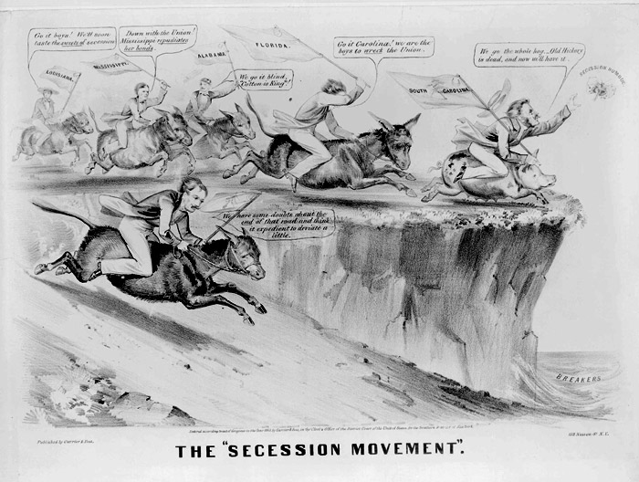

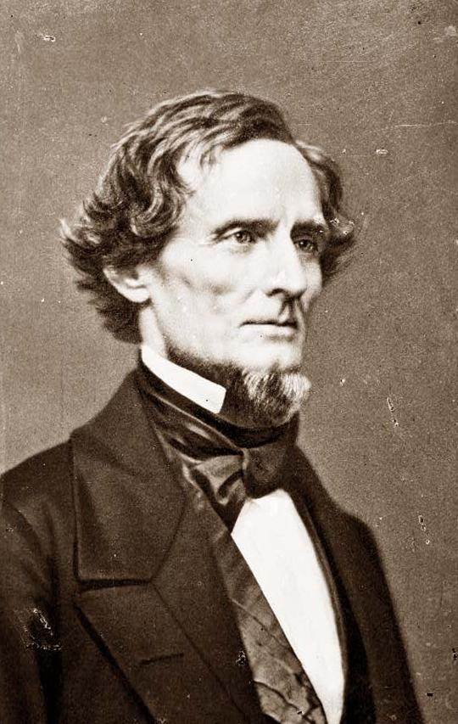
Secessionists argued for the constitutional doctrine of states rights. They believed that individual states retained ultimate sovereign power within the Union and could peacefully leave the Union the same way they had entered it through a special state convention. In early February 1861, representatives from all seven states met at Montgomery, Alabama, establishing the Confederate States of America and electing Jefferson Davis as president of the new republic. The eight slave states in the upper South, where Unionist sentiment was stronger, hesitated to see if the crisis could be resolved.

The original Confederacy represented those Southern states with the heaviest concentration of slaves and the highest percentage of white families owning slaves. Planters often lead the secession movement, and what opposition they encountered came from non-slaveholding farmers who had little or no connection with plantation slavery.

The vast majority of Northerners rejected secession and viewed it as a treasonable contempt of the Constitution. They equated secession with anarchy and feared that it would soon lead to a break up of the United States.

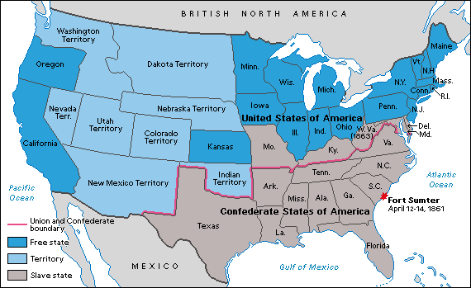
When Abraham Lincoln became President on the 4 March 1861, he faced a huge dilemma. If he took no action against the Confederacy, he risked demoralising supporters within his own party and shattering fragile Northern unity. On the other hand, any forceful step against the seceded states threatened to drive the Upper South into the Confederacy.
Lincoln’s First Inaugural Address
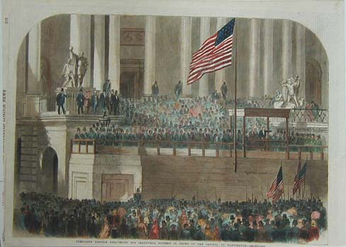
Although determined to save the Union at all cost, Lincoln hoped to do so without provoking a civil war. In his inaugural address, he promised to enforce the laws and to ‘hold and possess’ property owned by the federal government in every state. Trying to avoid any action that might give the upper South grounds for secession, Lincoln promised not to use force unless the government was attacked first and ended his inauguration with these words:
In your hands, my dissatisfied fellow countrymen, and not in mine, is the momentous issue of civil war. The government will not assail you. You can have no conflict, without being yourselves the aggressors. You have no oath registered in Heaven to destroy the government, while I shall have the most solemn one to "preserve, protect, and defend" it.
I am loathe to close. We are not enemies, but friends. We must not be enemies. Though passion may have strained, it must not break our bonds of affection. The mystic chords of memory, stretching from every battlefield, and patriot grave, to every living heart and hearthstone, all over this broad land, will yet swell the chorus of the Union, when again touched, as surely they will be, by the better angels of our nature.
Fort Sumter
The most pressing problem for Lincoln once he took office was Fort Sumter, a major federal fort located in Charleston harbour. Cut off from land, it was running out of provisions and Lincoln was required to make the decision whether to re-supply or evacuate the fort. Attempting to re-supply Sumter by sea ran the danger of being seen as an act that provoked war. Lincoln decided to send unarmed merchant vessels. If the Confederates attacked, they – and not the federal government would be blamed for starting the war.

In fact, Lincoln had left the Confederacy with little option but to fire the first shot in the American Civil War. The Confederacy could not permit the fort to survive as a symbol of federal sovereignty. On the morning of the 12 April 1861 Confederate guns opened fire on Fort Sumter.

Virginia, Arkansas, Tennessee and North Carolina rejected Lincoln’s call for troops, and all joined the Confederacy within the next five weeks. But Lincoln now had a North united behind the goal of preserving the Union by force. To Northerners, the Confederacy was the aggressor that had fired the first shot of the Civil War, and the North began its crusade to save the Union.
All images are from the US National Archives and are believed now to be out of copyright restriction.

