Unit 7

The Home Front

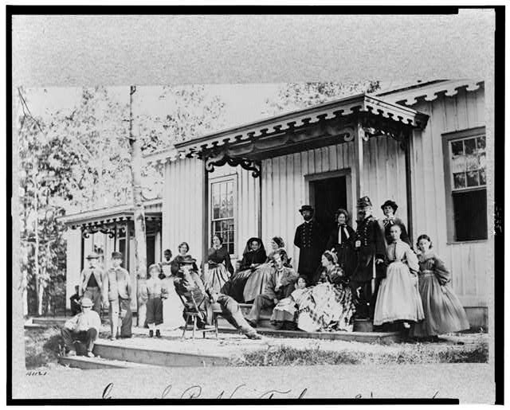
On the home front, domestic concerns such as rising prices, shortages of labour, family separations, and changes in religious faith affected the lives of northerners and southerners alike. One of the major differences between the northern and southern home front was their distance from the battlefield, being further away from the fighting meant that northern civilians experienced the Civil War less directly. Nevertheless, northern and southern zeal for the cause and its transforming nature remained similar.

Mobilization
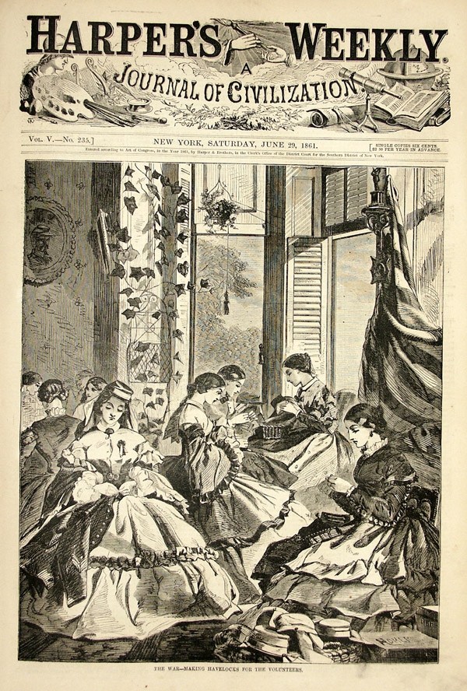
The war’s first impact upon communities and individual families came quickly following the beginning of hostilities with civilian mobilization into the northern and southern armies. By May 1865 37% of males of military age (between eighteen and forty-five) had served in the Union army a total of 2,778,304 men. The total percentage for the Confederacy was even higher with 87% of the white male population of military age serving in the army a total of over 750,000 individuals.

Women
Personal tragedy often stalked the lives of the women on the home front, some lost fiancés, others husbands, fathers and brothers. Nevertheless, the war also offered women an opportunity to enter public life in their own right. Ladies Aid societies opened up throughout the northern and southern states. In the north the Women’s Central Relief Association became the most important agency coordinating voluntary work on the home front. Their work involved producing uniforms, sewing head coverings, preserving fruits, sending boxes of supplies to the front, and organizing the popular fundraisers called sanitary fairs.

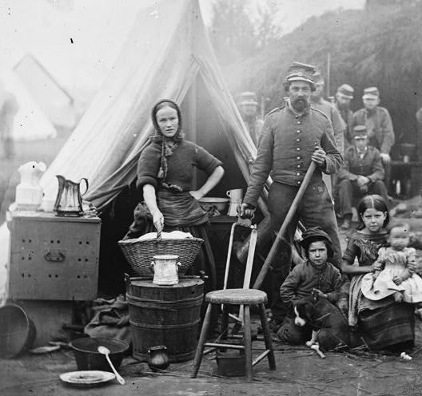
Wives of enlisted men also had to work to supplement their husband’s often meagre army wage. The labour shortages on the home front often meant that women had to substitute for men in activities outside the home - harvesting wheat, labouring in the textile mills and serving as nurses. Others went to war with their husbands often cooking and cleaning for the army.

Other women fought for their cause and had to dress as men in order to join the army. Historians today estimate that over four hundred women dressed up as male soldiers and fought for the Union.

The Economy
The Civil War began during a period of recession and economic difficulty, which continued until 1862. Then a recovery set in, fuelled by increased government spending and federal policies such as cutting off foreign imports by means of high tariffs and the granting of government war contracts. By the middle of 1862 the northern economy began to boom as a period of war driven prosperity developed. Demand for manufactured products such as railroad cars, woollen goods, ships, shoes, machine parts and guns increased five fold. Banks began to extend their credit operations, overnight the civil war had become a catalyst for capital development, some invested in government bonds.

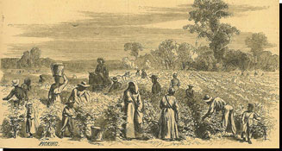
Although an estimated 680,000 northern farmers joined the union army, ante bellum levels of crop production were sustained. Areas devoted to the production of grain increased in the Midwestern states, as women and children worked in the field. In the southern states farm production decreased as a result of both male and slave workers being lost. In the north Labour saving machinery also helped to replace absent workers. The necessity of substituting machines for human labour brought enormous profits to the manufacturers of reapers, threshers and similar devices. Given both the domestic demands of feeding a great army and foreign demand, especially from Britain, food prices increased. As a result farmland in soil-rich states such as Illinois soared in price from $10 to $100 an acre. In the early years of the war, unemployment was high, but as prosperity spread and more workers enlisted in the army, there were jobs for all. Wages gradually increased but never as fast as prices

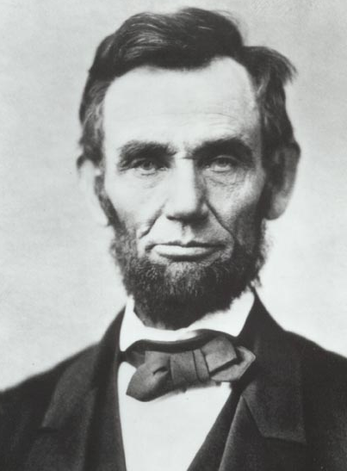
Immigration
The increased need for manufactured goods and food production coupled with the constant drain on civilian manpower produced a labour shortage, from which emerged an increased demand for foreign labour. In his annual message to Congress in December 1863, Lincoln noted ‘…a great deficiency of labourers in every field of industry’, and asked Congress to encourage immigration. Congress responded by passing a bill on the 4 July 1864 establishing a contract labour system whereby workers could be imported according to regulations fixed by the commissioner of immigration.

Influencing Opinion
Often described as the first modern war, the civil war advanced the extent to which the government tried to shape opinion through the press and other agencies. Both the north and the south had propaganda services poised to influence foreign sentiment. At home both government and private sources such as propaganda clubs like the Union League, tried to shape opinion, but their influence and power were dwarfed by the control exerted by the press. Newspapers were free agents, conducting themselves according to the philosophies of their editor – proprietor. Almost overnight the war created a new type of journalist – the war correspondent.
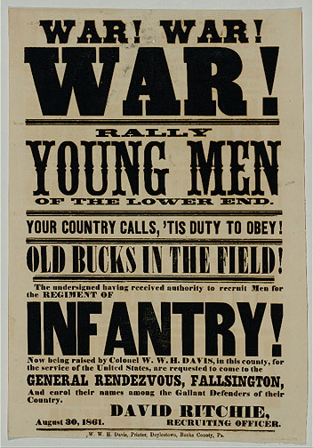
Reporters were welcomed and given special privileges such as government passes. They had the use of government horses and wagons; they were given transportation on government steamers and military trains. Throughout the war, opposition to the government’s policies and personnel, including the president, was freely expressed in speech and in print. Censorship, though not absent, was never systematic. Consequently the northern and southern press printed casualty lists; revealed the composition, location, and destination of military and naval expeditions; indicated the places of rendezvous for supply vessels; and in fact functioned as inadvertent spies for both the Federals and Confederacy.

Religion
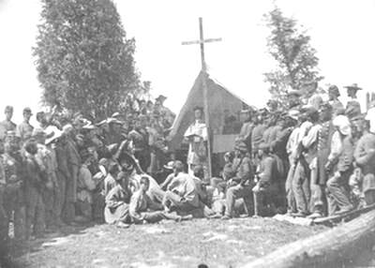
Religion played a major role in shaping both northern and southern opinion towards the conflict. For generations, Americans had divided their Protestant religion into different denominations and the issue of slavery had further split the denominations creating for example two Baptist denominations. When the war came, it seemed to many northerners a judgment of God on a society that had, according to the preacher Henry Ward Beecher, forsaken God’s commandments for ‘…luxury, extravagance, ostentation and corruption of morals’. By 1861, ministers linked God’s purpose with those of the Union and often recruited troops. Hymns also linked God to the northern effort – ‘Battle Hymn of the Republic’, ‘Stand Up, Stand Up For Jesus’. As southern losses increased, faith in religion and God’s providence shook Confederate morale, just as these same forces strengthened northern confidence.
All images are from the US National Archives and are believed now to be out of copyright restriction.

