Unit 8

The War

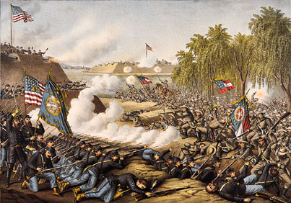
The Civil War was in many respects the first modern war. Its size was unprecedented. One out of every twelve adult American males served in the war, and almost every family in America was directly affected by the conflict. Over 625,000 Americans were killed in the war, more than in all other American wars combined. Because surgeons were constantly overworked and frequently lacked equipment, supplies and knowledge, almost any stomach or head wound proved fatal. Fifty thousand of the survivors returned with one or more limbs amputated. Disease however was the greatest threat to soldiers, killing twice as many as were lost in battle.

Armies and Strategies
In 1861 9 million people lived in the confederacy, one third of them slaves compared to 22 million people in the Union. The North also had 3.5 times as many white men of military age, 90% of all US industry and two thirds of the countries railway tracks. But the North faced a daunting if not impossible challenge of subduing the Confederacy and forcing the South back into the Union, the South in contrast was merely fighting for independence. To subdue the Confederacy, the North would have to control an area comparable in size to Western Europe.

The South, which relied on slaves for labour, could assign a higher proportion of its white male population to combat. As for technology, the North required and possessed superior railroads. Fighting defensively on interior lines, the South could shift its troops relatively short distances without using railroads, whereas the North had to move its troops and supplies huge distances.

The Civil War saw a variety of newly developed weapons, including the submarine, the repeating rifle and the Gatling gun, the forerunner of the machine gun. But by far the most important weapon development of the Civil War took place in the 1850s with smoothbore muskets being replaced by rifles whose bullets powder would not clog the rifle’s spiralled internal grooves after a few shots. The accurate range of the new rifles increased from eighty yards for the smoothbore to four hundred yards for the new Springfield and Enfield rifles.
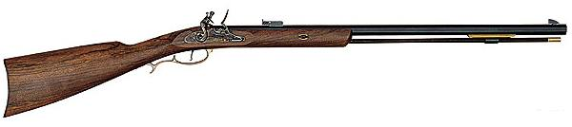
Manuals used at West Point Military Academy in the 1840s and 1850s had identified the infantry charge against the opponents weakest point as the key to victory. These manuals assumed that defenders armed with muskets would be able to fire only a round or two before being overwhelmed the same belief led Civil War generals at the beginning of the conflict to disregard trenches as being merely traps for defenders. Armed with rifles a defending army could now fire several rounds before closing with the enemy. As a result the bayonet almost became an obsolete weapon; less than 1% of the casualties in the Civil War resulted from bayonet wounds.
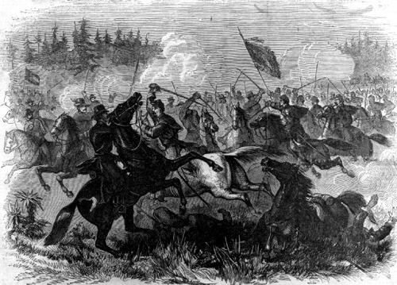
The increased use of the rifle forced both armies to rely less on the cavalry. Traditionally the cavalry had ranked as the most effective offensive weapon in war because cavalry charges often proved to be decisive in braking army defences. Rifles reduced the effectiveness of cavalry by increasing the fire power of foot soldiers. As a result the cavalry on both sides were relegated to reconnaissance missions and to raids on supply trains.

One of the most important strategies for Civil War armies was surprise. In most battles of the war if the attacking army stood an excellent chance of success if it achieved surprise. The South’s lush forests provided abundant opportunities for an army to sneak up on its opponent.

As in previous conflicts, the Civil War was fought basically as a succession of battles during which infantry traded fire, charged, and counter charged. Whichever side withdrew from the field usually was thought to have lost the battle, but the losing side often sustained lighter casualties than the supposed victor.

The Major Campaigns
Historians have divided the American Civil War into two theatres of war the east and the west separated by the Appalachian Mountains.

The Eastern Theatre
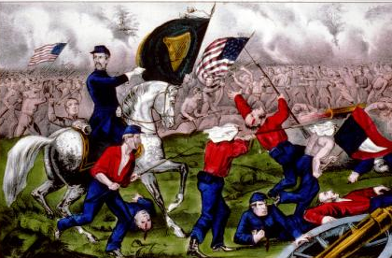
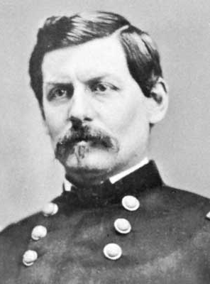
The Confederacy’s decision to move its capitol from Montgomery, Alabama to Richmond, Virginia, shaped the Union strategy in the eastern theatre of war. “Forward to Richmond” became the Union’s first war cry in 1861. But before they could conquer Richmond, one hundred miles to the south of Washington, Union troops would have to destroy a Confederate army encamped at Manassas Junction, twenty miles from the Union capitol. In the resulting battle of First Bull Run or First Manassas (a large number of Civil War battles have two names because the North names battles after local landmarks and the South named them after the nearest town) raw recruits clash in bloody chaos. Well dressed upper class Washington luminaries gathered to view the action. Aided by last minute reinforcements the Union forces were routed and “skedaddled” home to Washington. After Bull Run the Union general Irvin McDowell was replaced by General George B. McClellan.

The soldiers quickly came to adore and respect McClellan, but Lincoln became disillusioned by his new military leader. Lincoln firmly believed that the key to winning the war lay in a coordinated simultaneous attack on several fronts so that the Northern advantage in manpower and resources were fully exploited. McClellan, a proslavery Democrat, wanted to manoeuvre the South into a relatively bloodless defeat and then negotiate a peace to readmit the Southern states to the Union, leaving slavery intact.
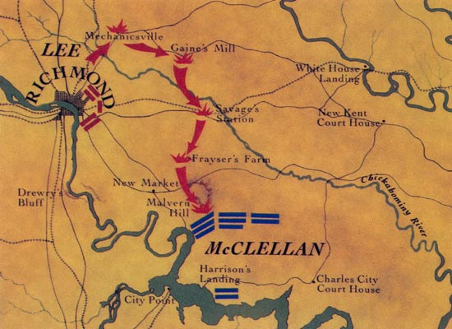
Rather than directly attacking the Confederate army, McClellan devised a plan in the spring of 1862 to move his Army of the Potomac by water to the tip of the peninsula south of Richmond and then move his army northward to capture Richmond. The Peninsula Campaign began well with over 100,000 Union soldiers and supplies pouring into the peninsula. By May 1862 the Army of the Potomac was within five miles of Richmond but McClellan hesitated before attacking. The general overestimated the Confederates’ strength and refused to launch a final attack on the city without more reinforcements. Seizing the initiative Southern General Robert E. Lee and his Army of Northern Virginia attacked McClellan in late June 1862. The ensuing Seven Days Battles led to a large scale slaughter and cost the South almost twice as many men as the North. Lincoln who was no fan of McClellan’s peninsula campaign, ordered McClellan to call off the campaign and return to Washington.

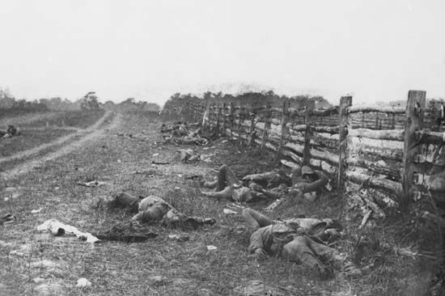
With the North in retreat Lee and his lieutenant, Stonewall Jackson daringly moved north and routed the North again at the Second Battle of Bull Run. Lee continued moving North and invaded Maryland and in doing so now threatened Washington. These improved the prospects of peace candidates in the upcoming mid term election and encouraged France and Britain to recognise the Confederacy as an independent nation. McClellan was forced to halt Lee’s advance at the Battle of Antietam on the 17 September. Although a tactical draw the battle proved to be a strategic victory as it led Lee to call off his northern invasion and led to Lincoln issuing the Emancipation Proclamation, to free all slaves under rebel control (see Unit 10). With over 24,000 casualties Antietam become known as the bloodiest day in American history.
Unable or unwilling to pursue Lee after the battle Lincoln replaced McClellan with General Ambrose Burnside. In December 1862 Burnside led 122,000 federal troops against 78,000 Confederates at the Battle of Fredericksburg. After capturing the town he ordered his army on a series of frontal charges against an entrenched Confederate force, the resulting carnage was enormous.

The Western Theatre
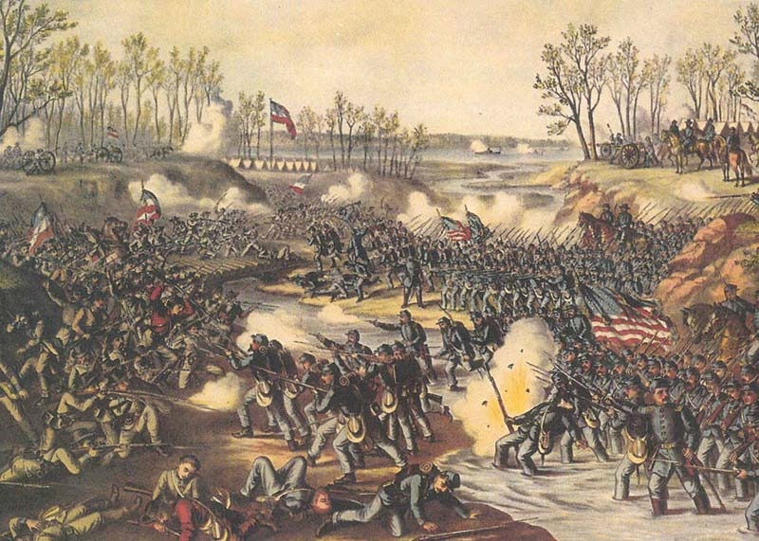
The Union were far more successful in the West where the Civil War was fought over vast terrain and for the control of the large southern rivers. Obscure Union General Ulysses S Grant, would come to dominate the western theatre of war. In 1861-62 Grant moved his army into Tennessee, capturing the two strategic forts, Fort Henry of the Tennessee River and Fort Donelson on the Cumberland River. He then headed south to attack Corinth, Mississippi, a major railroad junction.

In early April 1862, Confederate forces tried to relieve the pressure on Corinth by a surprise attack on Grant’s army near a church named Shiloh. Grant and his lieutenant, William T. Sherman, steadied the Union line and with the arrival of reinforcements counterattacked the Confederates and drove them off the field. To attack Grant at Shiloh, the Confederacy had removed soldiers from defending New Orleans. As a result a combined Union land and sea force took the city in late April before moving on to take Baton Rouge and Memphis.

1863 – The Turning Point
1863 began favourably for the Confederacy with Lee and Stonewall Jackson routing the Union army at the Battle of Chancellorsville, Virginia in May 1863. But Union fortunes dramatically improved in the summer and autumn of the year in every theatre of war. The upswing in Union fortunes began with Lee’s decision after Chancellorsville to invade the North. Lee believed that a major victory in the North would tip the balance in his favour.

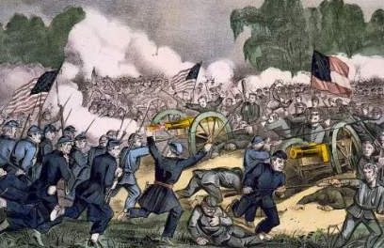
Early in July 1863, Lee’s attack ground to a halt at a Pennsylvania road junction named Gettysburg. Confederates looking for shoes in the town encountered some Union cavalry. Soon both sides called for reinforcements and the war’s greatest battle began. The Battle of Gettysburg would last for three days and culminate with a massive Confederate infantry charge led by Major General George Pickett. The Rebel charge was wiped out by the deadly effective fire from rifled Union guns. Over half of Pickett’s men were dead or wounded. When Lee withdrew he had lost over one third of his army. Despite the defeat the Union army failed to pursue and destroy the retreating rebel army.

Almost simultaneously, the North won a less bloody but more strategic victory in the West, where Grant finally captured Vicksburg. A few weeks later Port Hudson surrendered and the last Confederate holdout on the Mississippi fell. “The Father of Waters” declared Lincoln “flows unvexed to the sea”. Before the year was out the Union won another crucial victory in the West at the Battle of Chickamauga.

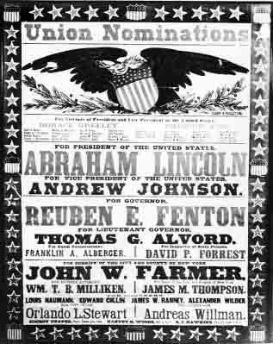
The End of the War 1864-64
Early in 1864 Lincoln appointed Grant commander of all Union armies and promoted him to lieutenant general. With the promotion Grant moved to take control of the Army of the Potomac. In early May 1864, Grant led his army against Lee in a forested area near Fredericksburg, Virginia called the Wilderness (Battle of the Wilderness). Grant tried to swing his army around Lee’s flank at the Battle of Spotsylvania. Pressing on Grant forced Lee to retreat and fought him again at the Battle of Cold Harbour. Once more Lee retreated and was forced to dig trenches to defend Richmond and Petersburg.
While Grant fought Lee in the East, a Union army under William T. Sherman attacked from Georgia and took Atlanta in early September. Atlanta’s fall boosted northern morale and helped re-elect Lincoln.
Having backed Lee into trenches around Petersburg and Richmond, Grant forced the evacuation of both cities. Lee made a last ditch effort to escape from Grant and reach Lynchburg, sixty miles from Petersburg. He planned to use the rail connections to move his army to join up with the Confederate army in the West. But Grant moved swiftly to halt Lee’s retreat and on the 9 April 1865 Lee bowed to the inevitable. Terms of surrender were offered and accepted and the two opposing generals met in the village of Appomattox Courthouse to sign the surrender. Within a month of Appomattox Confederate resistance collapsed.

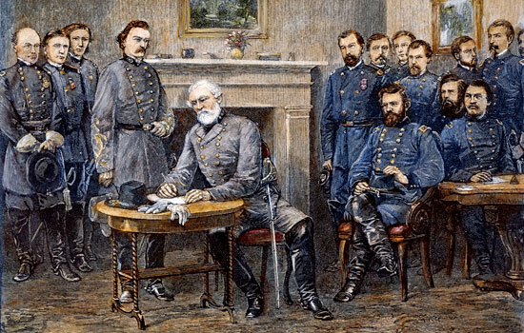

All images are from the US National Archives and are believed now to be out of copyright restriction.

