Unit 9

Emancipation

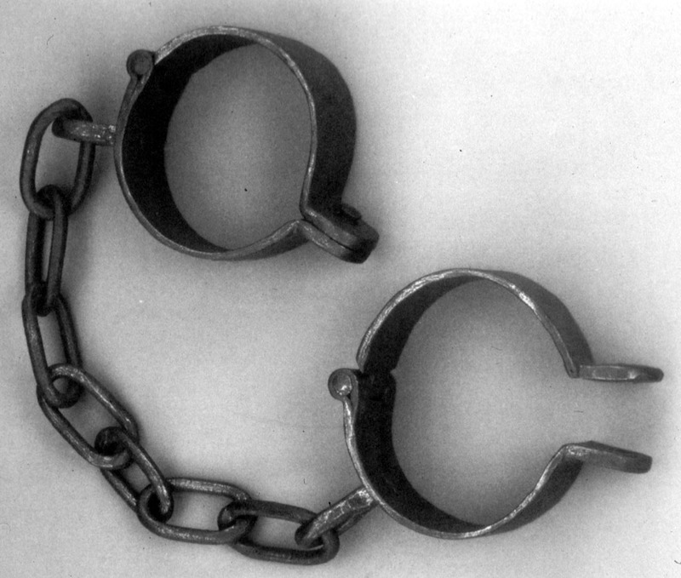
Upon hearing of the fall of Fort Sumter and the beginning of the Civil War, the abolitionist Henry Stanton wrote that ‘The Doom of Slavery is at hand’. In 1861 this prediction seemed to most Americans wildly inaccurate. Lincoln after all stated bluntly in his inaugural address ‘I have no purpose, directly or indirectly, to interfere with the institution of slavery in the states where it exists’. But as the Civil War wore on emancipation would come to dominate northern war goals. The rise of emancipation as a Union war aim reflected the changing character of the war. Northerners who saw no moral value in abolishing slavery began recognising that the destruction of slavery had a military value as a tactic that would cripple the South.
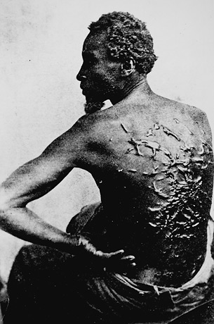
Northern policy on emancipation developed in stages. As Union soldiers invaded the Confederacy questions began to be asked as regards what to do with rebel property, including slaves. At the beginning of the war some northern soldiers viewed slaves as ‘contraband’ and as a result were seized and put to work for the Union army. These slaves were therefore not considered free. Northern politicians reacted very slowly in providing an official policy on how the slaves were to be viewed. Several factors underlay the Union’s cautious approach to the confiscation of southern property. Firstly the Union contained four slave states and secondly a sizable number of proslavery Democrats remained loyal to the Union. Many northern Democrats did not want to turn the war into a crusade against slavery. They feared that ‘two or three million savages’ would come north and compete with white workers.

Adopting the Emancipation Proclamation
From the outset of the Civil War, Lincoln faced mounting pressure from Radical Republicans to adopt emancipation. Radicals worked alongside black abolitionist leaders like Frederick Douglas to fight against slavery and with every Northern military setback, support for the Radicals grew. Emancipation also grew as a military measure with many northern soldiers coming to believe that freeing the southern slaves would cripple the southern economy.

Even though the pressure on Abraham Lincoln to issue an Emancipation Proclamation grew he remained reluctant. In an interview with the editor of the New York Tribune in 1861, Lincoln declared
My paramount object in this struggle is to save the Union, and is not either to save or destroy slavery. If I could save the Union without freeing any slave, I would do it, and if I could save it by freeing all the slaves, I would do it; and if I could save it by freeing some and leaving others alone, I would also do that.
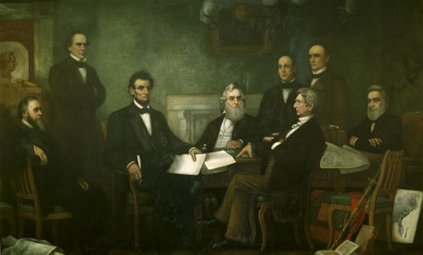
As the war wore on pressure on Lincoln for emancipation increased and by 1862 he had come around to the Radical position. By the summer of 1862 he had drafted a proclamation of emancipation and had circulated it within his cabinet and then waited for the right time to issue it. The time came after the Union victory at Antietam. The Preliminary Emancipation Proclamation declared that all slaves under Confederate control would be free on the 1 January 1863.
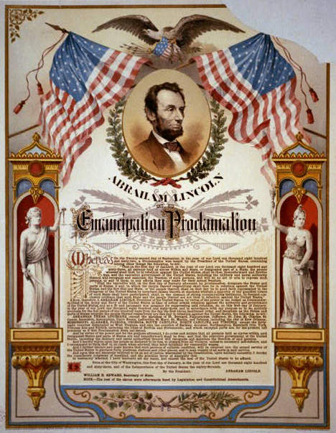
The proclamation had in fact a very narrow practical impact. It applied only to the areas of the Confederacy where the Union had no authority and exempted the Union slave states and those parts of the South which were under Union control. Nevertheless, the proclamation was an inspired political stroke. By issuing the proclamation Lincoln succeeded in appeasing northern conservatives, pacifying Radicals in Congress and mobilizing support for the Union in Europe. Finally it increased the incentives for slaves to escape as northern troops approached.

Nevertheless, it is important to note that the Emancipation Proclamation did not end slavery everywhere or free ‘all slaves’. But it changed the war. From 1863 on, the war for the Union would also be a war against slavery.

Black Union Soldiers
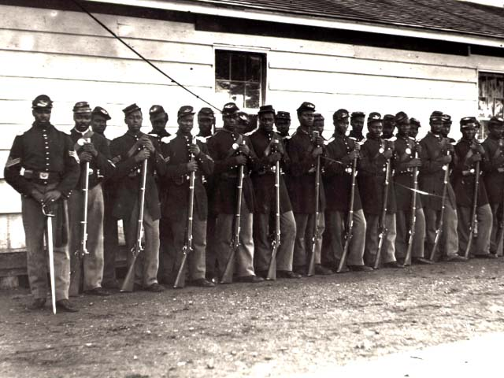
Throughout the first two years of the Civil War the North had refused to recruit black soldiers. Only after the implementation of the Emancipation Proclamation in January 1863 did large scale black enlistment begin. Leading blacks such as Frederick Douglas played an influential role as recruitment agents for the Union army. By the end of the war, 186,000 blacks had served in the Union army, one tenth of all Union soldiers.

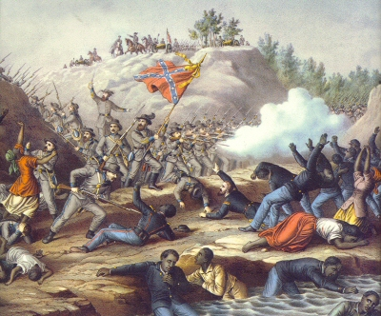
Black recruitment offered new opportunities for whites to secure commissions, for blacks served in separate regiments under white officers. Black troops suffered a far higher mortality rate than white troops because the Confederacy refused to treat captured black soldiers as prisoners of war. This policy denied captured blacks the opportunity to be exchanged for Confederate prisoners. Captured black slaves were treated appallingly and were either re-enslaved or executed. One of the most infamous incident occurred at Fort Pillow, Tennessee, in 1864 when 262 black soldiers were cold bloodedly murdered by victorious Confederate troops. But the use of black troops, especially former slaves was seen by northern generals as a major strike at the Confederacy.
Wartime Slavery
To maintain control over their three million slaves, white southerners often resorted to a variety of methods. Entire plantations were often moved en mass further south away from invading Union armies. Wicked rumours that the Yankees would harness black slaves to carts and use them like horses were widely circulated. White slave patrols also increased throughout the south.

Many slaves were often torn between loyalty to their masters and a desire for freedom. Given a viable choice between freedom and bondage, slaves usually chose freedom. Despite widespread fear in the South of a slave uprising none occurred during the Civil War. Another important facet of slavery during the conflict was the reduction of slave productivity. With so many white masters fighting in the Confederate army, women and boys were the only people left on the plantation to control the slaves.

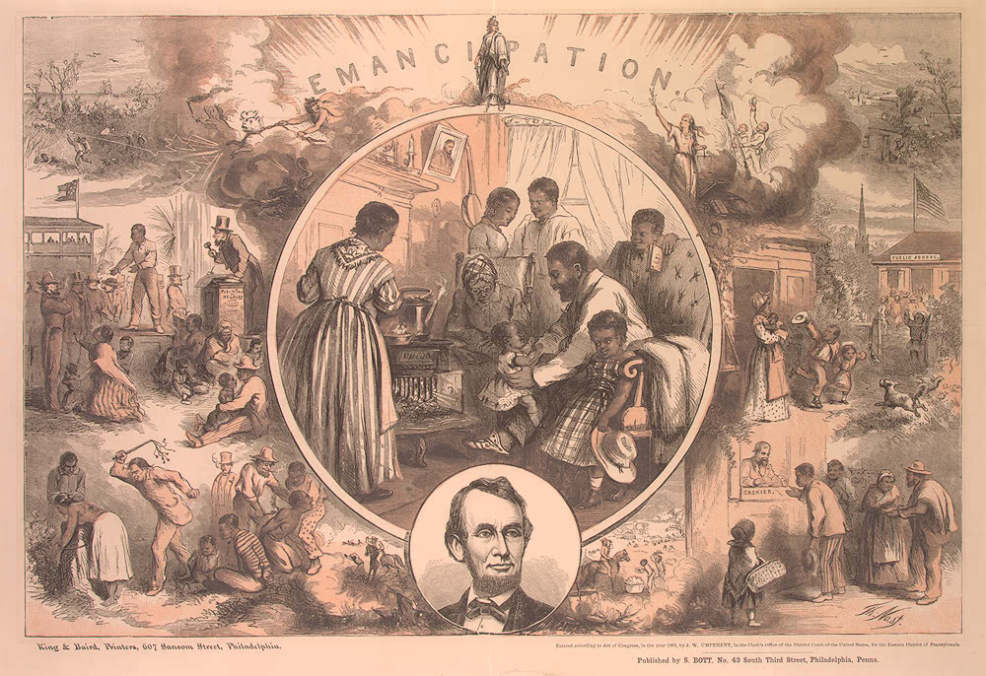
Whether southern slaves fled to freedom or merely stopped working, they effectively acted to defy slavery. Thus slavery disintegrated even as the Confederacy fought to preserve the institution. With the war beginning to slip away from the Confederacy drastic steps to impress slaves into the army as soldiers was considered in 1864. In March 1865 the Confederate Congress passed a bill to arm 300,000 slaves. But as the war ended a few weeks later, the plan was never implemented.

All images are from the US National Archives and are believed now to be out of copyright restriction.

