The Tudors

Teaching Guidance

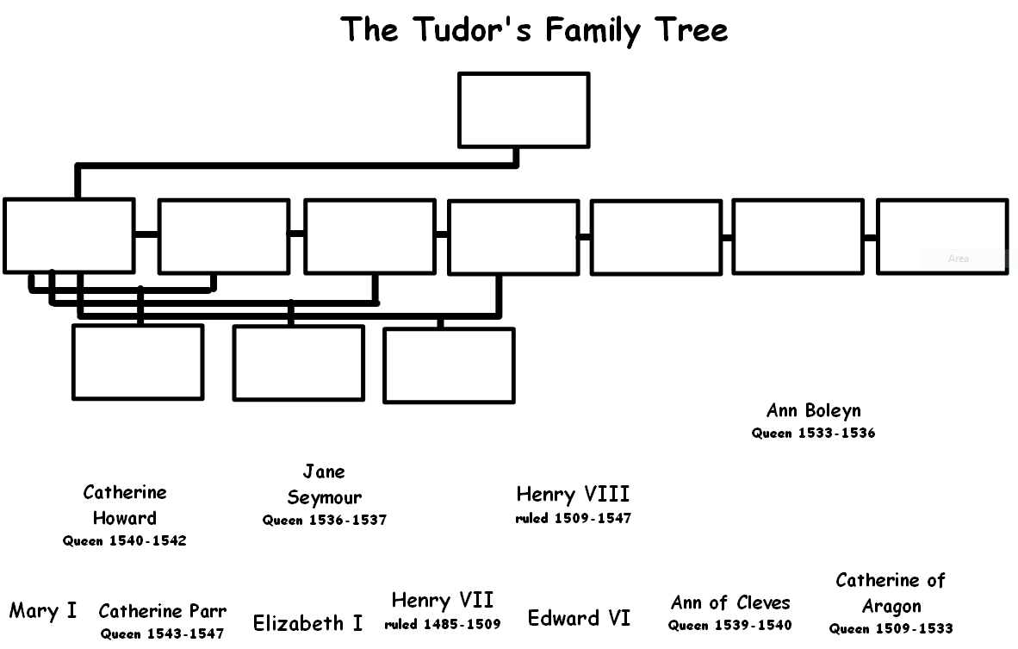  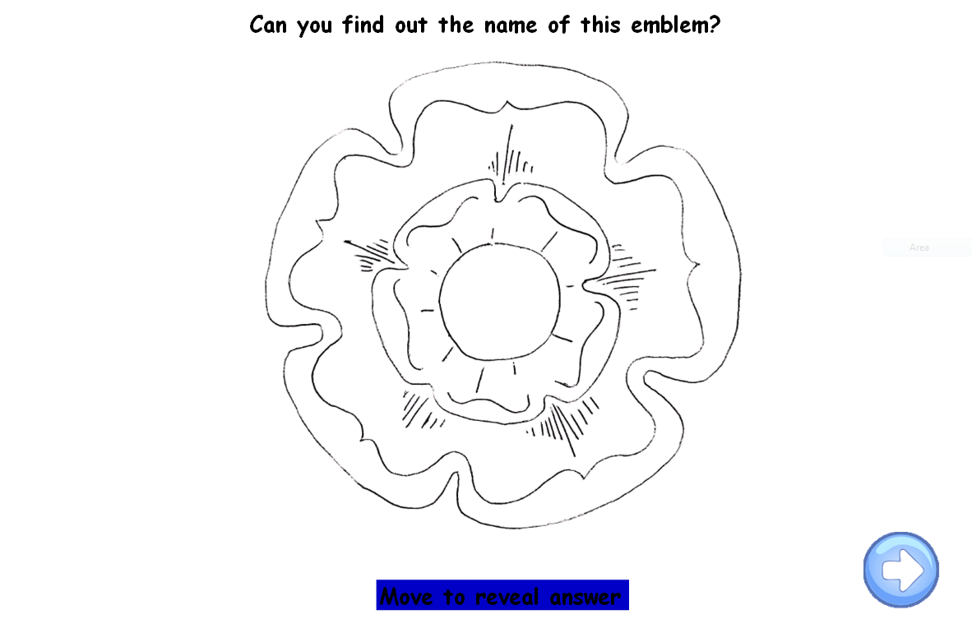 | The Tudors  Pupils should be encouraged to use previous knowledge to fill in parts of the family tree then use research to find the information they need to complete the rest.  Pupils are asked to research the Tudor Rose in order to colour it appropriately before going on to design their own family emblem
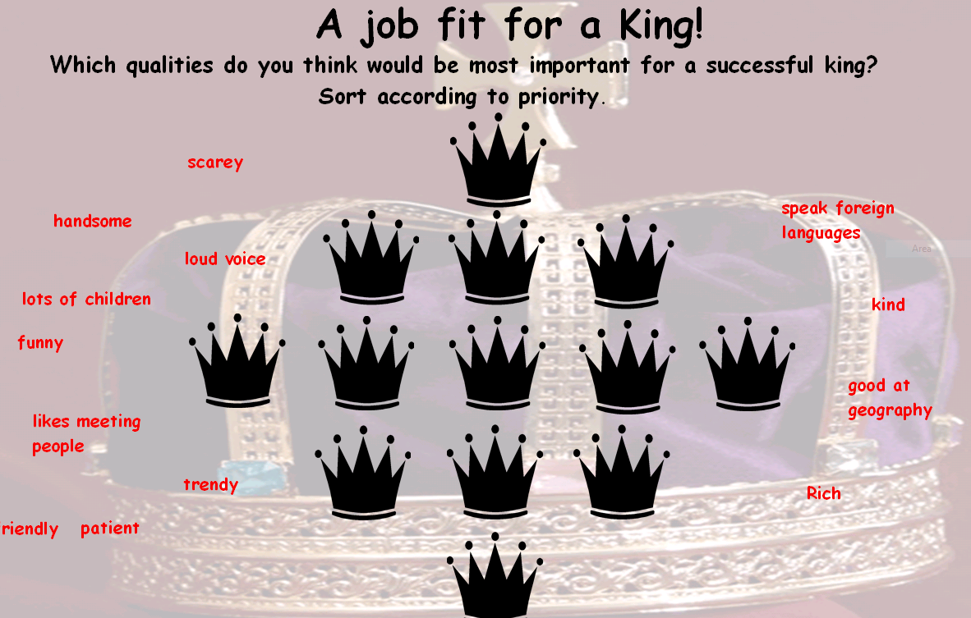  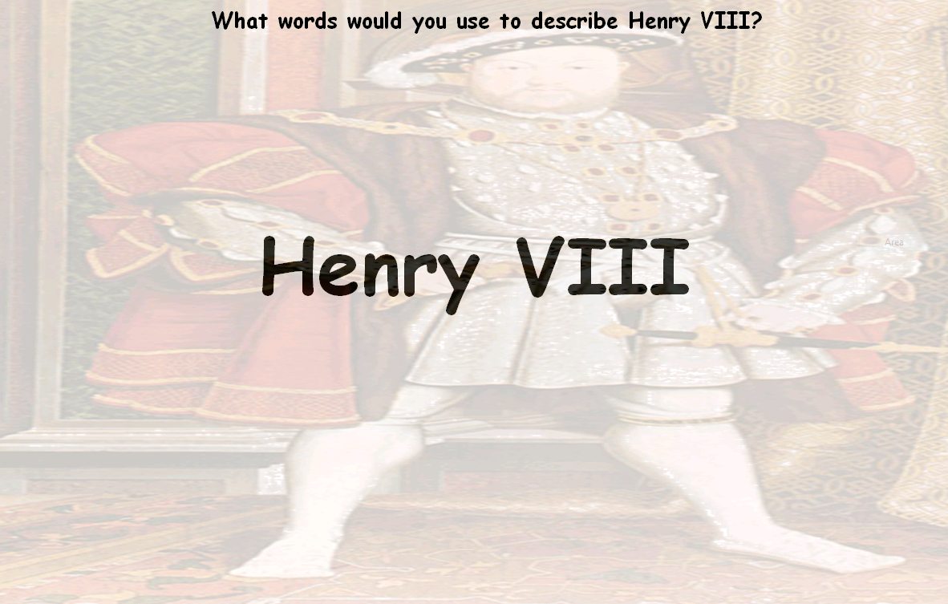  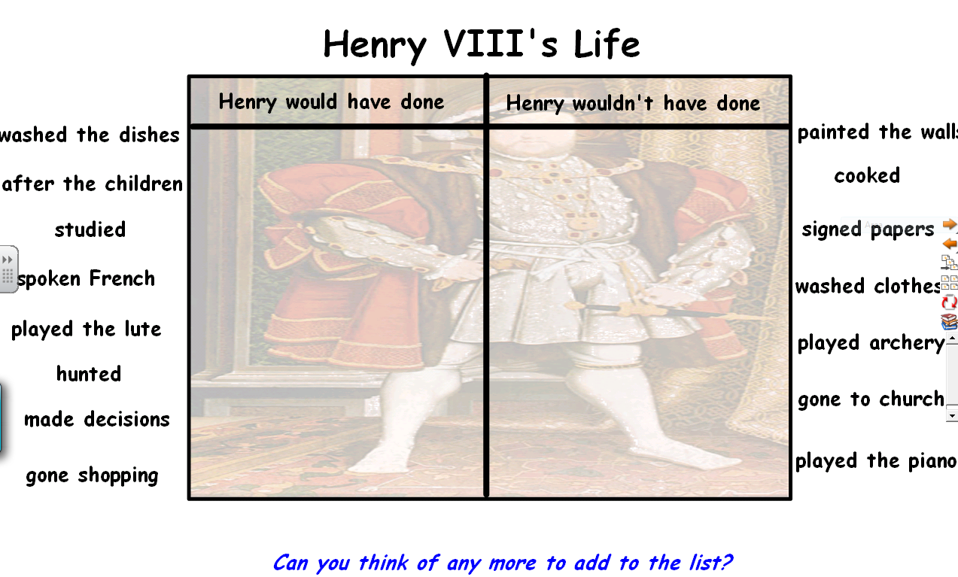 | Henry VIII  The first activity asks pupils to consider what qualities make a good king and rank them according to priority.  Use the Henry VIII mindmap to encourage pupils to describe Henry VIII  Drag and drop activity to encourage pupils to consider the type of things a King would do during Tudor times
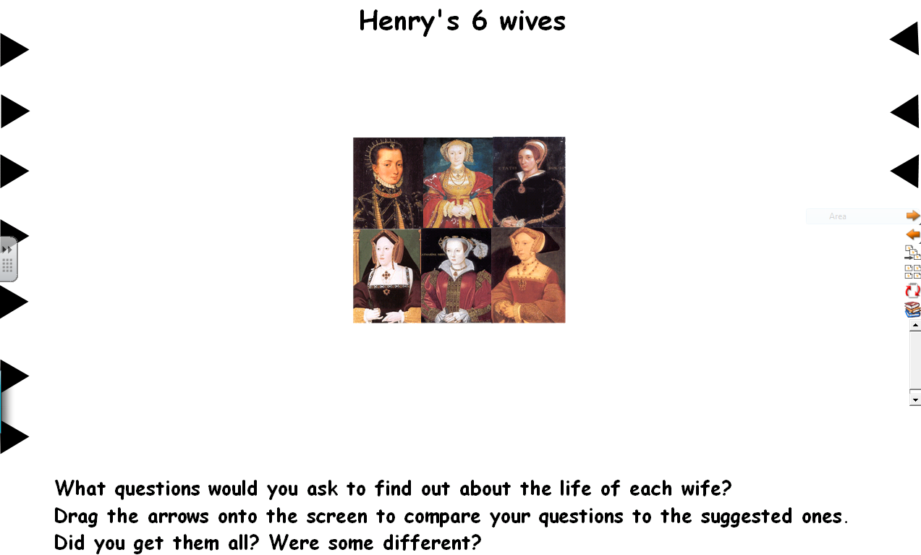  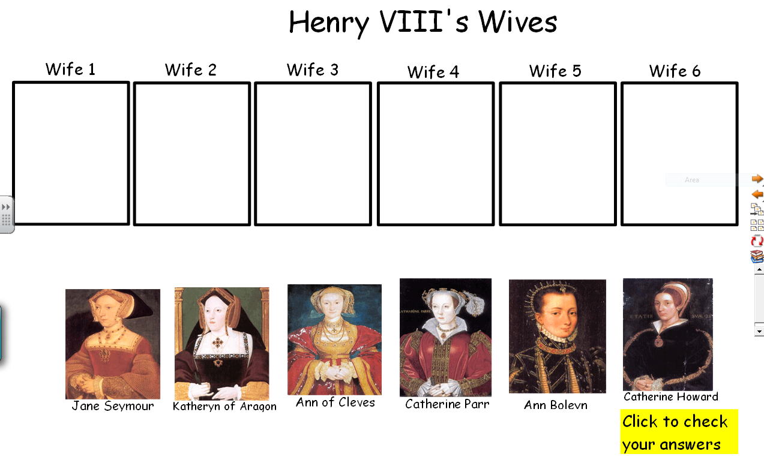  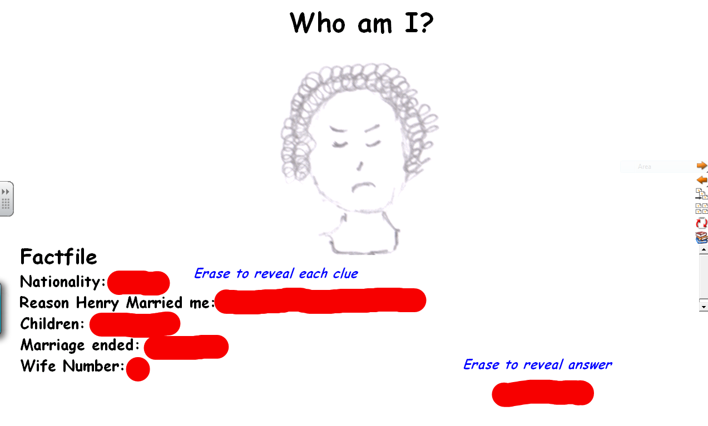  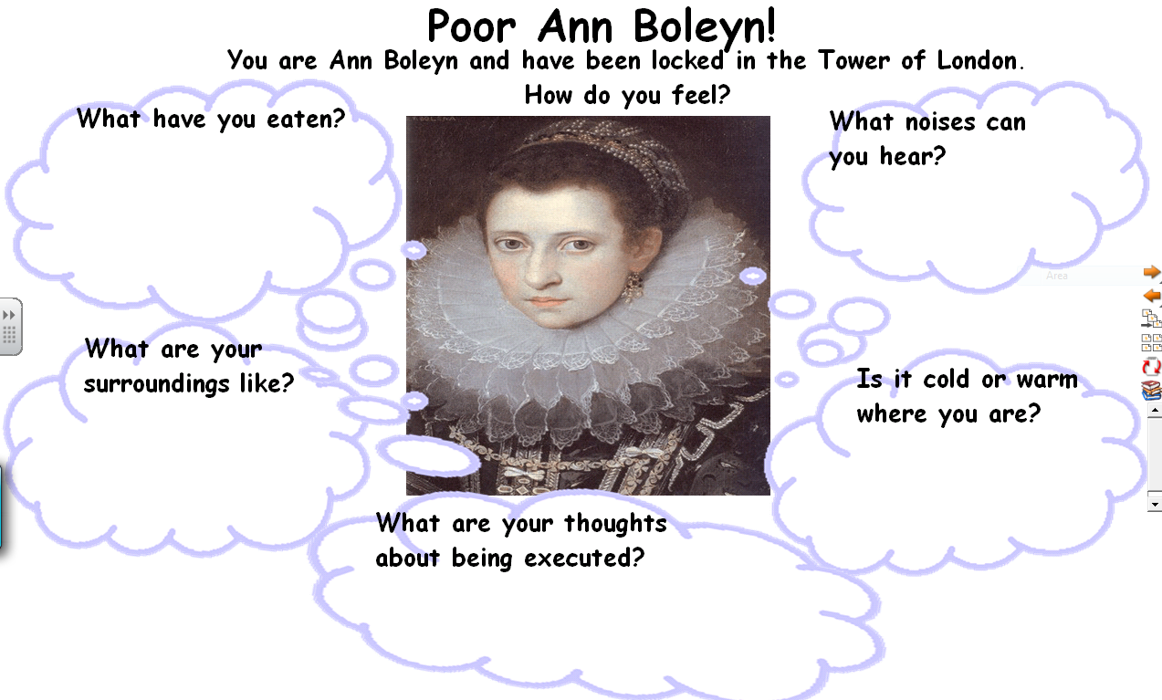 | Henry’s wives  This first flipchart will encourage pupils to focus on the type of questions they need to consider before carrying out research on a chosen wife.  Sequencing activity to help consolidate the order of the Queens’ reigns.  Who am I? quiz. To consolidate basic knowledge of the six wives.  Mindmap to encourage pupils to empathise with Anne Boleyn when she was locked in the tower.
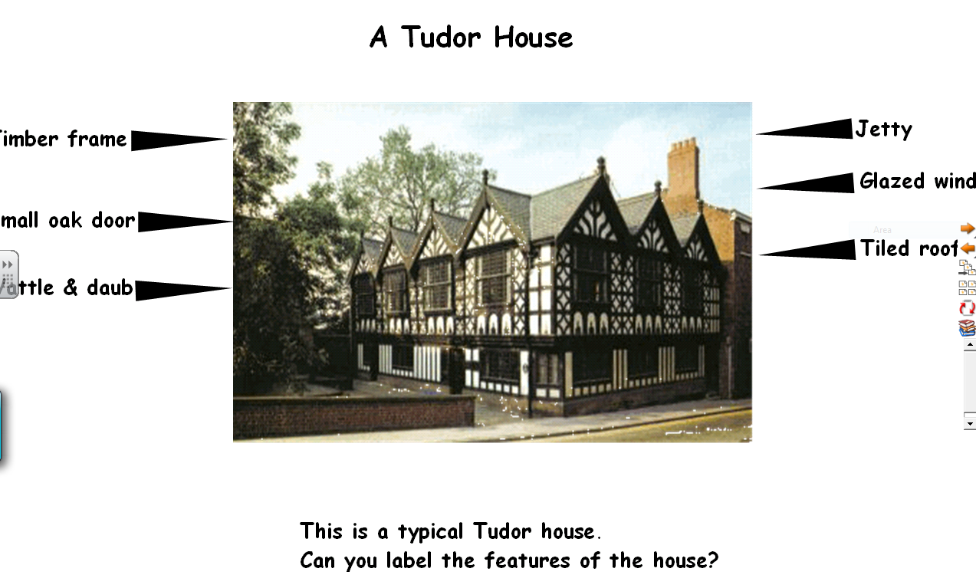  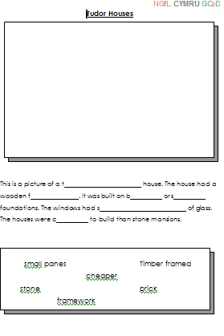  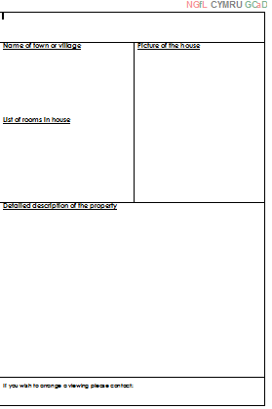  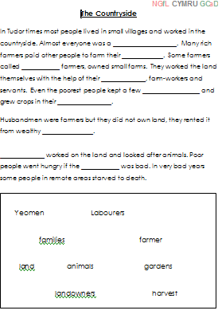 | Home Life  Drag and drop activity – label the features of a Tudor, timberframed house.  Printable cloze procedure, to consolidate knowledge of Tudor houses  Sales particulars template – pupils should be encouraged to use this to describe a Tudor house in their local area or one that they have found on the internet.  Printable cloze procedure to consolidate knowledge of the countryside in Tudor times
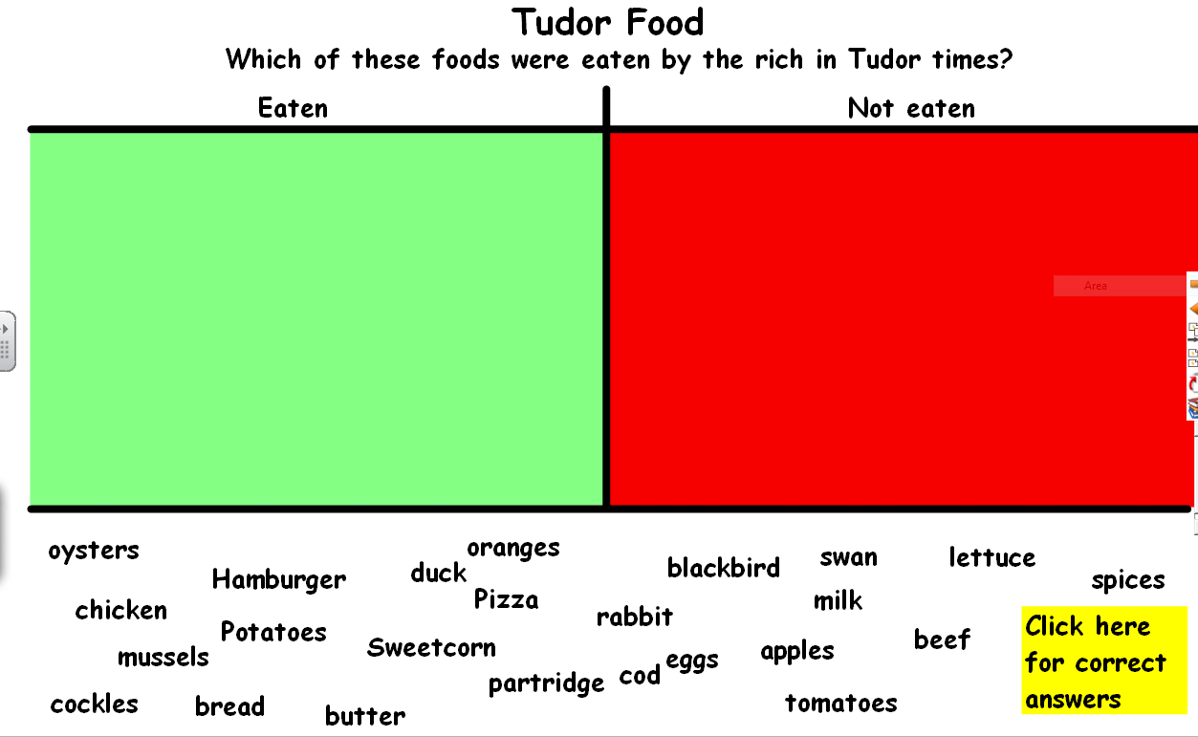  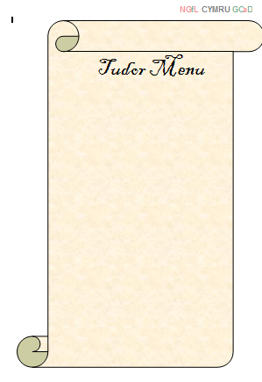 | Food  Drag and drop activity – encouraging children to compare and contrast modern and Tudor food.  Template for pupils to compile their own Tudor menu
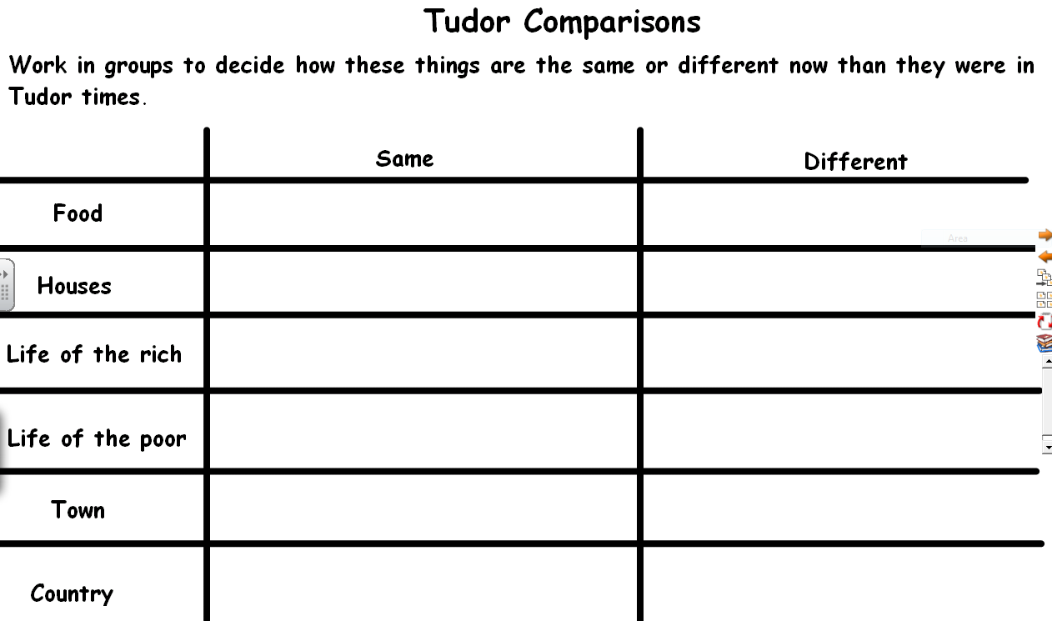  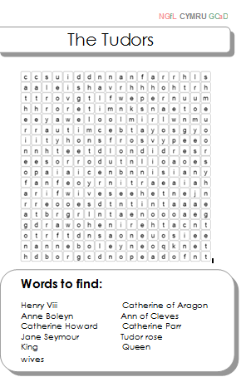 | Tudor comparisons  Drag and drop activity – encouraging children to use what they have learned to compare and contrast Tudor and modern times.  Printable wordsearch to consolidate Tudor vocabulary

