The Tudors

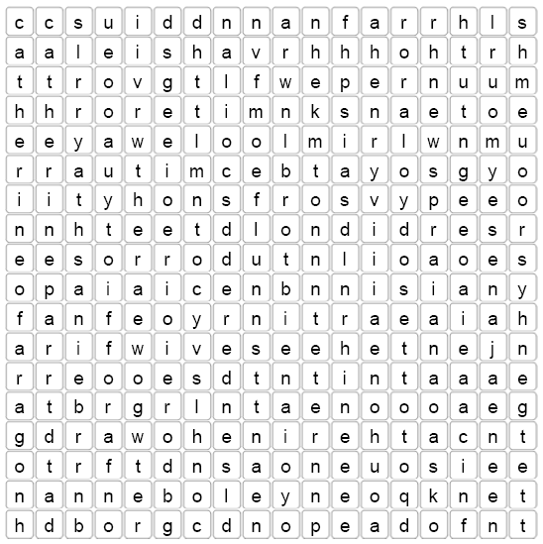

Words to find:

Henry Viii Catherine of Aragon
Anne Boleyn Ann of Cleves
Catherine Howard Catherine Parr
Jane Seymour Tudor rose
King Queen
wives

