MODULE 1A PART A: STUDENT FACTSHEET – THE BEEF INDUSTRY

World Meat Facts and Figures
These figures are accurate according to data for 2021
Beef accounts for 24% of the main meats that are produced in the World. It is third behind poultry and pork in popularity.
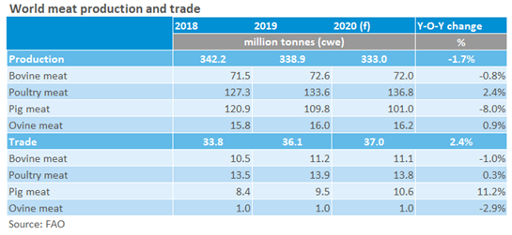
World’s meat production in billions of tonnes
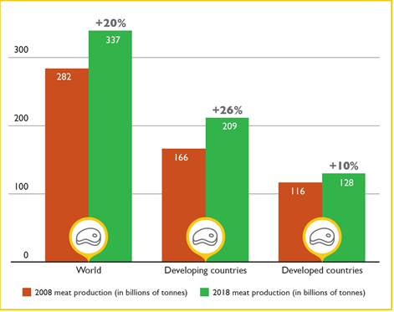

Who are the largest producers of Beef in the World?
The United States was the largest producer of beef in the world in 2020 followed by Brazil & the European Union.
The United States, Brazil and the European Union accounted for roughly 50% of the world's beef production.
The United States alone accounted for roughly 20% of the world's beef production in 2020.

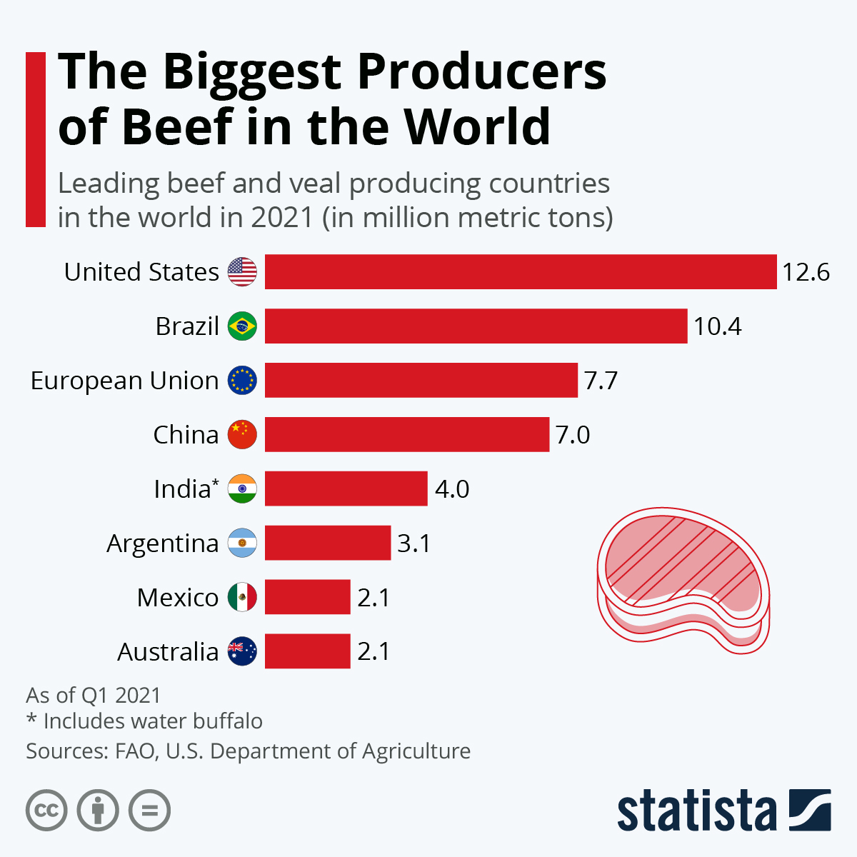
Global Beef Exports

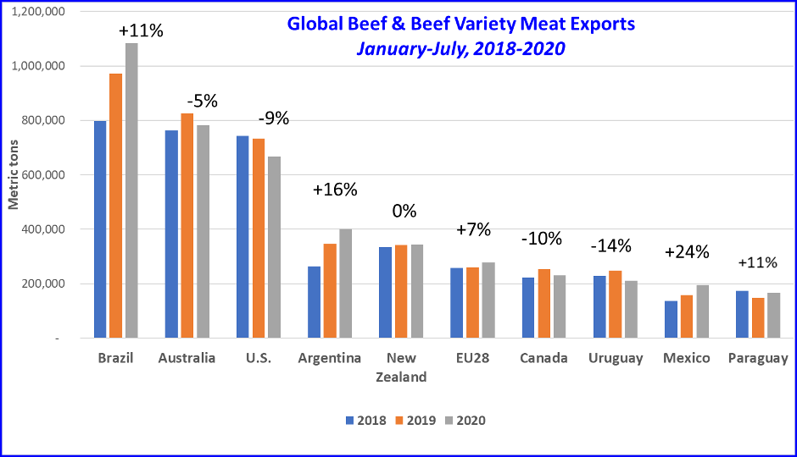
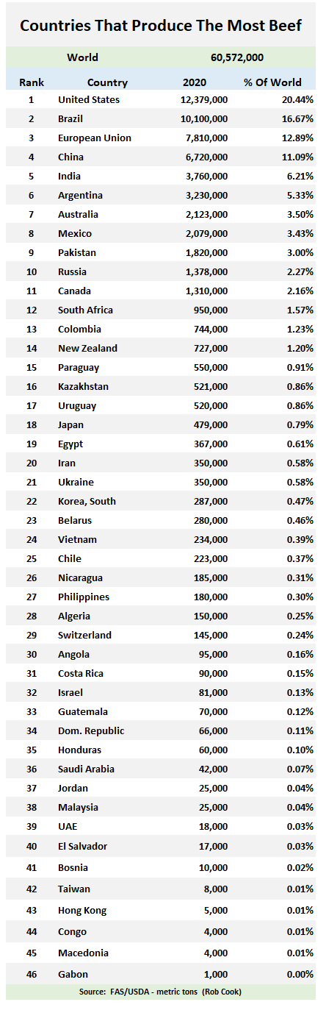
https://beef2live.com/story-world-beef-production-ranking-countries-0-106885
World beef production
In 2020 the USA and Brazil accounted for over 36% of the total World production of Beef.
The European Union which in 2020 included the United Kingdom was third with nearly 13 %.

European Union : Beef Production

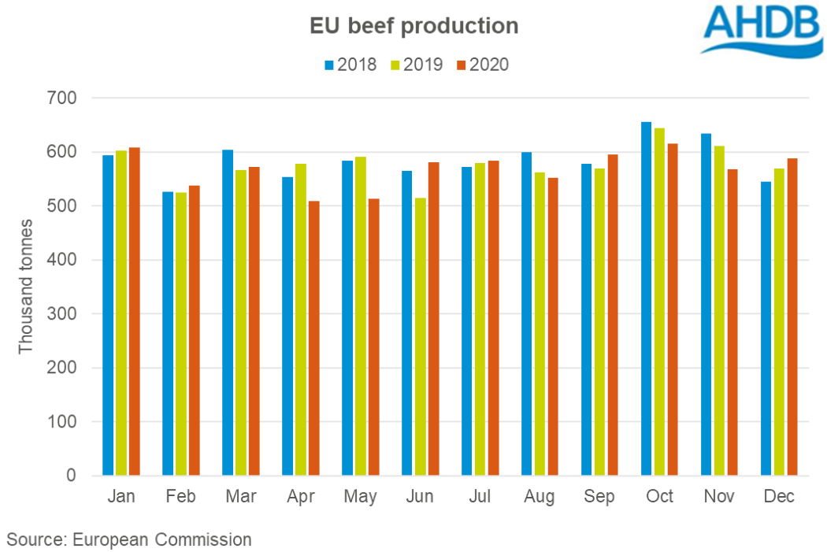
What are the trends in the EU?

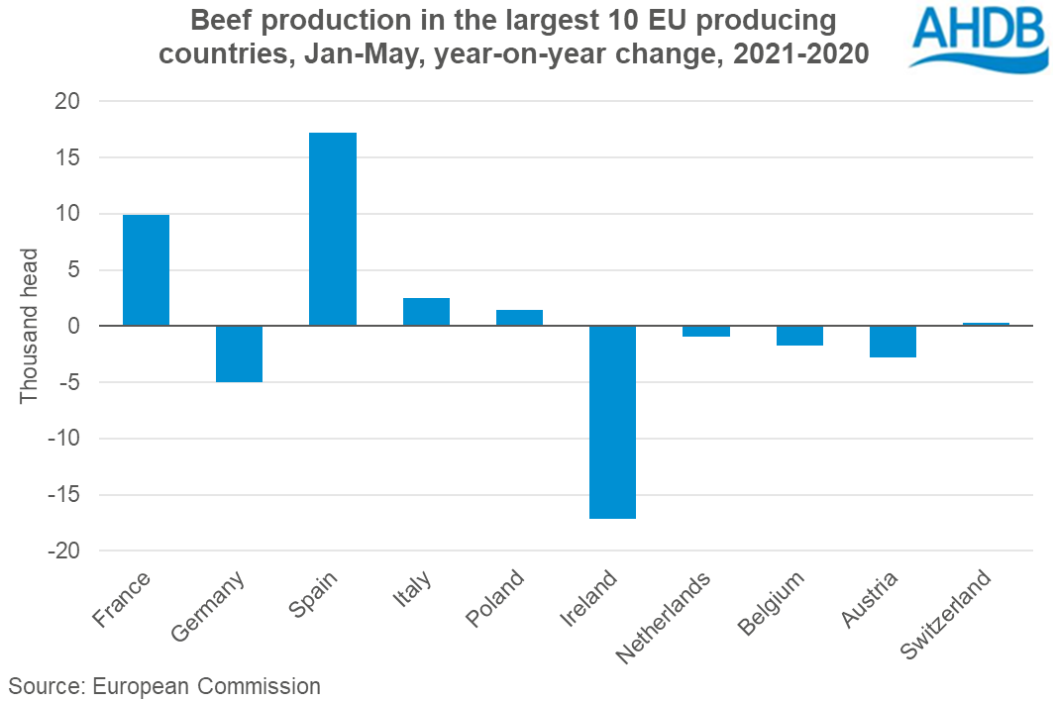

What is the future of Beef in a world context?

According to the FAO meat production has for the first time taken a dip in production

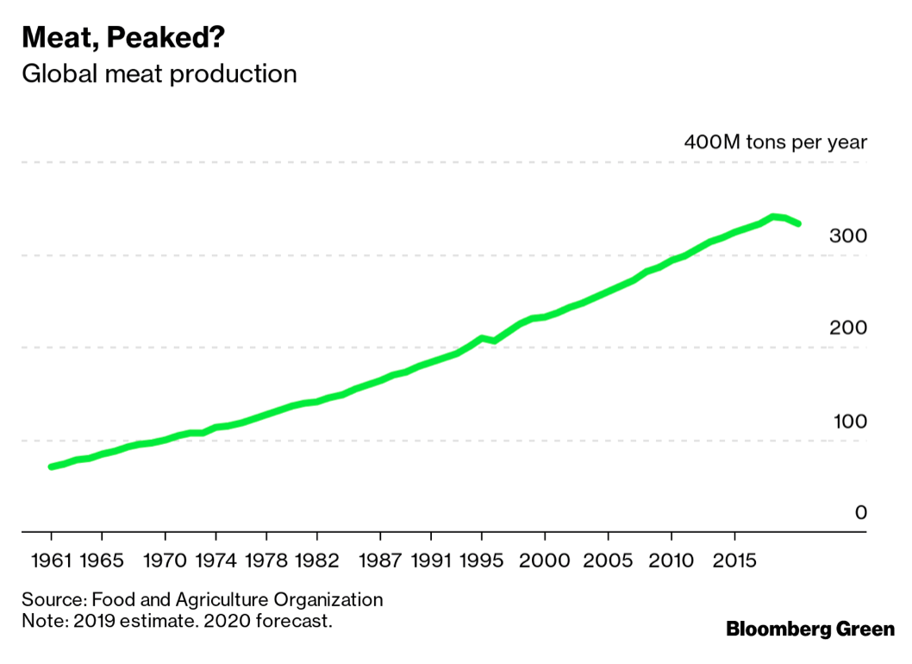

Why are there concerns over the production and consumption of red meat especially beef?
- Environmental implications
- Health scares
- Sustainability issues
- Ethical issues
- The rise of vegetarianism/veganism

