MODULE 1A PART B: STUDENT FACTSHEET

LOCATION OF THE BEEF INDUSTRY

Introduction
In countries where suitable lands to produce beef are scarce because of climate or economical circumstances e.g. where other initiatives such as producing milk are more profitable, the beef systems are much more intensive in nature. This is the situation in the European Union. Where there are no pressures on land use, the systems are less intensive e.g. Brazil. Very often, in countries with the largest surface areas, the intensive and less intensive systems co-exist.
Beef Systems
Intensive
Extensive
Mainly Grassland
Mainly Concentrates
Extensive Grasslands

Figure 1: classification of beef production systems

Ubited States of America
Calves are produced for the beef industry on the extensive grasslands of Missouri, South Dakota, North Dakota, Nebraska, Kansas, Kentucky, Montana, Tennessee, and Oklahoma. These are mainly cow and calf systems on large, extensive farms. In Texas, Colorado, Nebraska, Kansas, Iowa, California and Oklahoma, there are feeding farms (feedlot) where calves are finished for market needs, with concentrates and waste products from the food industry.
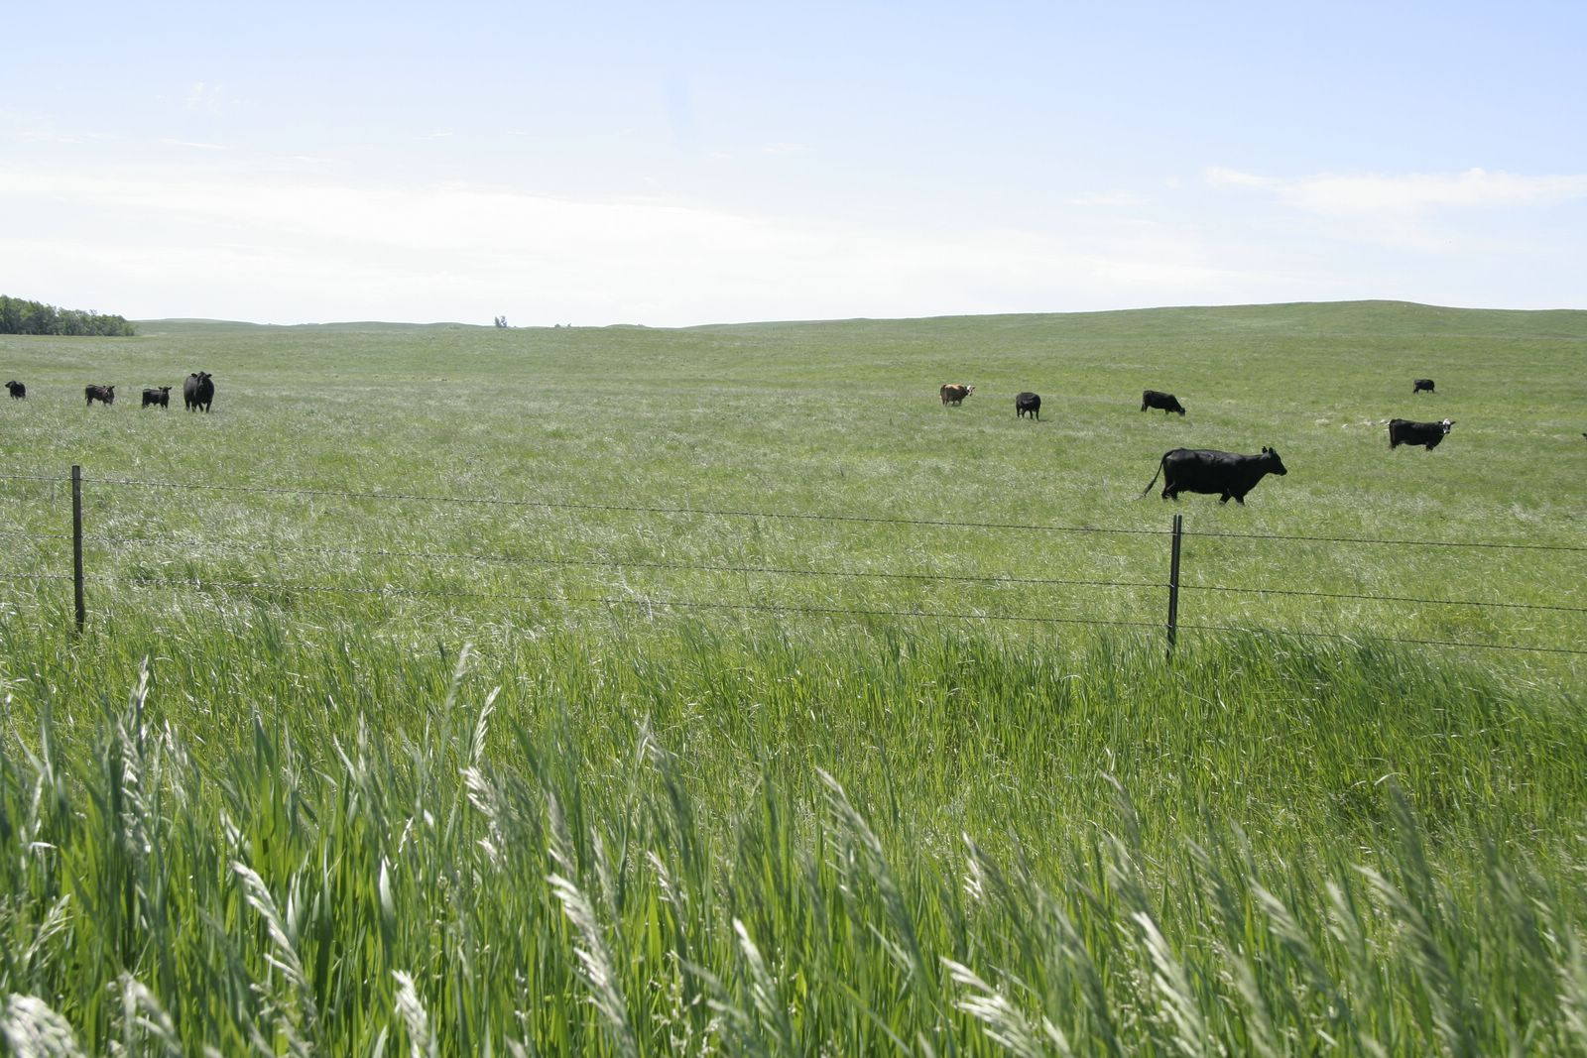
[Photo: Cattle on the prairie]
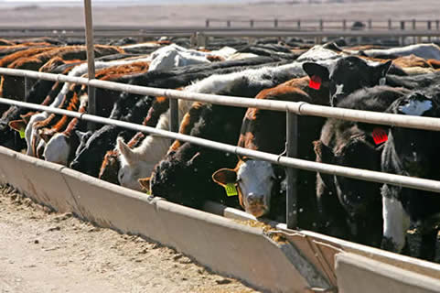
[Photo: Feeding farms (feedlot)]

Brazil
The aim of the country’s systems is to produce cheap beef by using extensive, natural grasslands, but also deforestated lands. Environmental concerns about this issue have been raised consistently by other countries and campaigners.
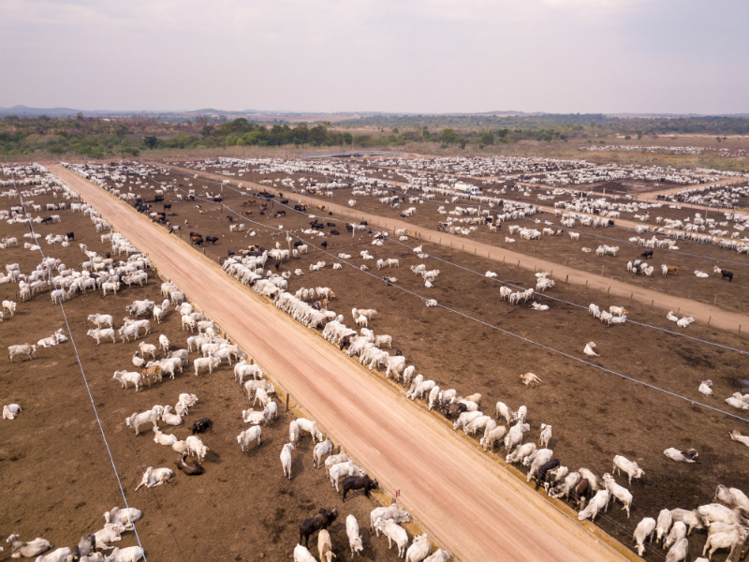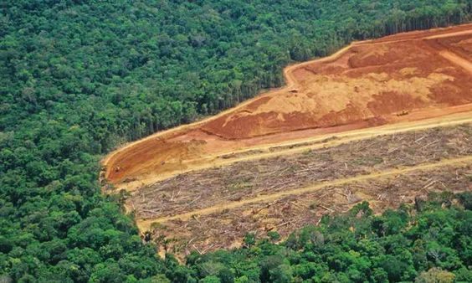

CHINA
The main sources of beef production are the small family farms that use poor quality feed and crops to finish the native breeds. Since these native breeds were originally used for hauling, the meat quality is poor. Since the Government has started to extend the industry, continental European breeds were imported, and more suitable native breeds were chosen. Therefore, some feeding farms were established to finish the cattle. These are finished in enclosures, using higher quality feed and concentrates.

European Union
European beef is produced in two categories of farms:
- specialized beef farms with suckler cows or young bovine cattle;
- dairy farms for which beef production is a by-product of milk production.
The UK with its mainly pastoral systems has withdrawn

Australia
Less intensive beef farming in north and mid Australia, using British beef as well as some breeds from tropical countries. There are more feeding farms in Queensland than in the other regions.
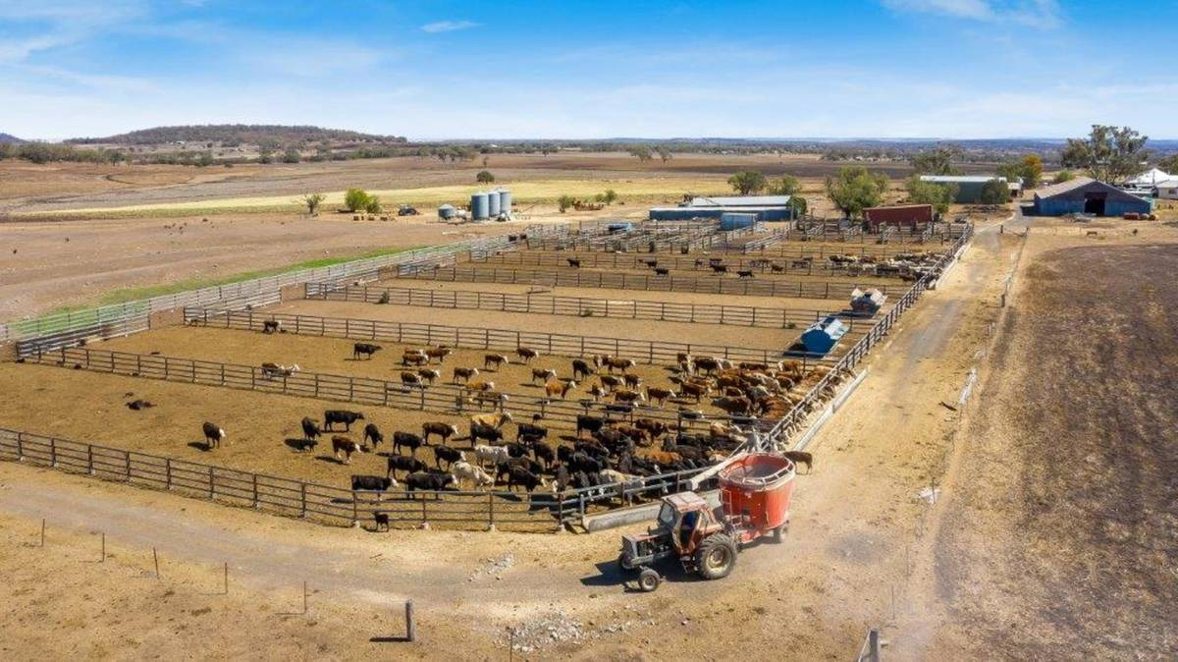
Source of image:
https://www.northqueenslandregister.com.au/story/6436206/biddeston-feedlot-on-the-market/

Argentina
Production of beef on the extensive grasslands of the Pampas using British, Continental Euorpean and Tropical breeds on cow and calf systems and finishing on grasslands.
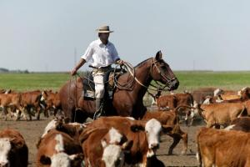
The above picture shows the original cattlemen or Gauchos herding their cattle.Now larger units are threatening this way of life.

Canada
Similar systems to the United States.
Watch the video on You Tube to see how cattle are cared for on one Canadian Ranch
https://www.youtube.com/watch?v=uKY84wJIJ3g&t=17s

