The sounds of the Blitz

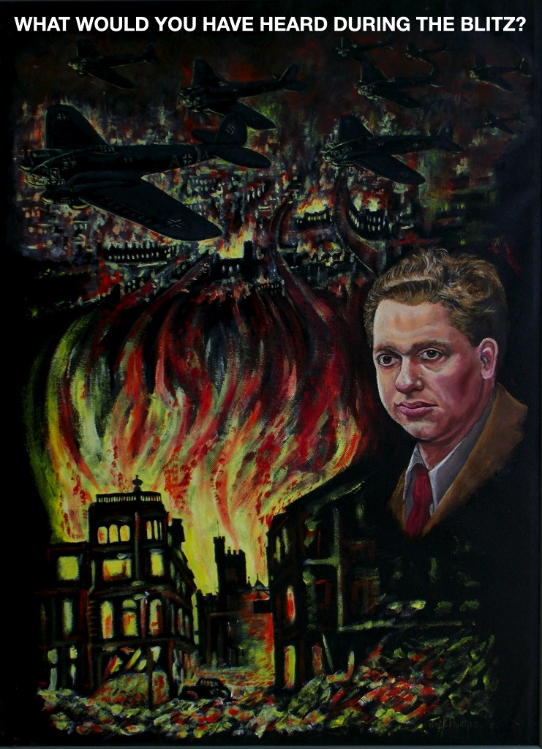

Teaching ideas

Explain to the learners that they are going to compose a piece of music which is going to be a 'soundtrack' for a blitz raid on Swansea.

Play the video 'Swansea - The Three Night Blitz' (found by going to http://www.rockandrollpoet.co.uk/videos )

Get the learners to discuss in groups how people would be feeling before, during and after the Blitz.

Play the video again and get the learners to listen to see what sounds they can hear.

More sounds, including the all clear siren, can be found on the BBC website -
http://www.bbc.co.uk/schools/primaryhistory/world_war2/air_raids/

The learners to begin composing ensuring that they think about
- what sounds they will be reflecting in their piece?
- what instruments would best be used to convey the sounds? (not forgetting their voices as possible instruments)
- what sort of sounds will they be - loud / quiet?
- what will the tempo of the piece be - fast / slow?

After being given sufficient time to compose the groups can perform their composition to the rest of the class.

