Dylan and Fern Hill
In Dylan’s 1945 poem ‘Fern Hill’, he reminisces about his childhood and the inevitability of growing old. He writes about the times he spent with his Aunt, Annie, on her West Wales farm. It describes the idyllic beauty of the Welsh countryside.

In the Dylathon during the centenary celebrations of Dylan’s birth, HRH Prince Charles shared one of his favourite poems, ‘Fern Hill’, to the audience through a recording he made to mark National Poetry Day. He believes it is a "poignant and moving evocation of a rural west Wales childhood".

Hear and read about his recording at www.walesonline.co.uk/whats-on/dylathon-listen-prince-charles-reading-8005287

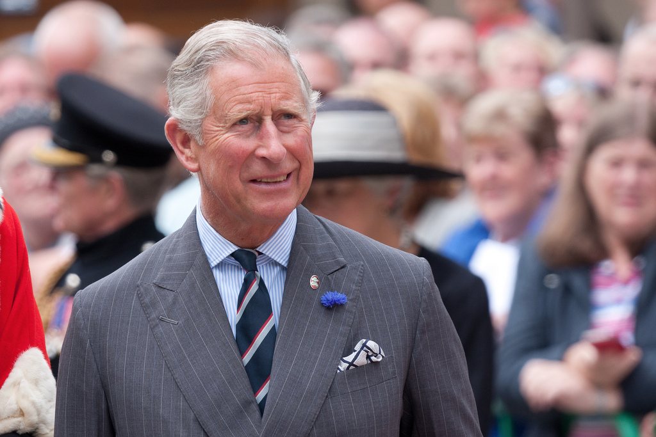

The Prince of Wales is a fan of Fern Hill by Dylan Thomas
Image sourced from: Dan Marsh - Flickr
A beautiful film and reading of the poem can also be found on http://www.rockandrollpoet.co.uk/videos.html

Teaching Activities (using part or all of the poem):
- What would Dylan have packed in his suitcase to visit his Aunt’s Farm?
List possible items as a class and then in small groups, ‘Diamond Rank’ them according to importance.
- What would you pack in a suitcase to go and stay on a farm for the holidays? Again, ‘Diamond Rank’ them and compare and contrast with Dylan’s suitcase.
- ‘Word Detectives’. Text mark the poem using 4 different highlighters. Learners highlight references to a) youth and childhood, b) happiness and contentment, c) nature and d) the passing of time. List some of these words using a table or spider diagram. Can learners use these elements and words to help them write a descriptive paragraph or poem about a place that they have visited?
- Can learners find examples of Personification in the poem? E.g. ‘The lilting house…’, ‘sun that is young…’ and ‘the whinnying green stable’. Pick out nouns used in the poems, can learners use personification to describe them in different way to Dylan?
- Dylan plays around with the order of words in the poem, e.g. ‘the dingle (small valley) starry’ and ‘like a wanderer white.’ Learners think of places from their childhood and adjectives to describe them. They then play around with order of the words to create poetic language in the style of Dylan.
- Dylan opens Line 7 with a variation on ‘Once upon a time’ – ‘Once below a time’. How else can we start stories? Learners could think of different story openings to add variety to future sentence and story structures.
- Fern Hill is scattered with repetition. What effect does this have? Can learners see how Stanza 2 is like Stanza 1? Can they find examples of this repetition? What effect does this repetition have to the ‘music’ and flow of the poem?

