Dylan and Hunchback in the Park
Dylan’s poem ‘Hunchback in the Park’ is set in Cwmdonkin Park in The Uplands, Swansea. The park is just around the corner from where he grew up and as such, was his childhood playground. It is the story of a man who is different from those around him. He is isolated and miserable, spending all his time in the park. He is teased and tormented by local children and avoids the park keeper.

The poem is told from 3 perspectives – the poet’s, the hunchback’s and the boy’s. In the poem, Dylan explores love, nature and imagination, through the world of children and the world of adults.
http://www.rockandrollpoet.co.uk/videos.html

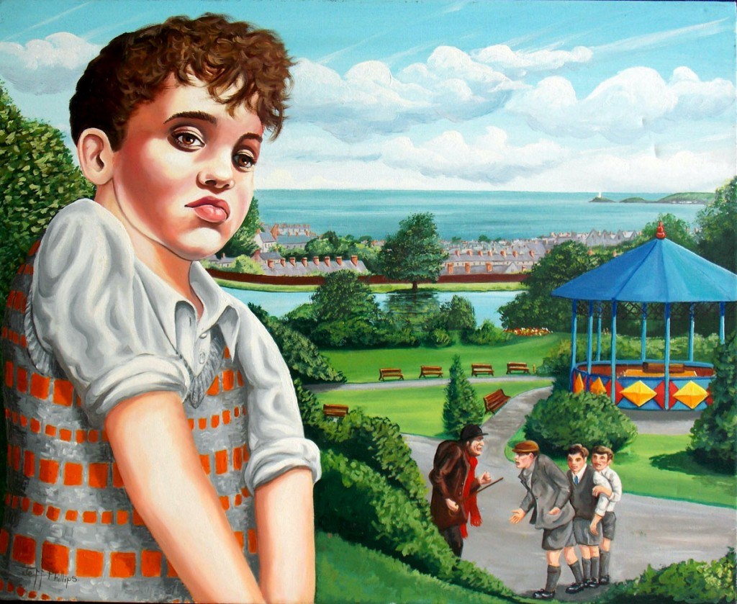

Teaching Activities:
- Look at the different perspectives in the poem. Hot seat the hunchback and the boy, encouraging the learners to ask open-ended questions. This could lead to a monologue of the hunchback’s thoughts as he sits on the bench.
- Compare and contrast to Anthony Browne’s ‘Voices in the Park’ which is also a story set in a park and told from various perspectives. This could be done using a Venn diagram.
- Explore Homelessness. How would the lifestyle of a homeless person differ to that of the learners? How might you survive on the streets? Are there any positives about this lifestyle?

- List adjectives to describe the hunchback and use them to write a descriptive paragraph about the old man. This can then be developed into a character analysis using ‘Point, Quote and Explain’.
- Use the descriptive language in the poem to complete a ‘graphic model’ of the park.
- Taking the hunchback out of the ‘present’, think about the hunchback’s ‘past’ and ‘future’.
Explore where he may have come from and what the future holds for him.
- Research the nature that would be found in the park. What sort of native trees/creatures would you find? Learners write fact sheets based on species of plants of animals found in Cwmdonkin.
- Look at how Cwmdonkin Park has been restored in recent years thanks to Heritage Lottery Funding. How is it different to Dylan’s time there?
Old photos and information can be found on http://cwmdonkinpark.com/

