Worksheet 1 – Colour Mixing

Materials needed:
Paint, charcoal, white oil pastel, pencil, water pots, brushes, pallets,
A3 drawing paper.

Look at the words you came up with to describe industry.
- Using these words, draw a picture to describe how it might feel to work in a steelworks or a quarry.
Your picture doesn't have to look like anything - just try to show feeling.

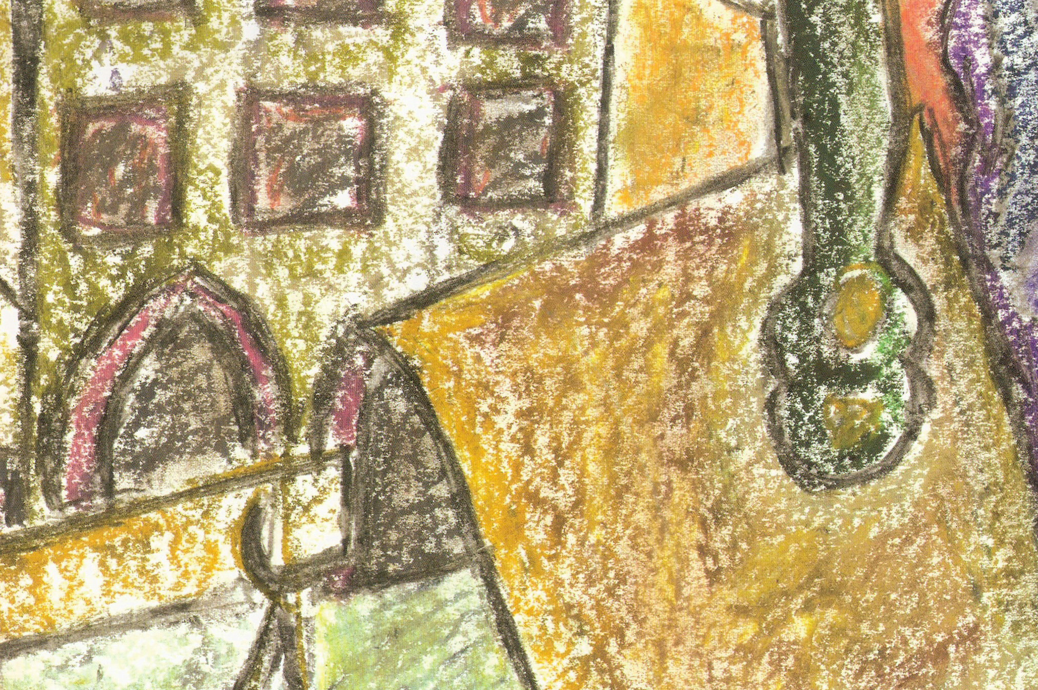

- Mix colours together to make new colours.

Red + Yellow = Orange
Red + Blue = Purple
Blue + Yellow = Green

Work out how to make different shades of these colours by adding more or less of the lighter and darker colours.

- Once you have mixed the colours that you need, then paint the shapes you have drawn.

You may find that you want to change some things in your drawing at this point - do it with a pencil but don't rub out your original marks.

You will see that changing things without rubbing out can create very interesting shapes.

- When you have painted your drawing, leave to dry.

- Once dry, draw over it again with charcoal and white oil pastel - remember that you can smudge the charcoal with your finger to create a dusty effect.

