Worksheet 2 – Drawing and Painting

Materials needed:
Pencil, coloured oil or chalk pastels, charcoal, paint, brushes, pallets, water pots, white oil pastels, large drawing paper. (4 pieces of A 1 cartridge stuck together/roll of drawing paper).

- In groups of 5-8 look at various images of industry these can be old drawings, photographs, other artists' work etc.

Look at the different scenes in the images, people working, machines etc.

In your group you need to decide what kind of drawing you want to do, people at work, machines, factories etc.

You also need to think about how you will draw this on the page - draw big to fill the page - remember not to worry about mistakes, just correct it but don't rub out.
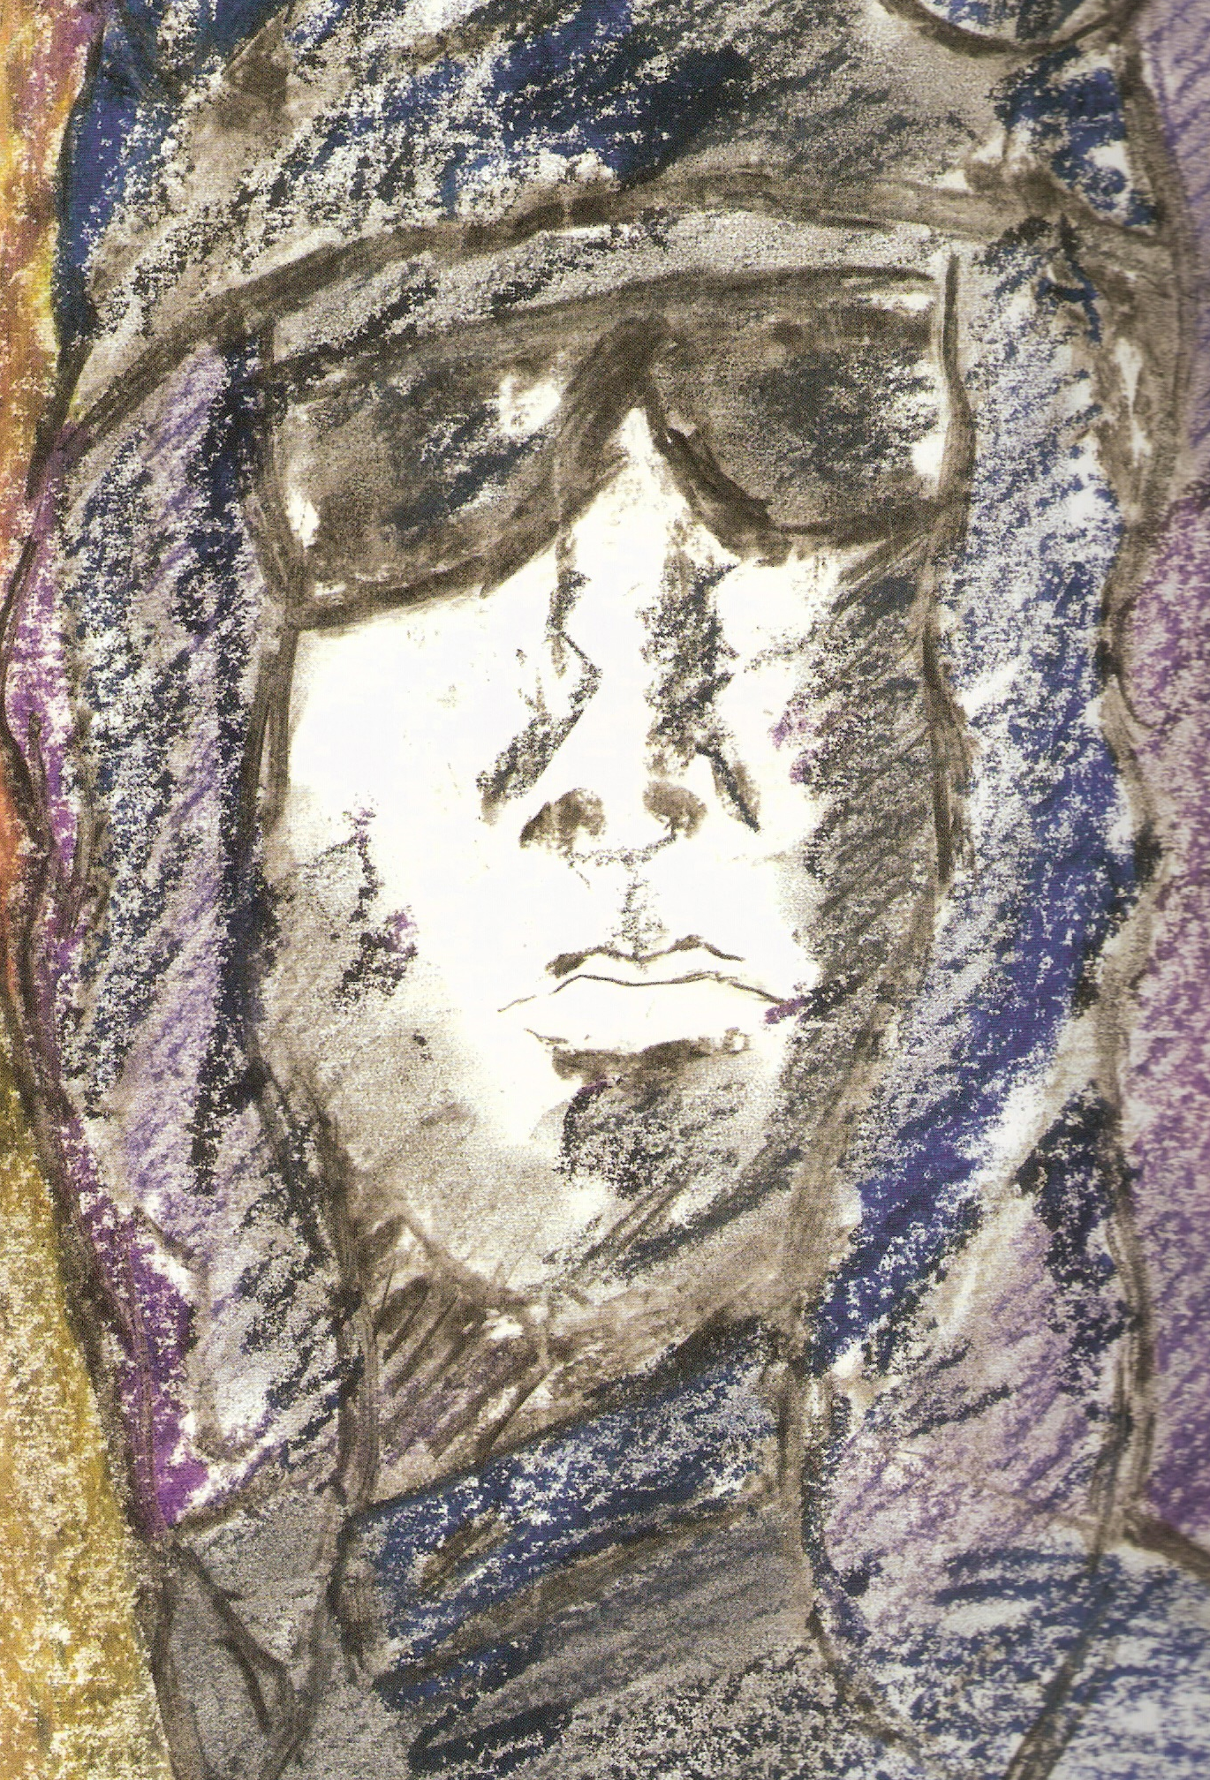

- Use charcoal or graphite sticks, or both, to draw your image on the paper. Make sure you use the whole paper. Once you are happy with the image use the oil or chalk pastels to colour your picture.

- You need to decide as a group what kind of feelings you would like the image to convey - choose your colours carefully to ensure that the picture shows these feelings.
Make sure that you fill the picture with colour covering the whole paper.

- Once you have finished colouring you now need to use the paint - (Black-white-red-yellow-blue).
You don't need to paint over the colours you have already put down - use the paint to create interesting tones and highlights in specific areas.

- Use the black to outline things and make them stand out. Use the white to show where light might reflect off surfaces.

- Stand back from your picture, look at the entire image. Are there any areas that need more detail?

If so, use the paint to add more detail to those areas. Once you are happy with the picture, place it next to the images made by the rest of the class.

