The Making
Build one step at a time.- don’t cut every piece of wood that you need at the same time.
Its a good idea to put the framework on a firm base such as plywood or MDF.

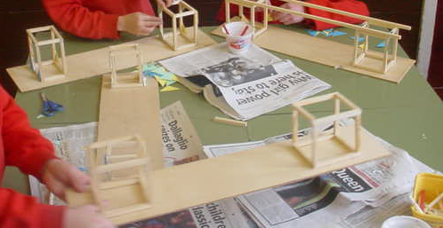

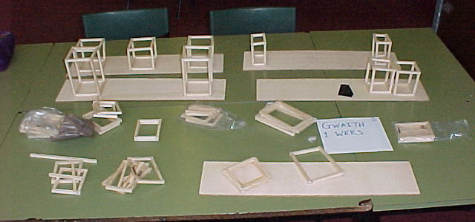
Year 3/4 work.
Left- the results after 1 session.
Throughout the building work it is
necessary to emphasize the
importance of using triangular
cards.

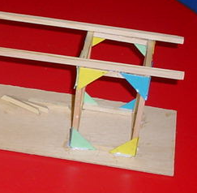

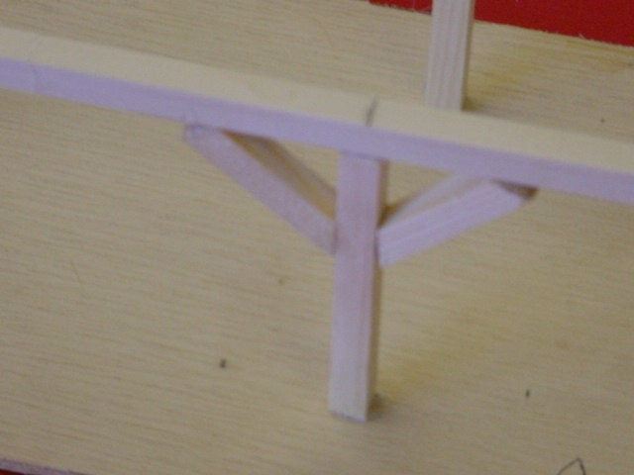
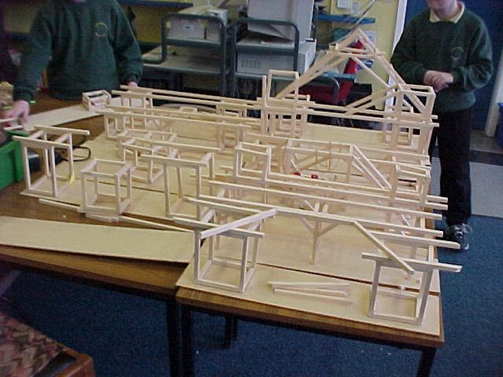
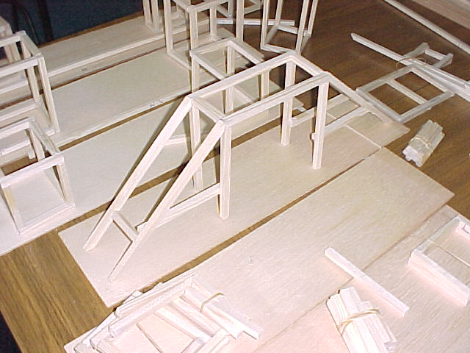

If you have followed the design process carefully the pupils will have a good idea of how to build the bridge and will move on quickly to the work of making it. This is an example of work completed by Year 3-6 in one morning.

