Starting the Work - Session 1
An introduction to the work – how to strengthen materials and structures and discussing the PowerPoint presentation.

The lesson should last an entire afternoon.
Resources – paper, small car, geostrip, wood, cutting and glueing equipment etc. Start the lesson with a problem. A car reaches the river bank but unfortunately the bridge has been swept away by a great flood. Show this in the form of a simple model (see pictures below). The only thing that the children have to help the car to cross the bridge is a piece of paper. How can the paper hold the weight of the car? Ater discussion and contributing ideas one should suggest folding the paper into a concertina shape. This is then placed across the gap and the car on it. It should hold the weight of the car easily and then the children are asked to place other things on the ‘bridge’, such as a pencil case, a book etc, until the weight causes its collapse.
Compare the zig zag pattern of the paper with corrugated cardboard = strong and light.

SPLASH!
Yes!
WAW!
Give 4 plastic strips or geostrip of the same length to each child and challenge them to make a square that isn’t flimsy. Impossible! Ask them to remove one side to form a triangle. They will notice that it is no longer flimsy. Explain that if another member is placed diagonally in the original square creating two triangles the square will be strengthened. This is the principle of triangluating, that is using a triangle to strengthen structure.

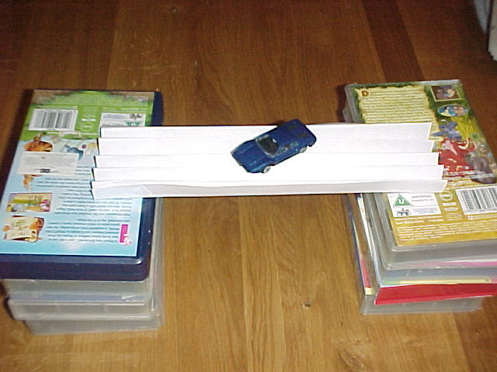
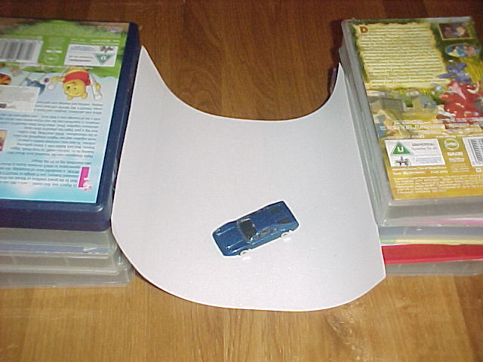
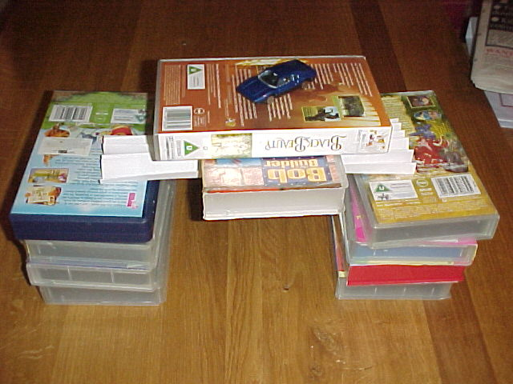

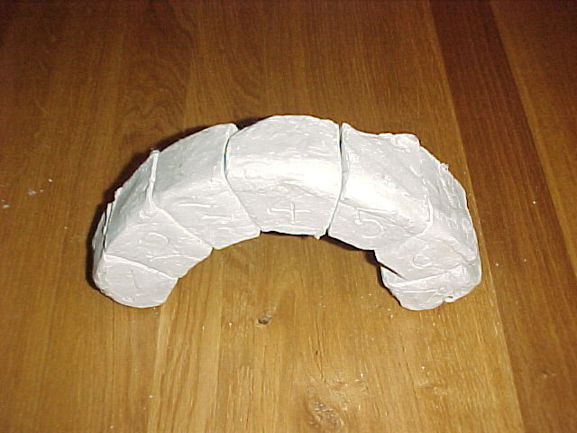
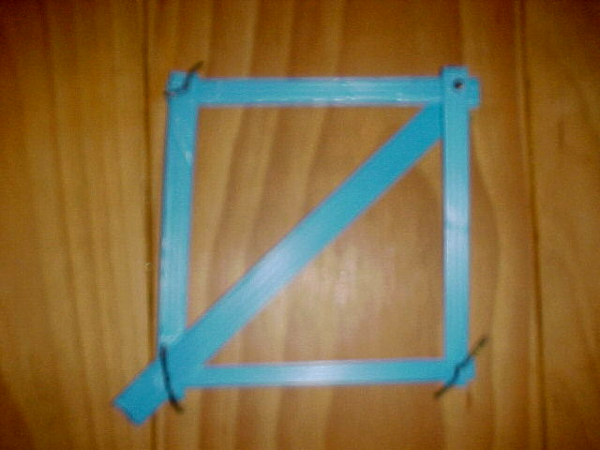
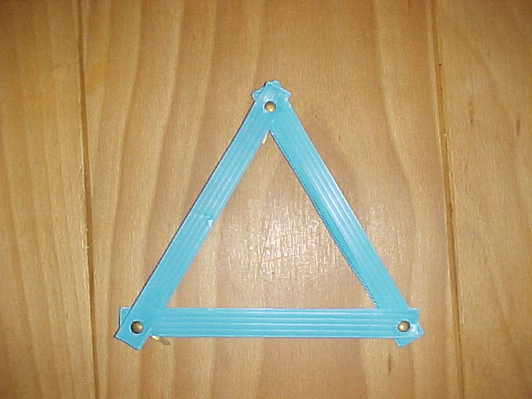
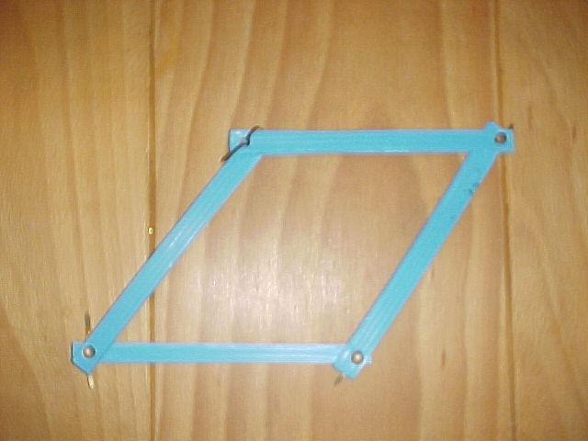
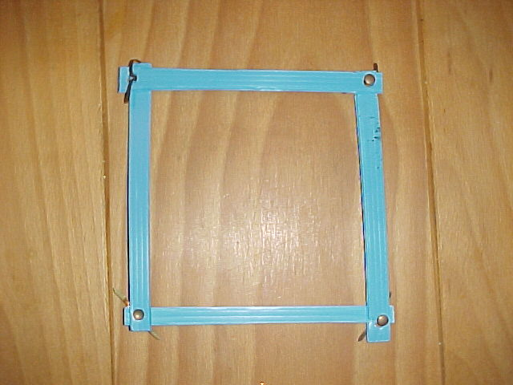
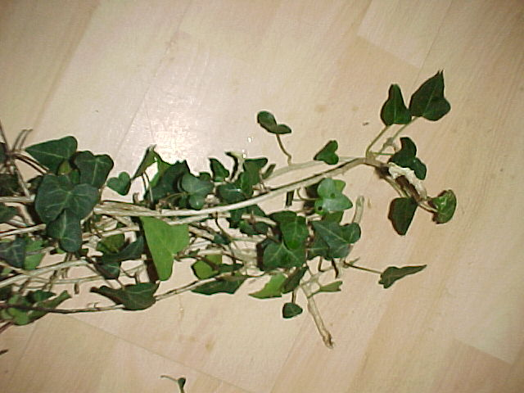
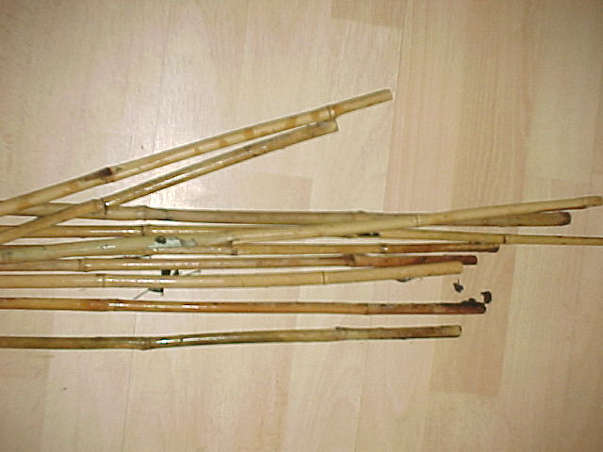
1
4
3
2
Experimenting with frames
1.Square frame but very flimsy as seen in 2.
3. Triangular frame is very strong.
4. Square is strengthened by the horizontal member. The frame is now very strong!
To make the PowerPoint presentation more interactive it is possible to show examples of the raw materials that are used to make real bridges as well as models e.g. similar to this arch bridge made from clay.
Clay bridge
Bamboo
Ivy to make a hanging bridge.

Clay arch bridge
Bamboo

After the presentation a simple wooden square frame can be made. It should be emphasised:-
1. The need for care when using the glue gun and sawing equipment. Make sure the wood is held firmly in place in a vice or sawing block. On the left you can see a red sawing block held in a vice. This is very easy to use and extremely safe. They are available from TTS.

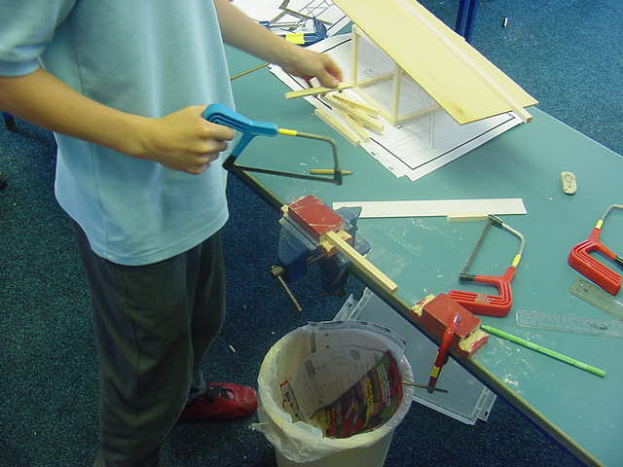
2. Glueing.
The glue gun is very convenient because it dries quickly but it isn’t very strong. The frame can be strengthened using card triangles glued using PVA glue in the corners.

3. Explain that the triangular card strengthens the frame in the same way as the diagonal piece in the plastic frame.

4. What the tools are called. This is a great opportunity to present the terms used for the tools. Very few additional tools will be required to build the bridge.

