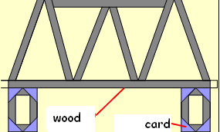
The final idea
One method of improving the look and the quality of the final idea is by using the programme Techsoft- Primary Design.

A piece of work by a pupil in year 3

The pupil should make a list of the wood necessary before starting on the model.

Look at the examples once again – refer to the location of the motor, the switch and check that there is sufficient room for the road to be raised up easily. It’s easier to make a mistake on paper than in wood, try also to make sure that the final idea will work. When evaluating at the end of the work it will be necessary to compare the finished work with this drawing.

