The Battle of Britain London Monument
The foundry process in detail
This article was written with the help of Chris Boverhoff,
Director of Morris Singer Ltd
This article describes the process that takes the sculptor's designs and turns them into the final bonze castings.

The design
The foundry receives silicon rubber moulds which the sculptor (Paul Day) has produced of his designs. These are produced from the full sized fired clay models he has built. Some very intricate parts will have their own moulds. On one 8 metre section of the design there could be up to 80 different rubber moulds produced.

The rubber moulds are given a plaster backing jacket to hold them steady.

Wax stage
Once the moulds are received at the foundry, hot wax is hand painted into each one. This wax is built up in the mould to the thickness of the eventual metal.
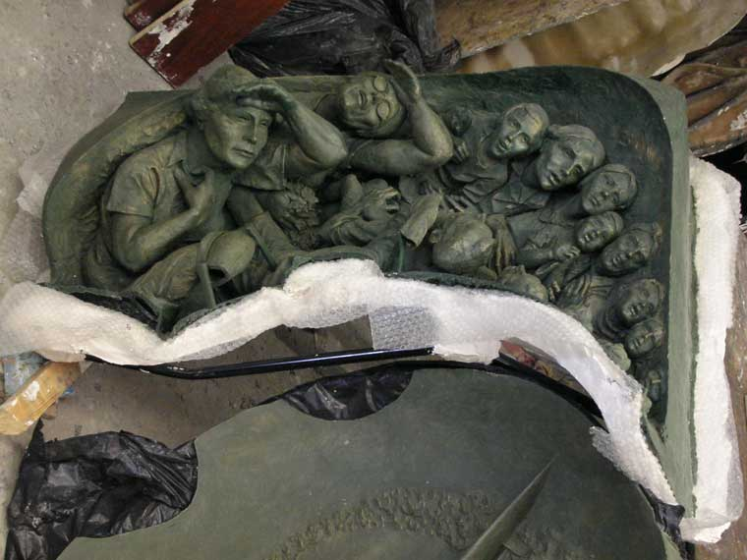
This is typically 6 8 mm thick. This wax positive image is carefully removed from the rubber mould and supported by fibre glass. At this point the sculptor carries out a detailed check of the wax and makes any adjustments necessary to the design.

Ceramic shells
Once approved, the wax positives are completely covered in ceramic layers to form a ceramic shell (now a negative again). During this process runners and vent tubes are added to enable the hot metal to be poured in and air to escape. The ceramic shells are then fired in an oven to melt the wax which is drained off. This leaves a void into which the hot metal will be poured.
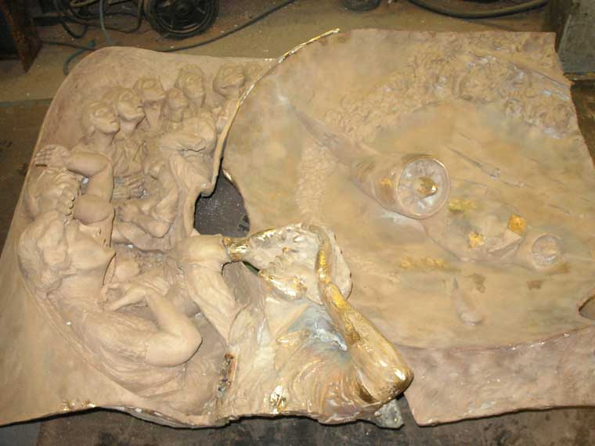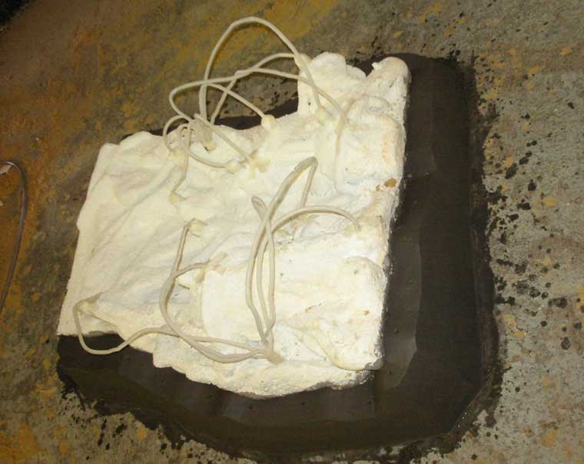
The ceramic shells are then packed in sand that sets hard, and clamped in metal jigs to take the pressure when the actual casting takes place.

Casting
Casting is done by pouring hot bronze at a temperature of 1200°C into the ceramic shell via the runner tubes. This has to be done quickly (within 20 seconds) before the bronze solidifies. Bronze is an alloy of copper and tin. Once cooled the ceramic shell is broken open to reveal the fledgling bronze casting.

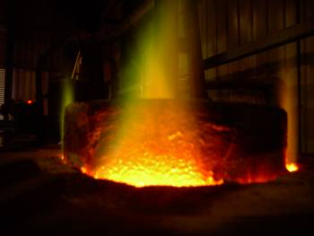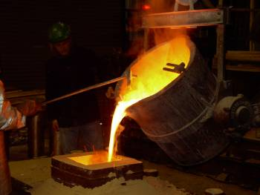

The runner system is removed and the piece is blasted with very fine sand to remove any remaining ceramic particles. The pieces are then welded together to create the full size sculpture. The welds are treated to make them invisible and the sculptor checks the cast panel.
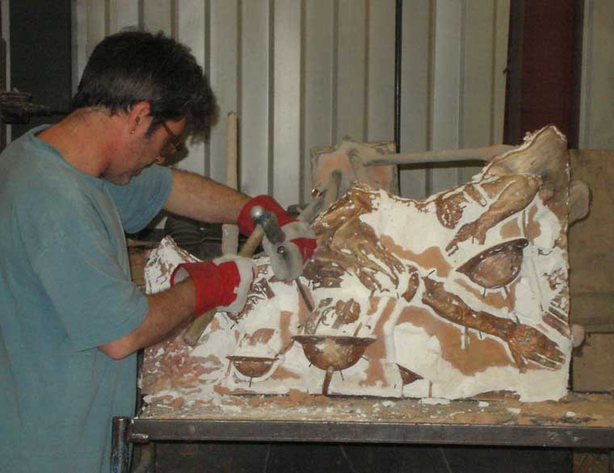
The final stage is to patinate the bronze. This is a chemical aging process which leaves the bronze in the final desired colour.
The castings are then stored safely before transporting to the construction site.

The skills
Beyond the obvious creative skill of the sculptor, many other specialist skills are required. All the stages are done by hand and in each case a different specialist craftsperson is involved. Each person has their part to play in the successful production of the final castings.
www.bbm.org.uk/process.htm
www.morrissinger.co.uk

