Andreas Vesalius

Fact File

Relations:
* Great-great grandfather – doctor
* Great-grandfather –doctor
* Grandfather – doctor
* Father – Apothecary (chemist) to the Holy Roman Emperor Charles V.

Background:
* Born in 1514 in Brussels, Belgium.
* Went to University in Louvain (1528-1533)
* Moved to Paris to further his knowledge of anatomy before moving back
to Louvain (1536).
* Moved to Padua in Italy (1537). Appointed professor of surgery.

Important Ideas:
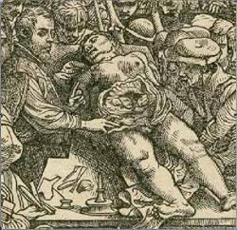
* Vesalius argued that doctors should carry out their own dissections and not rely on Barber Surgeons to do this task for them. This meant that doctors could see for themselves errors made by earlier anatomists when describing the body.

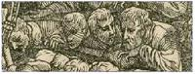
* Vesalius encouraged public dissections. He also encouraged students to get involved in dissections with their teacher, to watch closely and compare what they were seeing with up to date publications and illustrations.

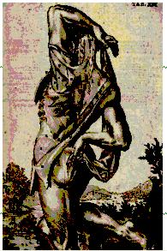
* Vesalius said that accurate drawings or illustrations should be used alongside written descriptions of the body. This would lead to a better understanding of what was being described.

Vesalius put letters on illustrations so that he could refer to each part of the body he was describing.

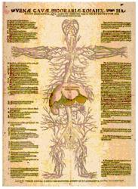
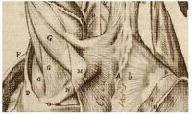
- Vesalius began to reject some of Galen’s theories concerning anatomy and the working of the body (physiology).

- Vesalius put medical arguments, put forward by doctors before him, onto a more scientific footing. He provided reasoned explanations and descriptions for why some theories could be accepted.
- Vesalius personally checked his publications at the printers before copies were made. This cut down on general printing errors and errors in translation.

Important Works:

- In 1528 Vesalius published The Tabulae Sex. This was a set of anatomical drawings (6 sheets) that accurately illustrated parts of the human body, as well as animal anatomy. Vesalius stopped short of criticising Galen openly, but by showing a part of the human body, for example the liver, next to a picture of an animal liver, doctors could see for themselves that Galen’s reliance upon animals when carrying out dissection had led him to make mistakes.

- In 1539 Vesalius published Letter on Venesection (the practice of bleeding a patient). Vesalius used scientific explanation and accurate illustrations to show how the veins within the body were connected.

- In 1543 Vesalius published The Fabric of the Human Body. A small summary of this book was also published in the same year - The Epitome. This text provided a map of the human body and was extremely detailed in its explanations and illustration. Vesalius used the best artists that he could to provide accurate illustrations and all drawings and descriptions were based upon hundreds of actual dissections. This text did correct some of Galen’s errors and Vesalius oversaw the publication of the text through all of its stages – to ensure that no mistakes were made.

