Medical family background
Born in 1514

Studied in Louvain, Paris and Padua
Died in
1564

Andreas Vesalius

Professor of surgery and teacher of anatomy
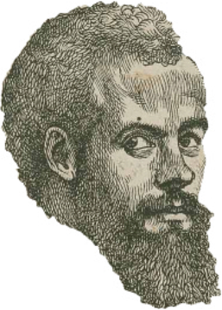
Vesalius said that:
* Dissections should take place in public
* Doctors and lecturers should perform the
dissections
* Students should have the opportunity to view
dissections close-up

Vesalius worked as a doctor at the court of the Holy Roman Emperor Charles V

Tabulae Sex 1538

Letters on Venesection 1539
** Fabric of the Human Body 1543
1) A complete human anatomy – map of the body

2) Corrected some of Galen’s errors

3) Accurate illustrations were put alongside the text.
4) It showed what could be achieved when dissection,
accurate description and illustration were all put
together

5) Vesalius emphasised accuracy by overseeing each
stage of the publication of his work.
1) Sees some errors in Galen
2) Accurate drawings of animal and human anatomy
1) About the practice of bleeding patients
2) Vesalius provided scientific reasons for why some of
Galen’s theories could be accepted.

