Highlight the areas of the image that you would like to discuss
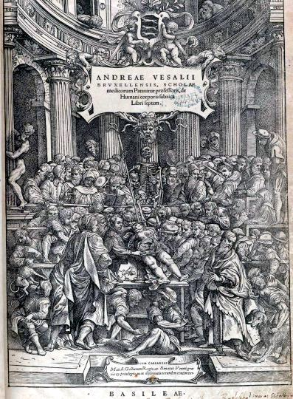
Image courtesy of the U.S. National Library of Medicine
Write down three quick questions that you would like to be able to answer before the end of the lesson.

1 _____________________________________________________________________________________

Answer:_________________________________________________________________________________

2 _____________________________________________________________________________________

Answer:_________________________________________________________________________________

3 _____________________________________________________________________________________

Answer:_________________________________________________________________________________

