Teachers’ notes – 2-D shapes
Year Group 1
Key objective references; Use everyday language to describe features of familiar 3-D and 2-D shapes.
This activity is to consolidate knowledge of regular 2-D shapes. Children will familiarise themselves with the names of the shapes and look at differences and similarities between the shapes.
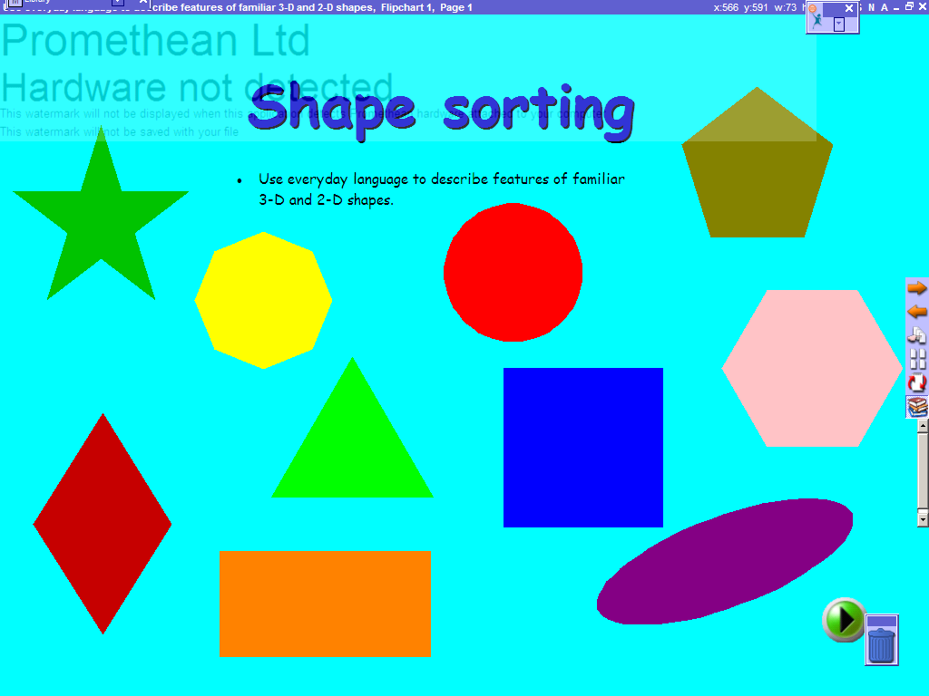 | Title screen.  Lesson objectives. Use green advance buttons to move between screens.
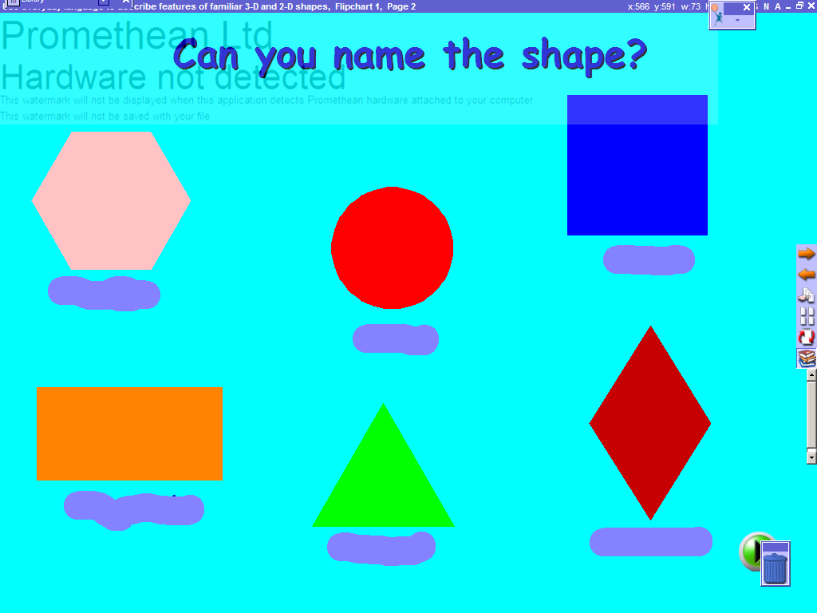 | Screen 2  If you have Activ studio software you can use the eraser tool to rub out and reveal the names of the shapes.  If you are using a version of the Promethean viewer then you can drag the coloured block away to reveal the name of the shape.
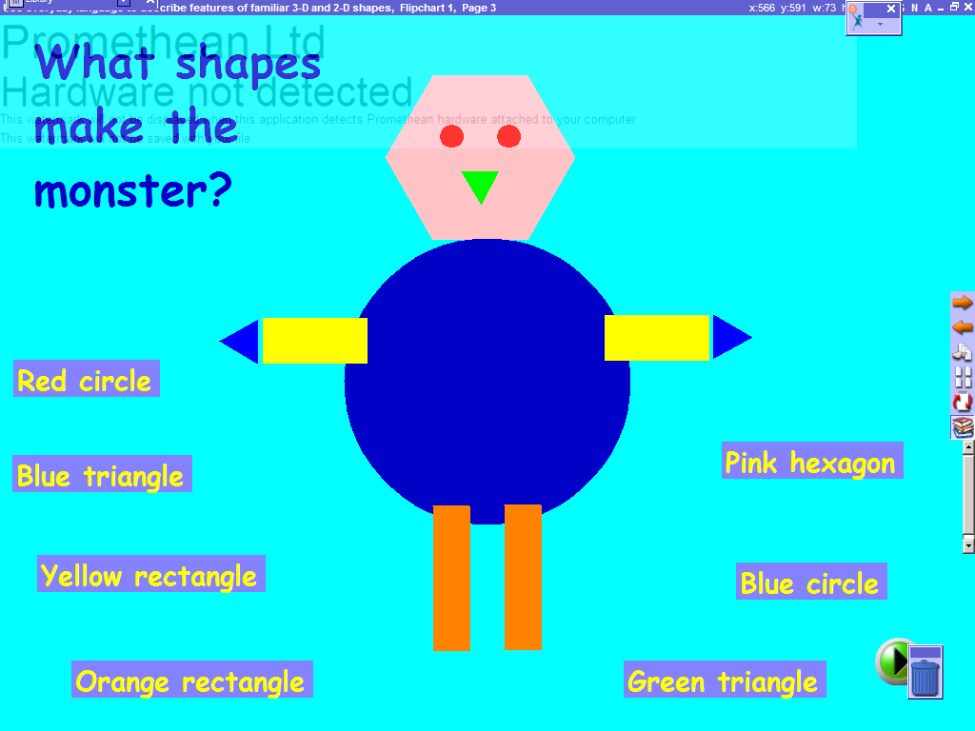 | Screen 3  Either use the pen tool to draw lines from the name of the shape to the shape or drag the name of the shape to the shape.
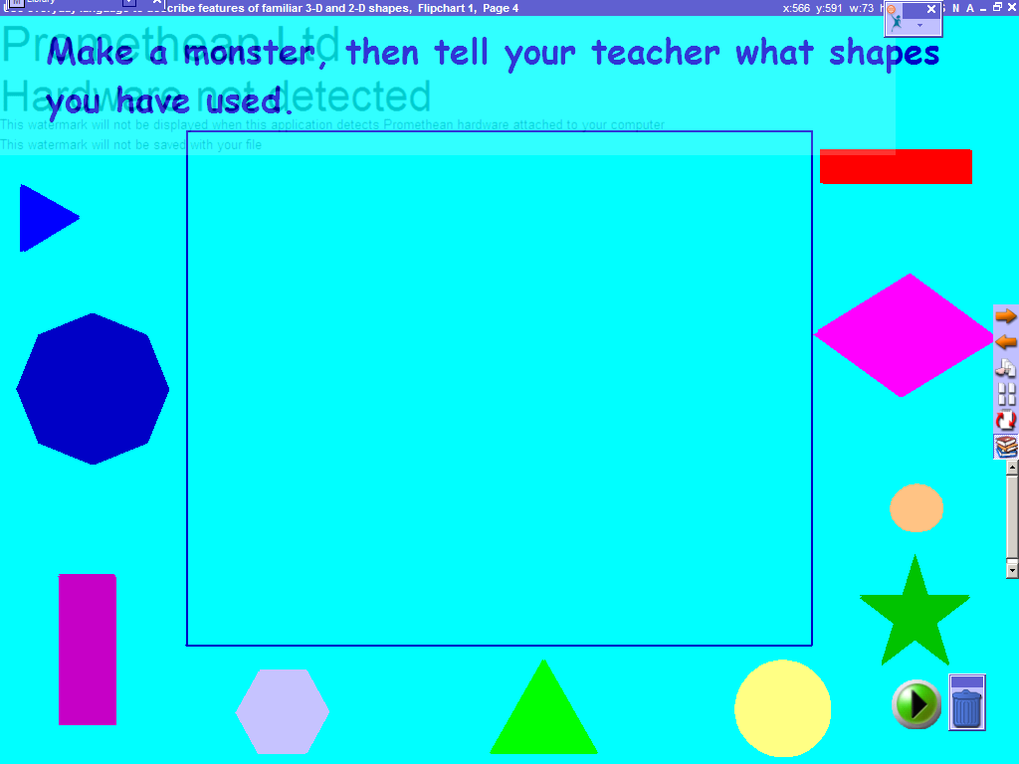 | Screen 4  Drag the shapes to the centre of the screen to make a picture. Encourage the children to tell you what shapes they have used for each part of the body.
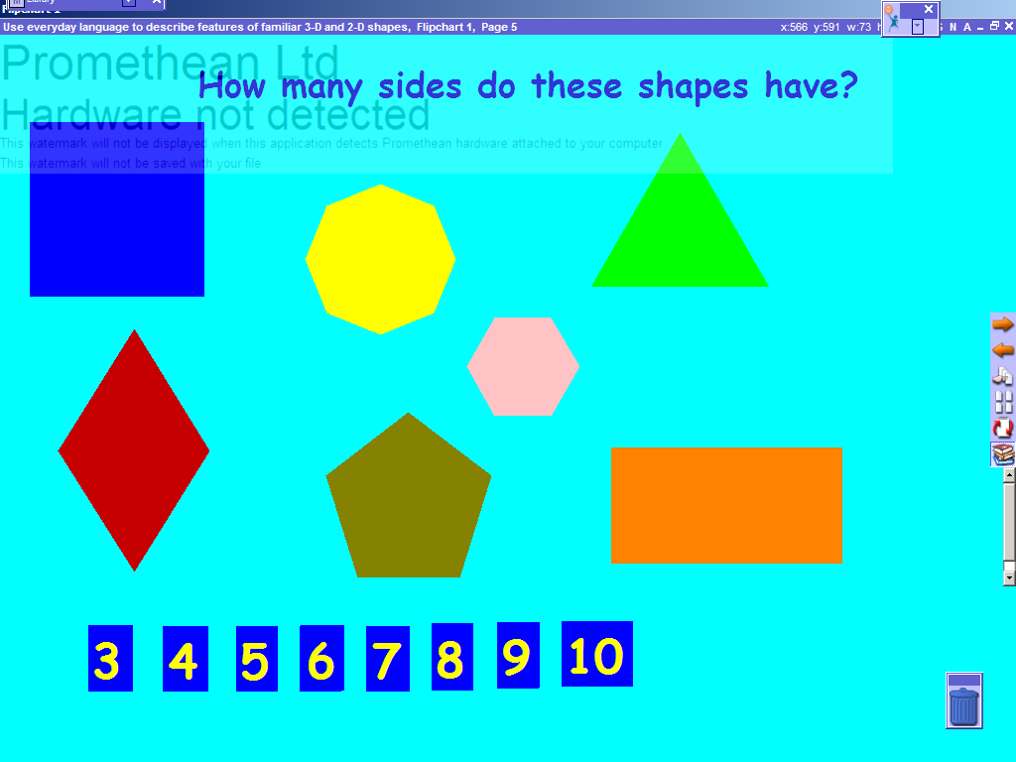 | Screen 5  Encourage children to count the number of sides each shape has. It may help to use the pen tool to tick off each side as it is counted. Then have the children drag the correct number on top of the shape.
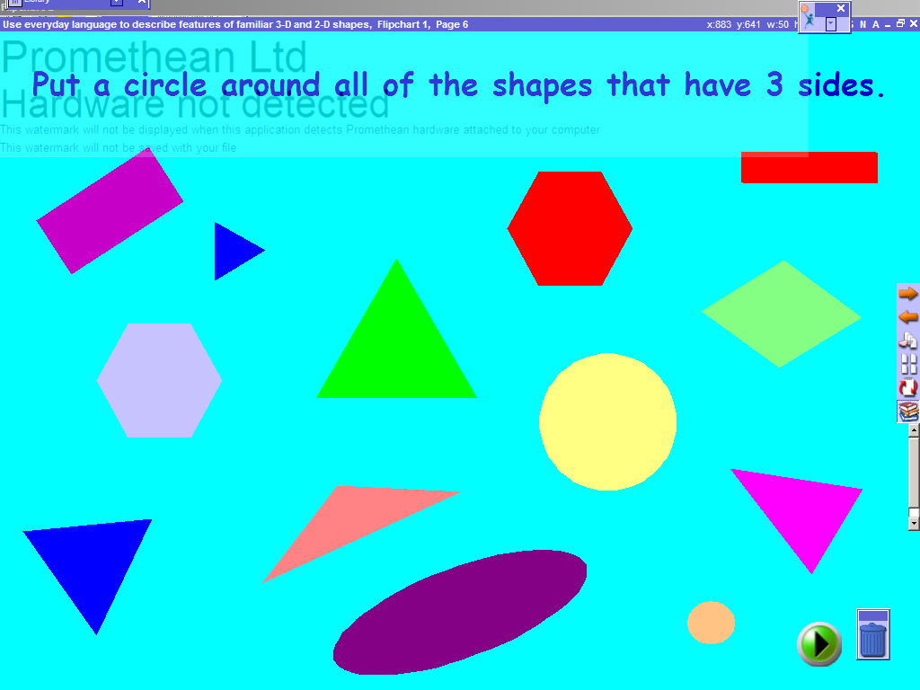 | Screen 6  Have children circle the shapes that have three sides using the pen tool. Question their decisions to encourage discussion about the properties of shapes. Do they know the name of the shape they have circled?
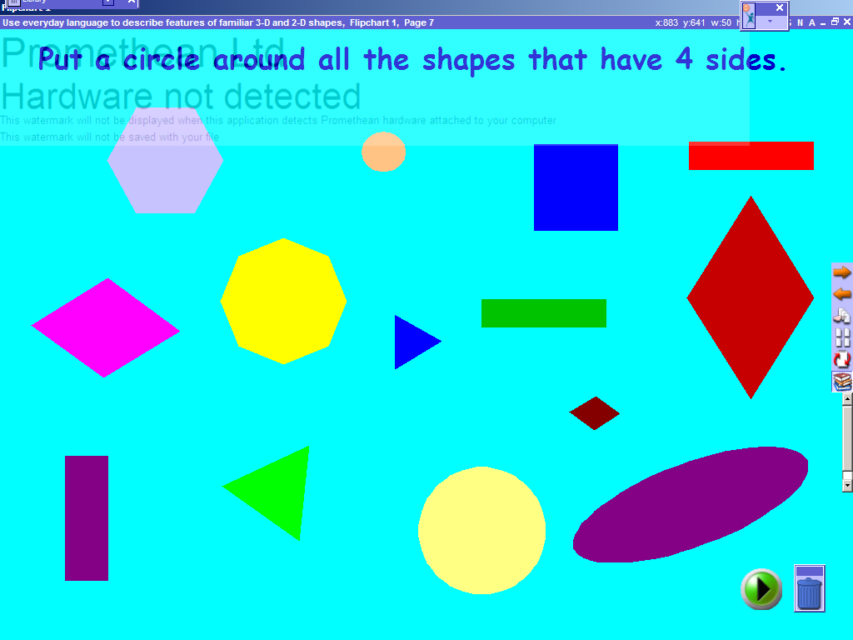 | Screen 7  Have children circle the shapes that have four sides using the pen tool. Question their decisions to encourage discussion about the properties of shapes. Do they know the names of the shapes they have circled?
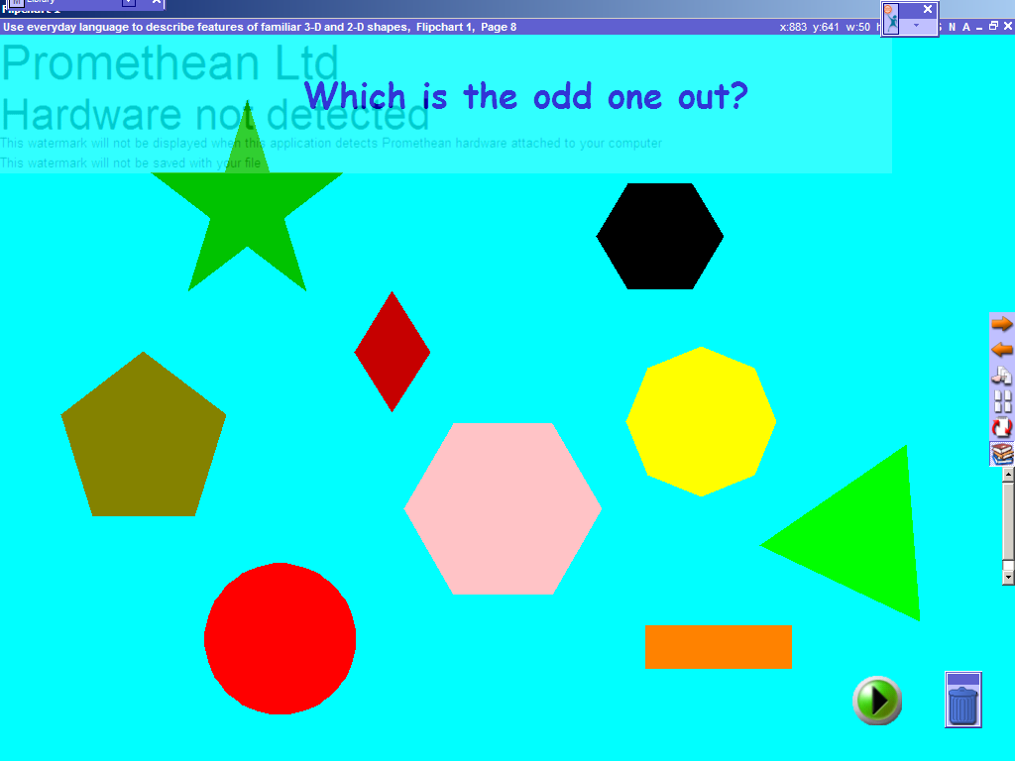 | Screen 8 – 9  Have children circle the odd one out using the pen tool. Question their decisions to encourage discussion about the properties of shapes. Why is their chosen shape different to the others?

