Place Value Flip Charts Teacher Notes.
Objectives: Count, read, write and order whole numbers to at least 100.
Know what each digit represents.
To develop awareness of place value, read numbers from 100 square grid, develop appropriate language for number.
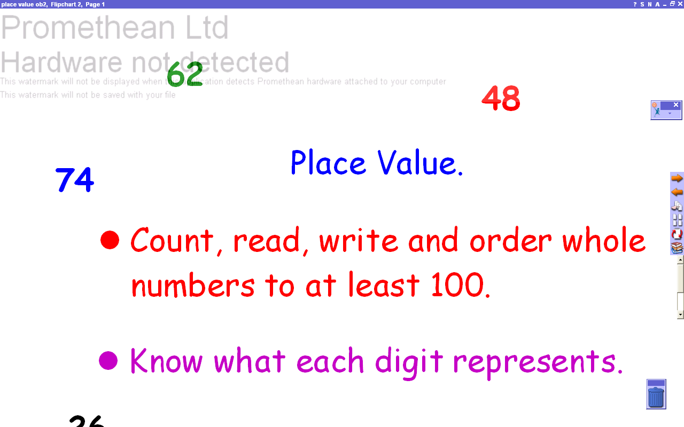 | Page 1. Title page and objectives.
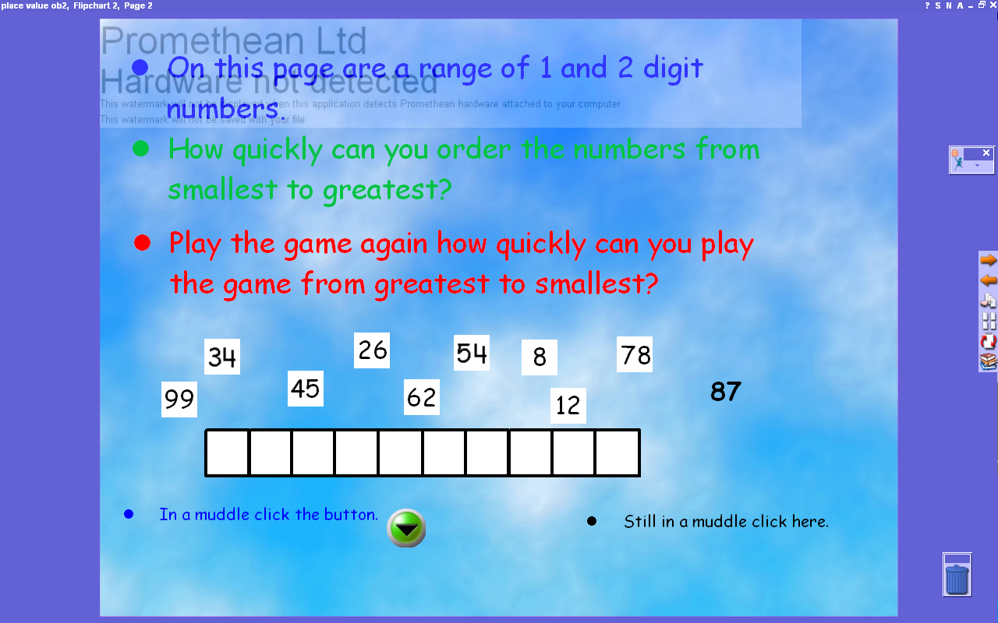 | Page 2. Ensure children are familiar with terms, i.e. do they know what a 2-digit number is? If you want to add timed element to game click on Man icon then Toolbox Customize then Tool Store then Presentation Tools - drag and drop clock onto tools box. Click on clock - choose count up.  Help buttons hyper link to page 7, use the Reveal Tool to pull down over 100 square and order numbers. Remember to stop reveal button before returning to page 2.  Further hyperlink to page 8 shows an example of how to find a number on the 100 square.
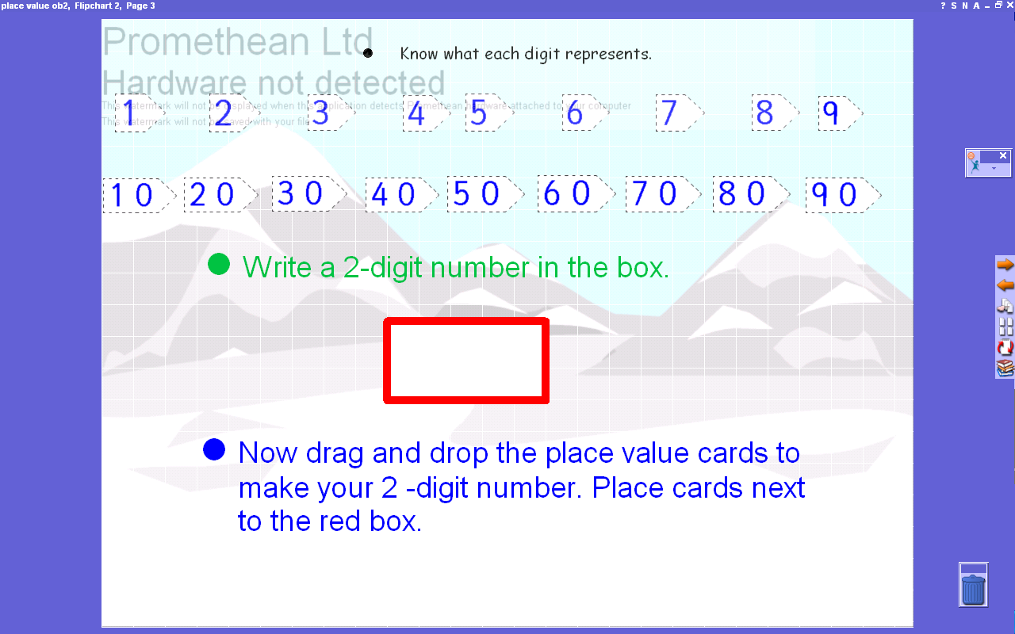 | Page 3. Introduce activity as a class. Select 2-digit number to write in red box by using Pen icon (remember to click off pen when drag and dropping place value cards, [or if only using lap top T text symbol to create text box and type in number.] Use white board pen to drag and drop 10’s and 1’s cards to make 2-digit number next to red box. Continue as a class or in pairs.
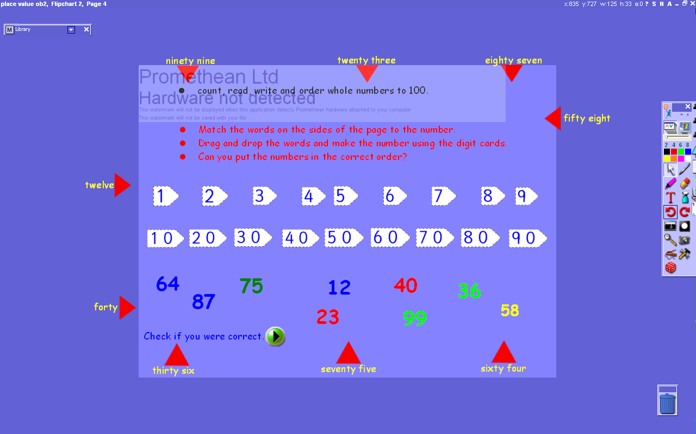 | Page 4. Pupils drag the arrows to the correct 2 digit number. This page can either be class or individual with hyperlink button to page 9 to check answers. This page acts as a plenary consolidating use of place value cards, numerals and word recognition.
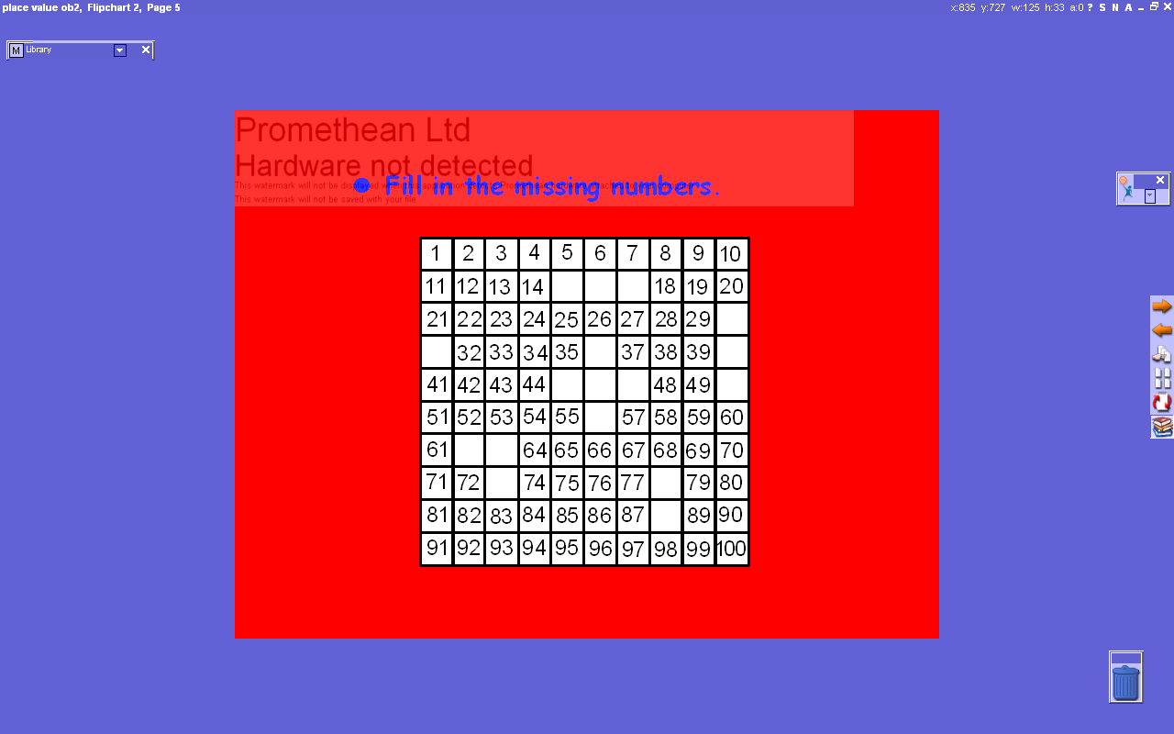 | Page 5 Fill in the missing numbers. Consolidate read, order and identify 2-digit numbers. Identify missing 2-digit number to write in. Choose either from smallest to greatest or following unit’s column counting on in tens. Use Pen icon, [or if only using lap top T text symbol to create text box and type in number.]
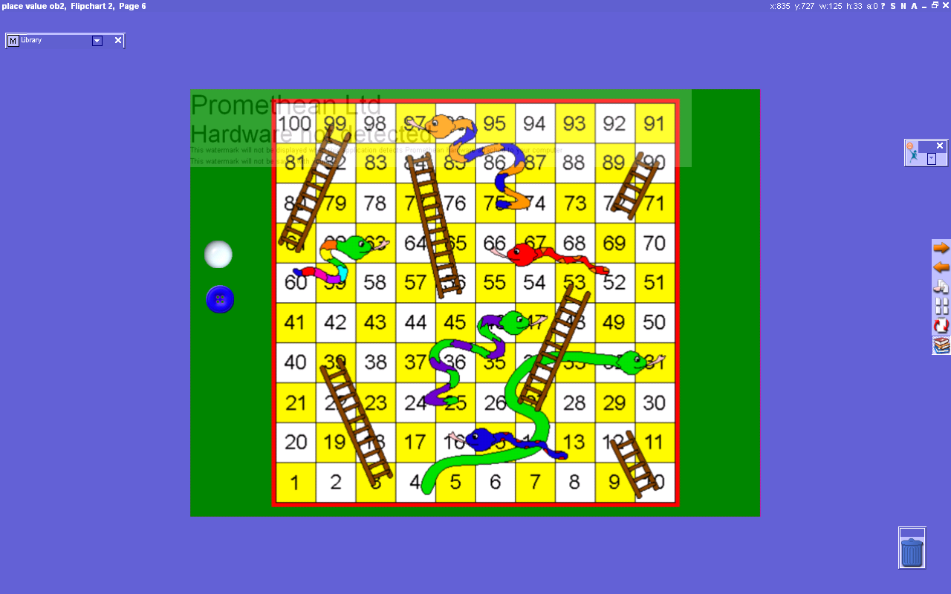 | Page 6 Snakes and Ladders game. Split class into 2 groups. Use dice  If you do not have dice on your tools box click on Man icon then Toolbox Customize then Tool Store then Power Tools - drag and drop dice onto tools box. Click on dice to play the game.
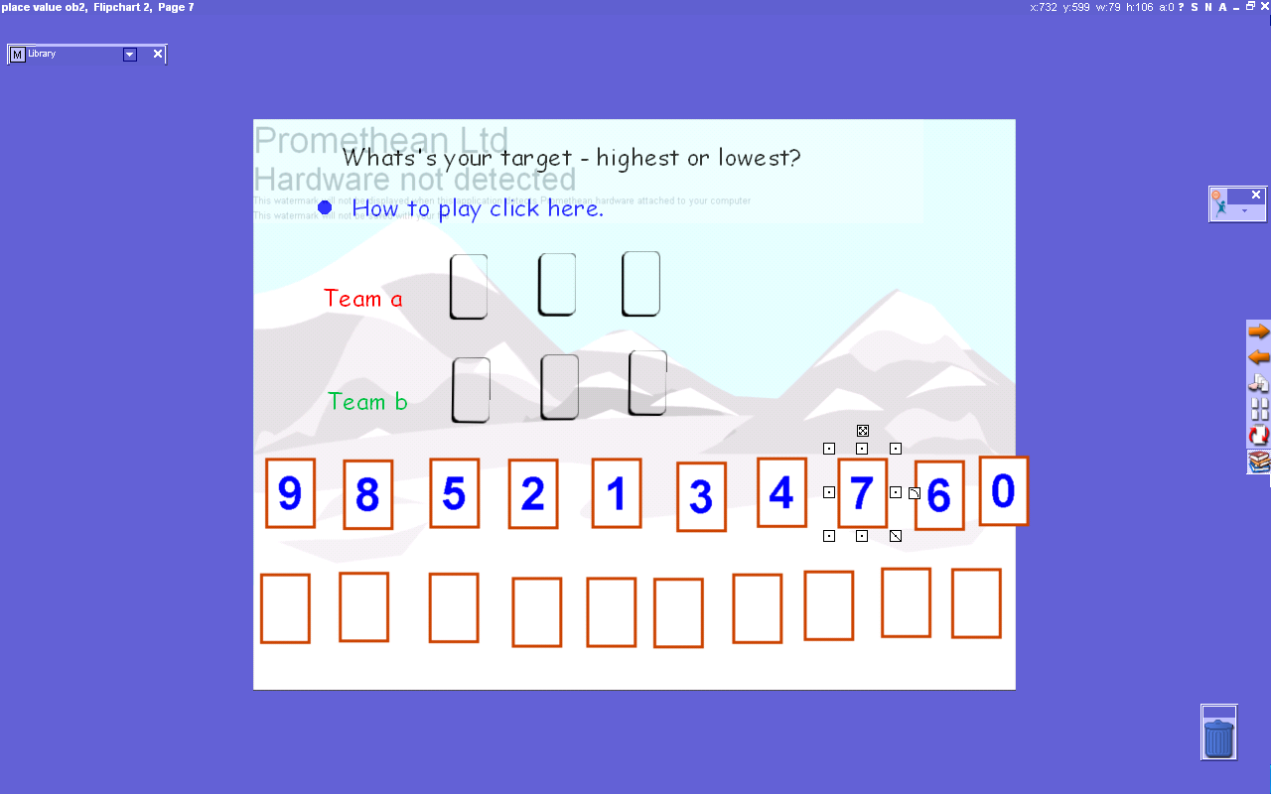 | Page 7 What’s your target – highest or lowest. Split class into 2 groups. Put 0-9 cards in random order and cover with blank card. One pupil is chosen from each team. Team a select one card and have to decide by its value to place it in the hundreds, tens or units space. The rest of their team can offer advice. The card cannot be moved once a selection has been made. Then Team b select their card and try to put it in a space which will make their number nearest to the chosen target e.g. highest or lowest number, highest even/odd number etc
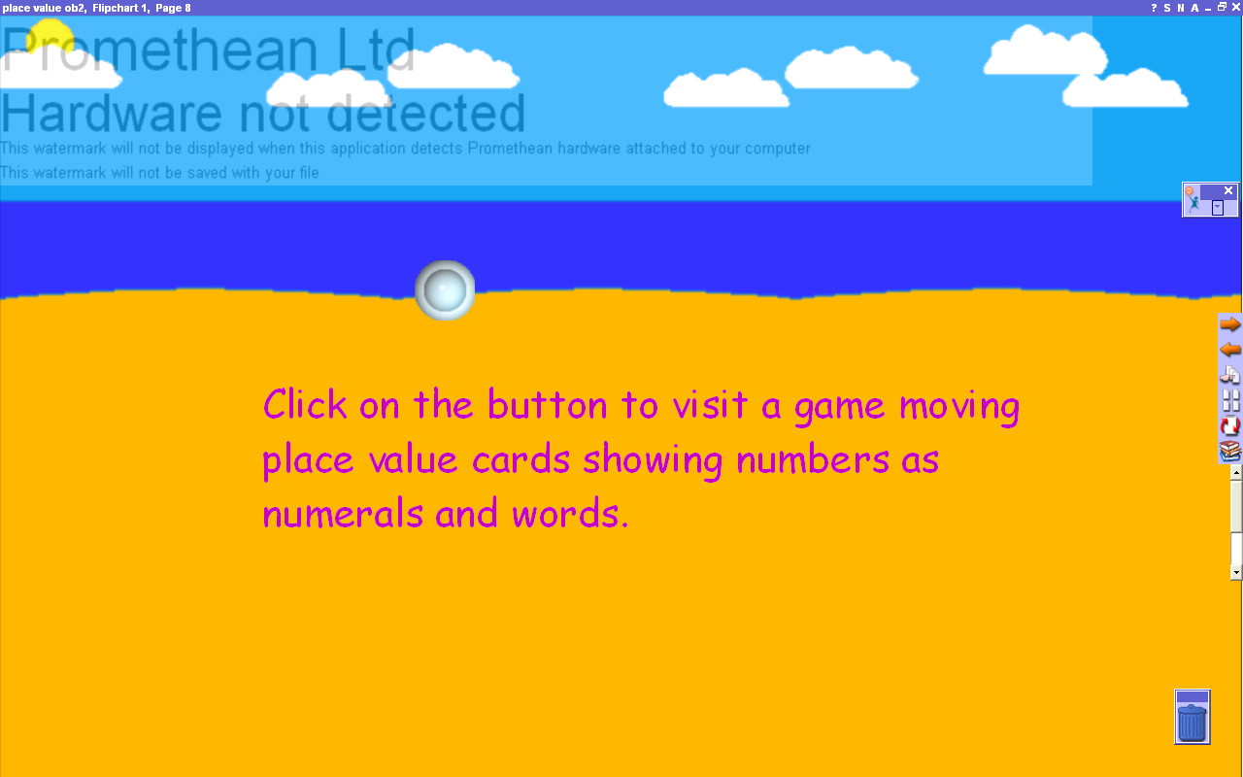 | Page 8 Access to an interactive place value game. Reinforcing use of place value cards, using a place value grid, reading numerals and numbers in words. To play the game, highlight the numbers on the place value grid. The place value cards will change to the number highlighted.  You can drag and drop the place value cards to make 2, 3 or 4-digit number highlighted. The two boxes on the left of the page can be clicked for hidden or not hidden allowing pupils to say or write the numbers on a hand held white board before showing whole class.
 | Pages 9, 10, 11 and 12 are all hyperlinks to previous pages.

