
SUMS UP!

Year 3 KO Reference j

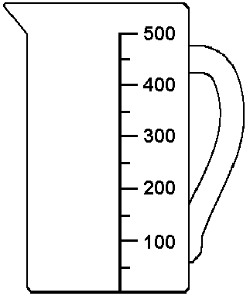
Read a simple scale to the nearest labelled division, including using a ruler to draw and measure lines to the nearest centimetre.

10. What is the reading on this scale to the nearest 100?

22. Measure the length of this line to the nearest centimetre

Key Words
Scale, ruler, centimetre, litre, measure, nearest …

Key Questions
How did you decide on your estimate?
What clues do you use when deciding which is the nearer 10/100/cm etc.?
What did you have to make sure of before you started measuring?

Practical Activities
- Looking at scales on jugs & a wide range of measuring equipment.
- Looking at containers – Which hold more than 1 litre? Which hold less than 1 litre?
- Drawing/measuring lines to the nearest centimetre. (Wool/String can be used).
- Making simple scales: instead of ml, mark out a jug in ‘cups.’ The pupils can then read the scale to the nearest cupful.
- A simple scale showing kg could be used for the pupils to read.

See Suggested Practical Activities for Year 3 KO i

Written Activities
Worksheets/activities to link with practical activities above’ How much water is in each jug?

Draw the level of water on each container;
Draw the level of 50Cups
20 cups of
water on the
container.
(other levels can be drawn – 15 cupfuls,

4 cups, 6 cups etc).
(N.B. Use different shaped containers –
Long/thin, taller etc).

Similar to above; Use the same container/scale as in the box above – show a given amount of liquid (e.g. 20 cups), pupils to work out how much water to add to each container to fill it to the top mark (50 cups).

See Suggested Written Activities for Year 3 KO i

IT
http://www.wmnet.org.uk/resources/gordon/Bingo%20-%20reading%20scales%20v2.swf
http://www.standards.dfes.gov.uk/primary/teachingresources/mathematics/nns_itps/thermometer/num_itp_thermometer_1_7.swf
http://www.standards.dfes.gov.uk/primary/teachingresources/mathematics/nns_itps/thermometer/num_itp_thermometer_1_7.swf

http://www.standards.dfes.gov.uk/primary/teachingresources/mathematics/nns_itps/measuring_scales/num_itp_measuringScales_1_8.swf

http://www.interactive-resources.co.uk/ :
Teaching Measures : Capacity

BBC Megamaths Measure video available from Library Services

NNS ITP : ‘Measuring cylinder’ and ‘Measuring scales’

Games

Matching – scales/description (e.g. picture of container/scale above; 20 cupfuls, match with words 20 cupfuls).

Home activities/Homework
Any everyday activities to develop skills: reading scales, measuring in cm etc.

Springboard 3
Unit 10
Pages 110 - 119

