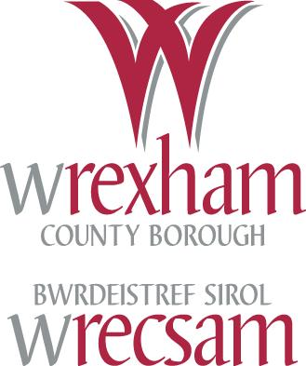
SUMS UP!
Year 3 Maths Puzzles

1. What is the value of the 6 in the number 68?
60

2. Write down the next three numbers in this list :

8 10 12 14 …
16
18
20

3. You know that 13 + 4 = 17.
4
13
What is 17 – 13? What is 17 – 4?

9
4. What is 3 + 6?

5. Write three numbers that have a sum of 15
various solutions

4
6. 3 + 3 + 3 + 3 is the same as x 3.

7. What is half of 12?
6

8. What are eight 10s?
80

9. Which of these lines is the longer?
Check by using a ruler and circle the answer.

B

A

7.5
6.4
cm cm

10. What is the reading on this scale to the nearest 100 millilitres?
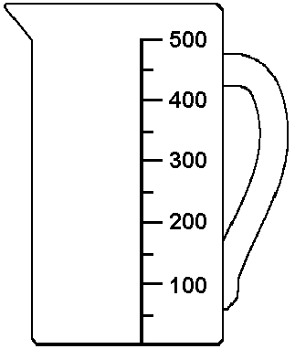

400
ml

11. What are the names of these shapes?

Triangle

Square

Cube

12. What sign does each  stand for?
24  6 = 18 14  2 = 7
−
÷

13. Write these numbers in order, smallest to biggest :
46 29 31 18
18
29
31
46

14. What are the next three numbers in this
sequence :
38
48
58
8 18 28 …

15. You know that 17 - 5 = 12.
5
17
What is 17 – 12? What is 12 + 5?

9
16. What is 2 + 7?

17. Write three different numbers that have a sum of 30
various solutions


18. What two numbers would I multiply to find the total number of stars?
4 and 5

7
19. What is half of double 7?

14
20. What are seven 2s?

21. My cat is 30 cm tall. My dog is 25 cm taller. How tall is my dog?
55cm

22. Measure the length of this line to the nearest centimetre

12
cm

23. Tick the shape which is not symmetrical.

√

or

Draw a line of symmetry on one of the other shapes

24. A tricycle has 3 wheels. How many wheels do 4
tricycles have altogether?
12

