Doubling and Halving 1
Objective: To understand division as inverse of multiplication.
Year 3
Introduce activities as whole class. Consolidate knowledge of 2 x time’s table.
Range of activities including real life situations and money.
Ensure that you have internet access.
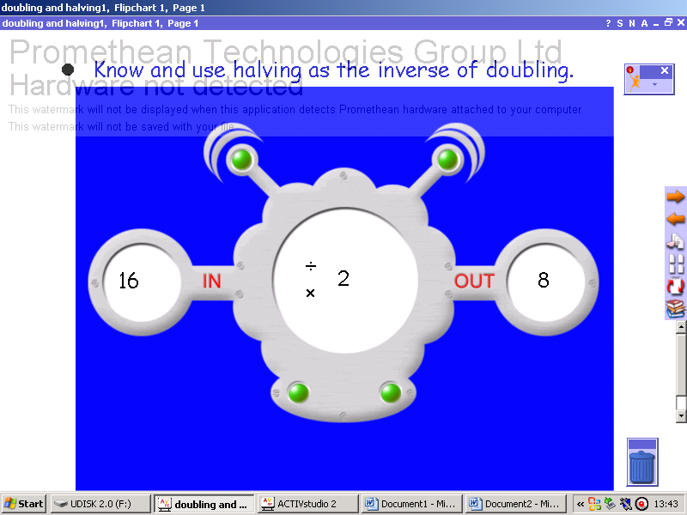 | Page 1. Title page and objectives. Target group Year 3
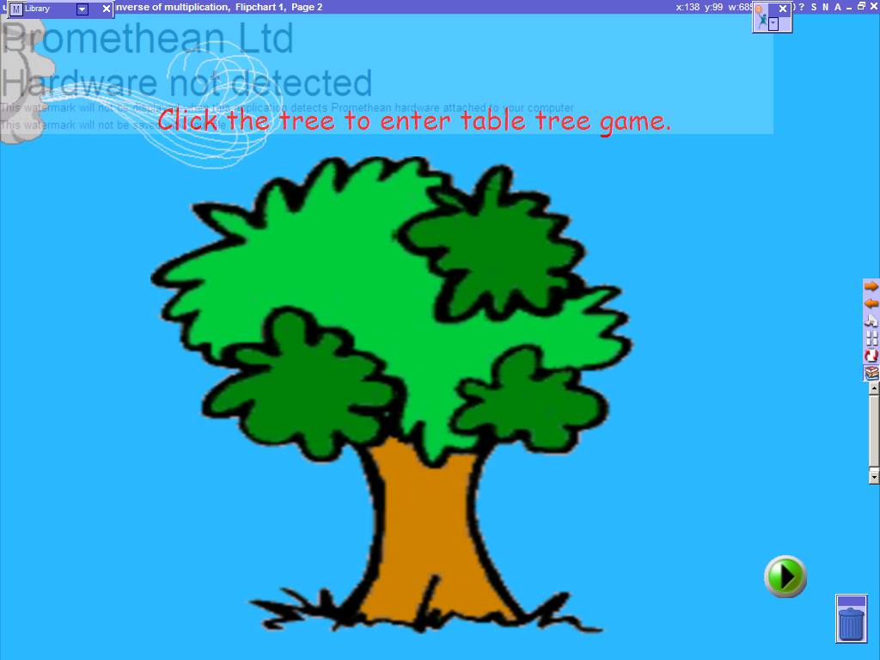 | Page 2. Whole class activity: Consolidating 2, 5 and 10 x tables. Internet needs to be open to access web site. Revisit page to consolidate further tables.
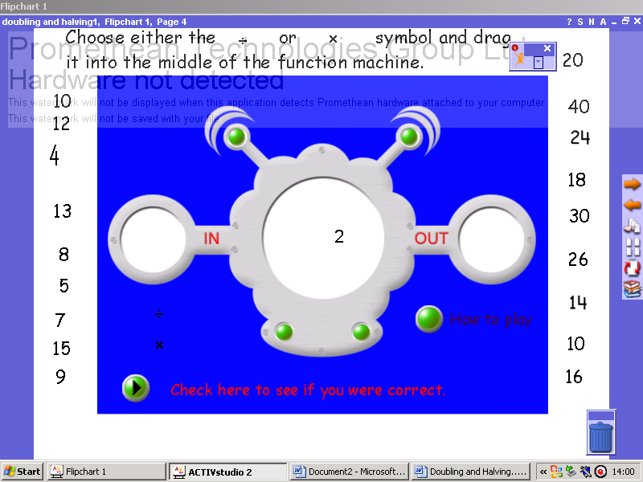 | Pages 3 - 5. Function Machines. Will help to reinforce the concept of division being the inverse of multiplication. There are three screens that look at the 2, 5 and 10 x tables. There are hyperlinks from each page to screens showing the multiplication table and the corresponding division sums.
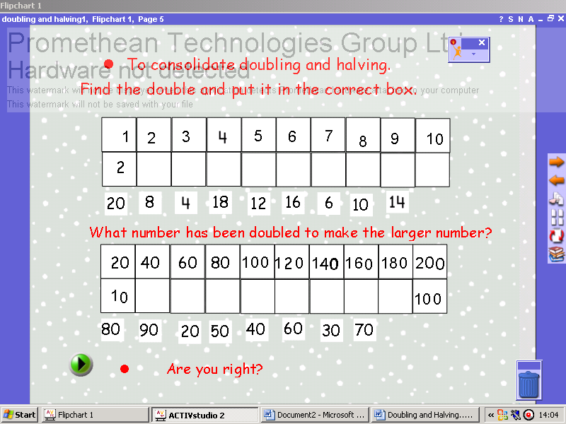 | Page 6. Snow Flakes. Pupils drag and drop correct answers into box. This screen reinforces multiples of 10.
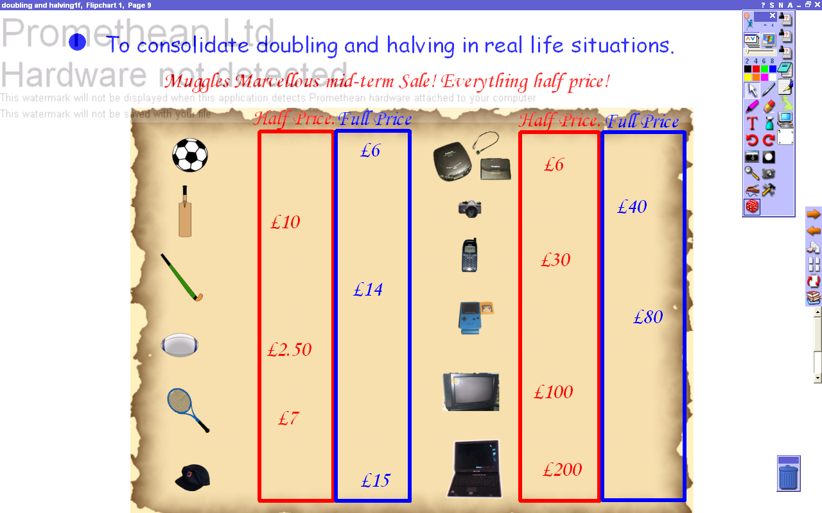 | Page 7 Sale Prices to consolidate halving and doubling (multiplying and dividing by 2) using real life situations.  Use Pen icon, [or if only using lap top T text symbol to create text box and type in number.] Key teaching points are doubling £2.50. Encourage the children to break the amount up into doubling £2 and doubling 50p and then adding the 2 totals together. The other key teaching point would be halving £15. Discuss what strategies they could use, would it help to split the number into £10 and £5? If we know double £2.50 is £5 what would half of £5 be?
 | Pages 8 - 14 are all hyperlinks from previous pages.

