Recognise unit fractions
Objective: Recognising unit fractions such as ½ ,½ , ¼, 1/5 , 1/6, 1/8, 1/10, and to use them to find fractions of shapes.
Beginning to recognise simple fractions that are parts of a whole, for example ¾, 2/3, 3/10.
Beginning to recognise simple equivalent fractions, for example five tenths and one half.
.
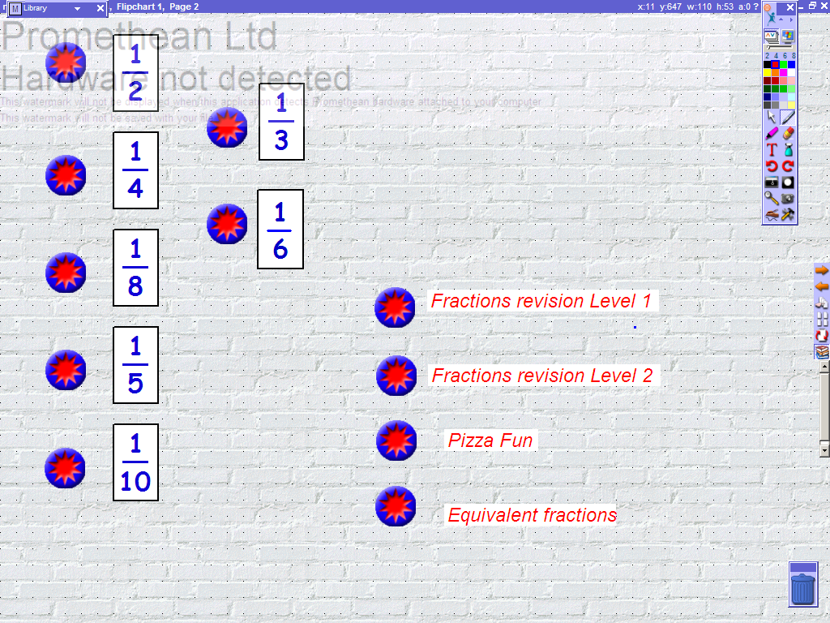 | Page 2. Navigation page. This page links to all of the activities within the flipchart
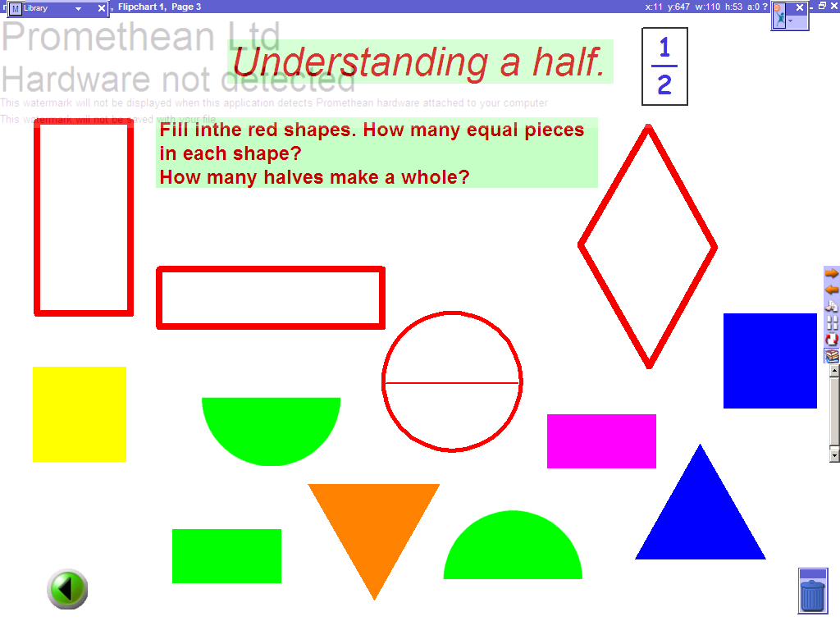 | Page 3. This introduces children to the ‘half’, and also ‘equal’. Children can drag and drop the pieces into the correct shapes. To encourage understanding of whole, the teacher can ask the children, ‘how many more pieces of the same size do they need to make a whole?’
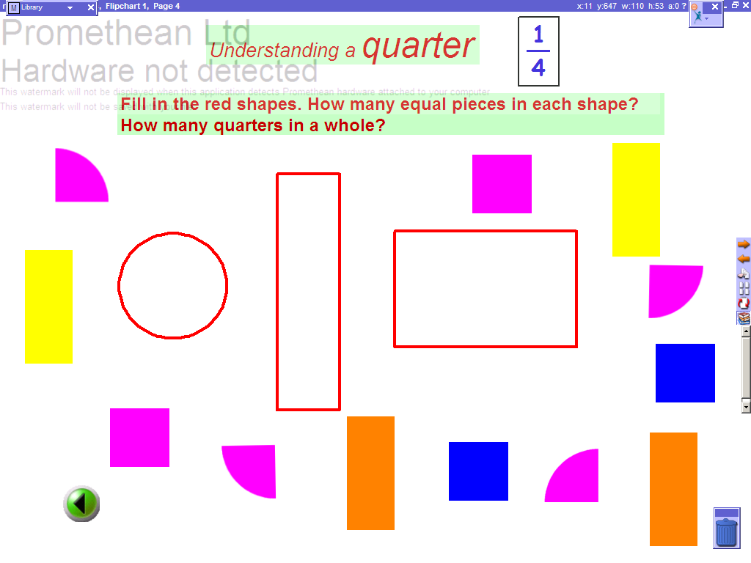 | Pages 4 (As P3) This introduces children to quarters. Children can drag and drop the pieces into the correct shape.
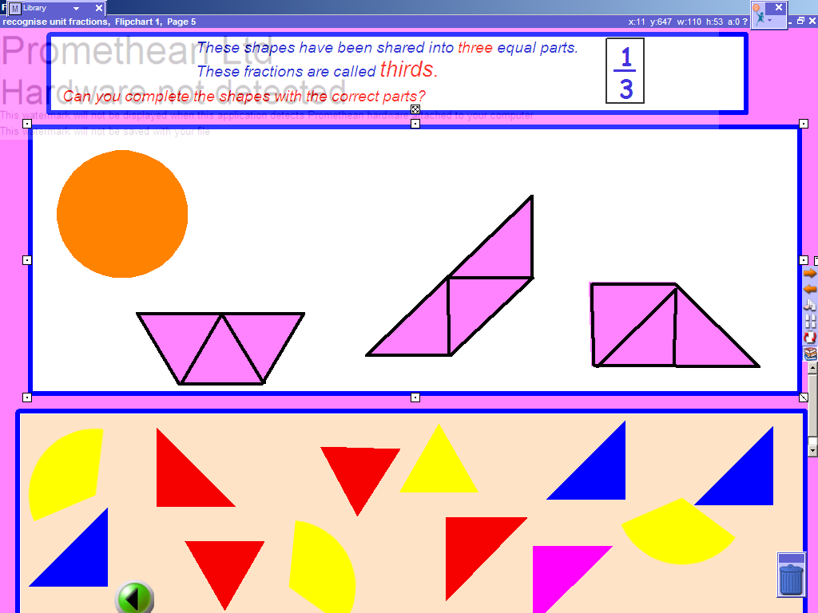 | Page 5. (As P4)This introduces children to thirds. Children can drag and drop the pieces into the correct shape.
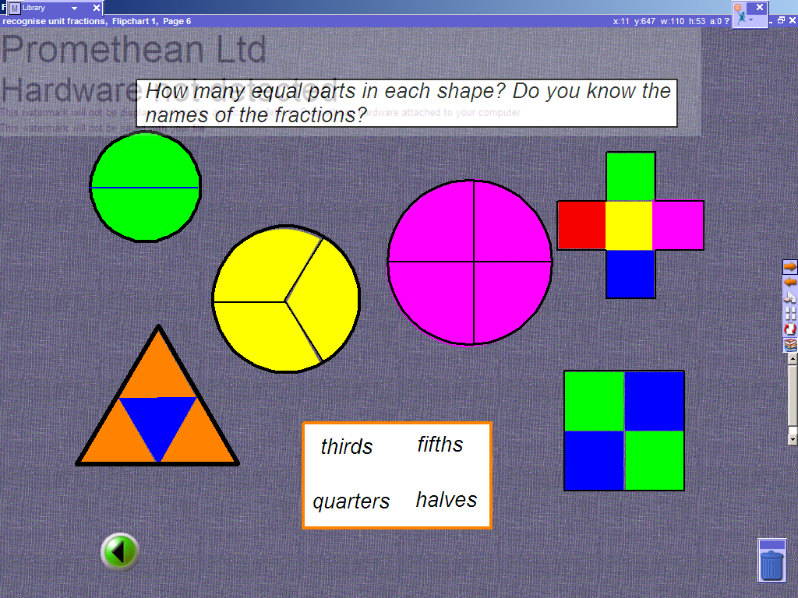 | Page 6 This page consolidates the children’s understanding of ‘whole’. The fractions can be removed for flexibility. The pen tool can be used to write what fraction of the shape is filled in, empty and so on.
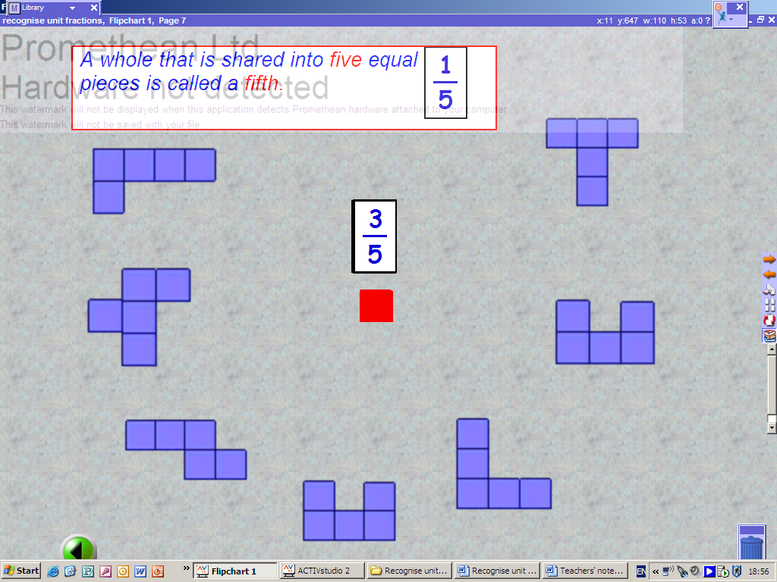 | Pages 7 This page introduces children to fifths. Take a fraction card off the pile and drag it next to one of the shapes. Use the red squares to make that fraction. Ask how many are shaded, un-shaded.
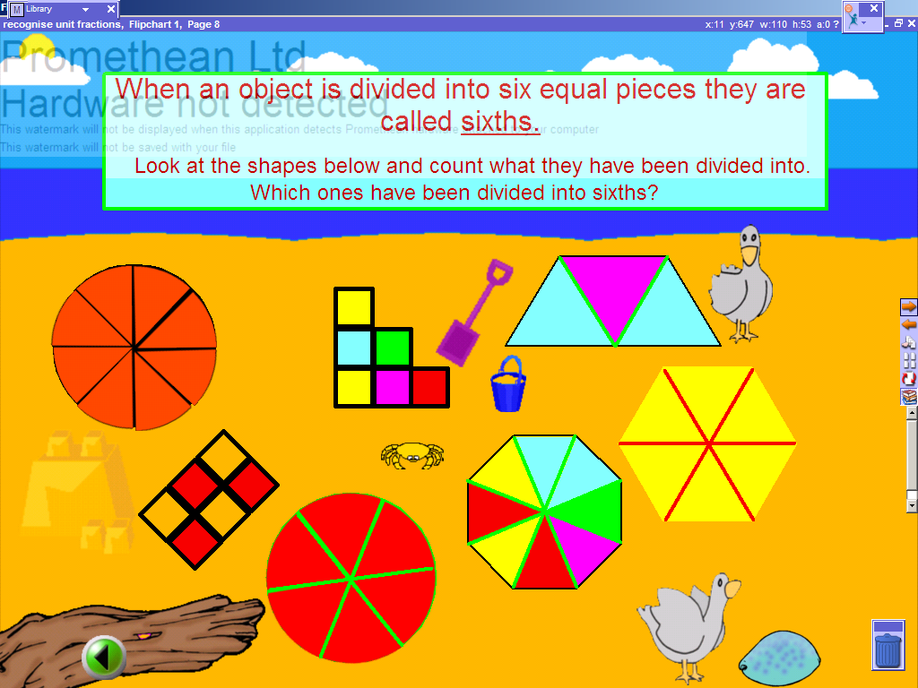 | Page 8 This page introduces children to sixths. Use the pen tool to circle the shapes that have been divided into six equal parts..
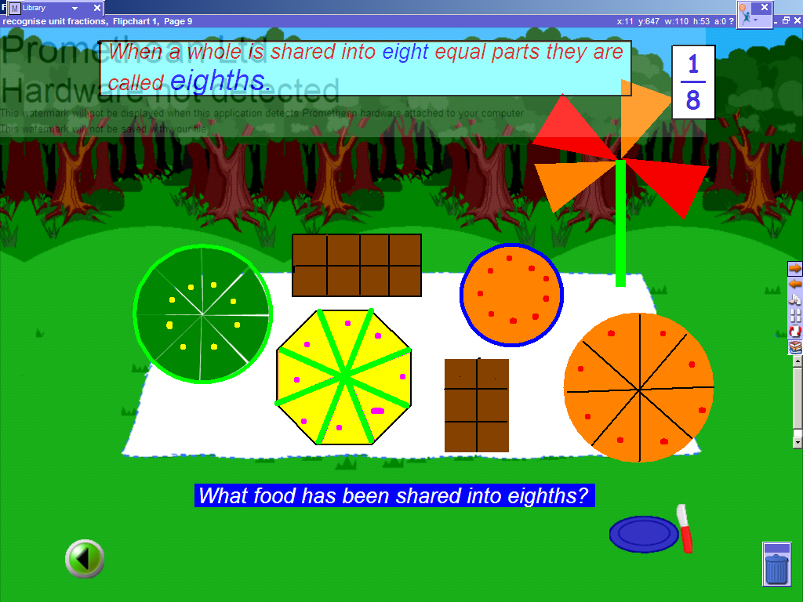 | Page 9 This page introduces children to eighths. Use the pen tool to circle the shapes that have been divided into eight equal parts.
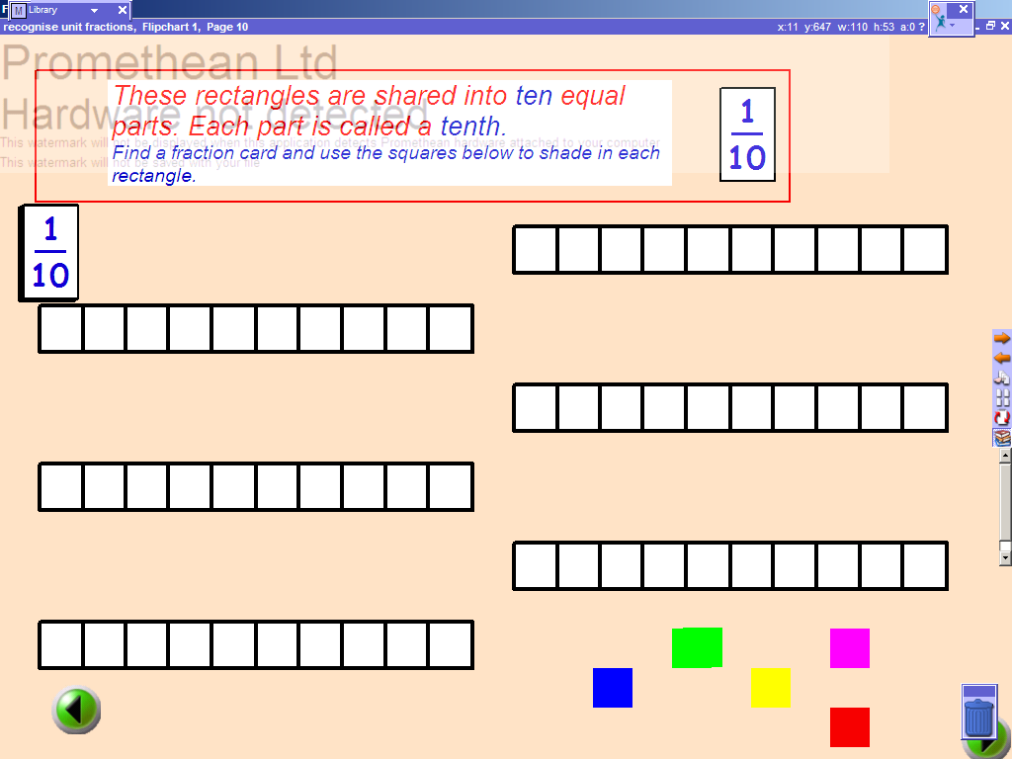 | Page 10 This page introduces children to tenths. Drag a fraction card from the top of the pile and ask the children to shade in the rectangle using the coloured squares.
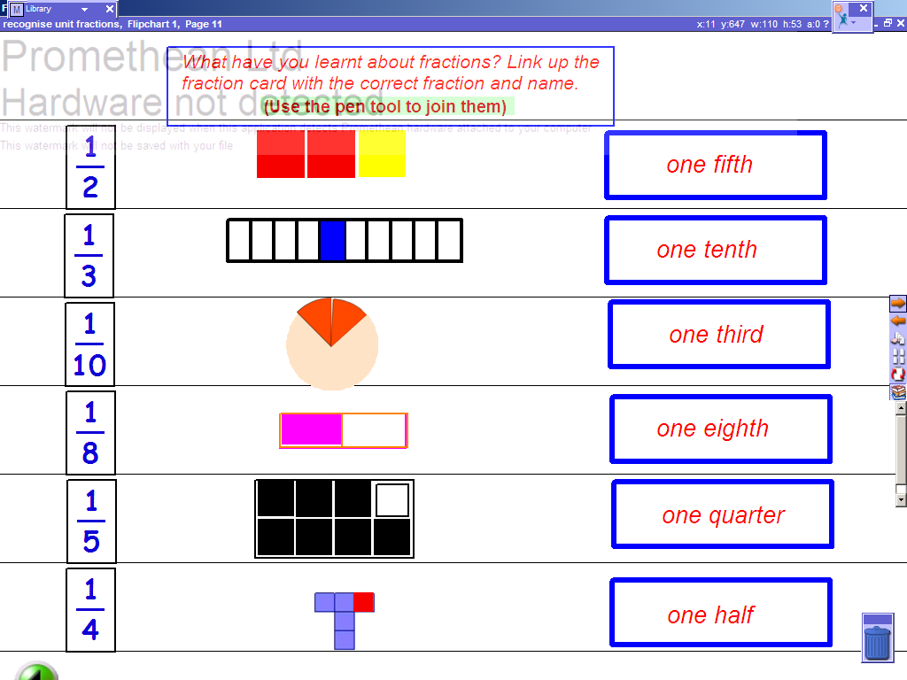 | Page 11 This page consolidates what children have learnt so far. Use the pen tool to join the notation, the fraction and the word.
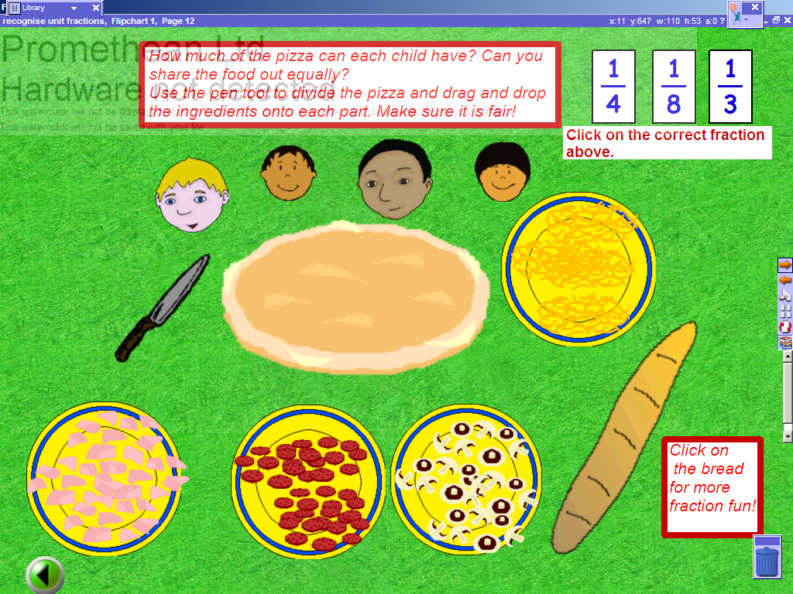 | Page 12 This is a very simple introduction to the concept of sharing. Click on the correct fraction. Use the pen tool to divide the pizza fairly and drag the food onto the pizza. Click on the bread to link to a website that consolidates fractions and also has activities for independent use.
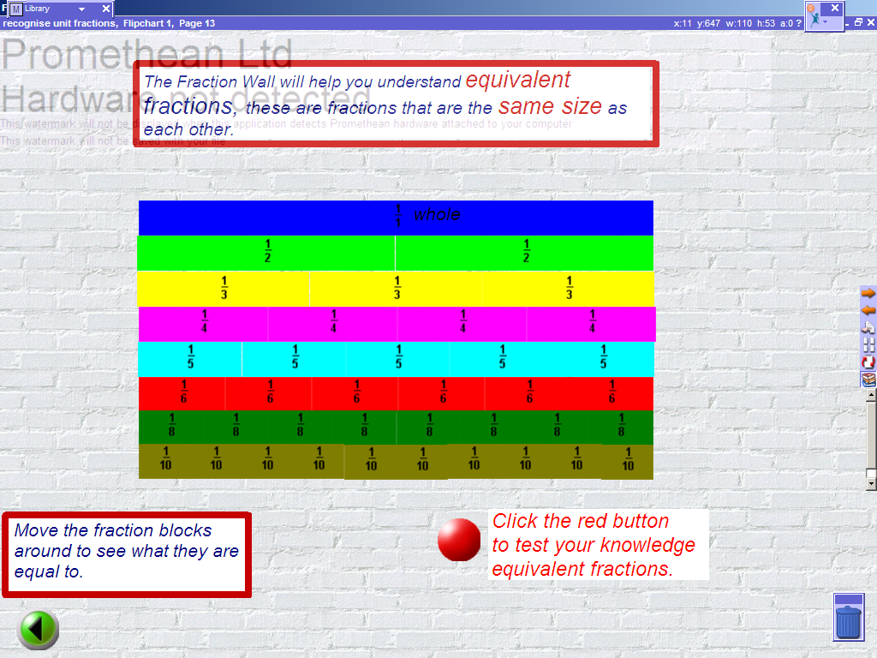 | Page 13 This page introduces the children to equivalent fractions. The blocks can be moved around for the children to see what is equal following teacher prompts. Clicking on ‘S’ and minimising the screen will allow the teacher to place fractions that are not being used to create more space. Clicking on the red button will link to a page that consolidates equivalent fractions.
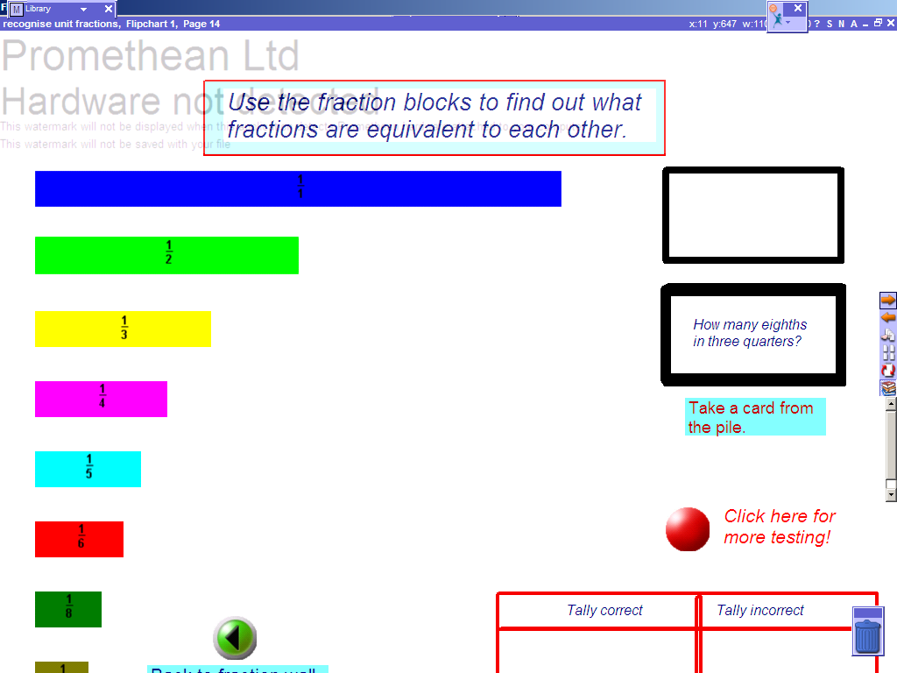 | Page 14 This tests the children’s knowledge. Use the question cards for prompts. The fractions can be moved to see what they are equivalent to.
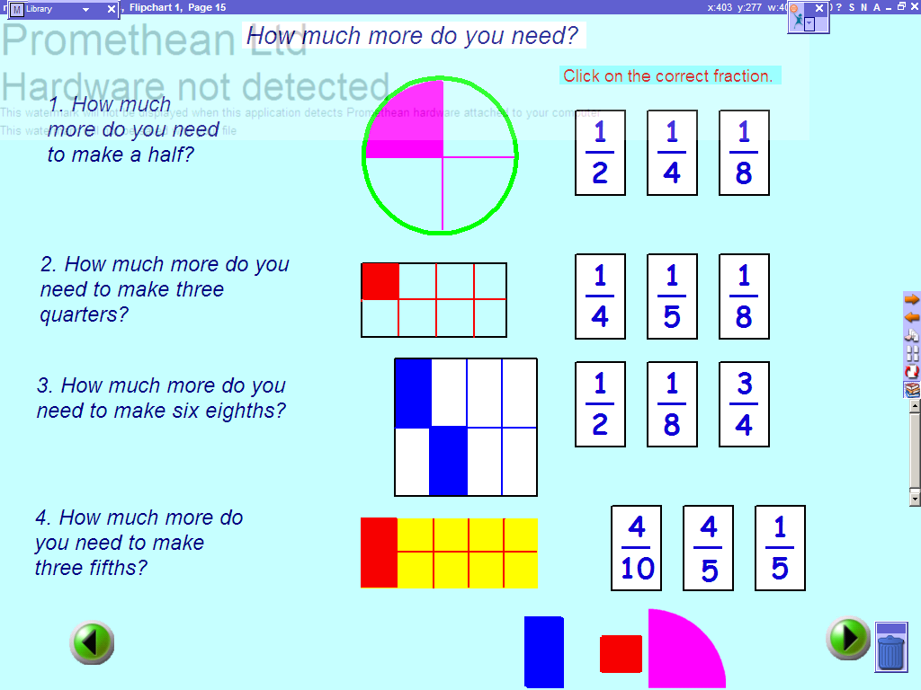 | Page 15 This page requires the children to convert the fraction into an equivalent fraction. The shapes next to the navigation buttons can be used to support their understanding. Click on the fraction cards to hear which one is correct.
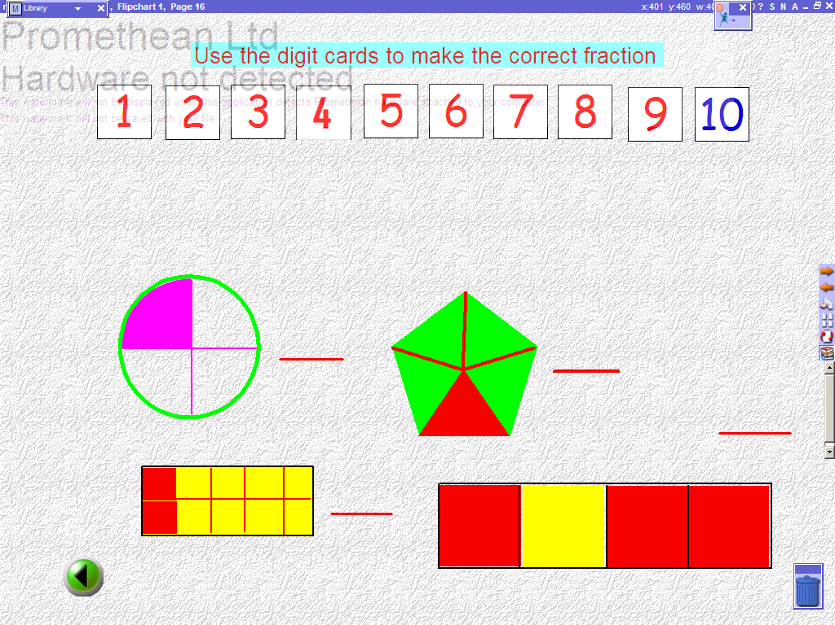 | Page 16 This page allows the children to use the digit cards to make the fraction. They can either create fractions for shaded or unshaded.

