Teacher’s Notes
Shade ‘em In
Objectives:- To use known number facts to add or subtract mentally, including any pair of two digit numbers.
Year Group Year 4
A game of strategy that involves reaching a predetermined target number by selecting groups of numbers which have the greatest difference.
The game can be played off the computer if required by printing out the activity sheets and there is the opportunity for the pupils to develop their own version by writing in their own rules.
The game has been designed in Power Point but if the full version of Power Point is not available you will need to download Power Point Reader.
Have your whiteboard software running prior to starting the Slideshow so that you can use the whiteboard pens..
Page 1 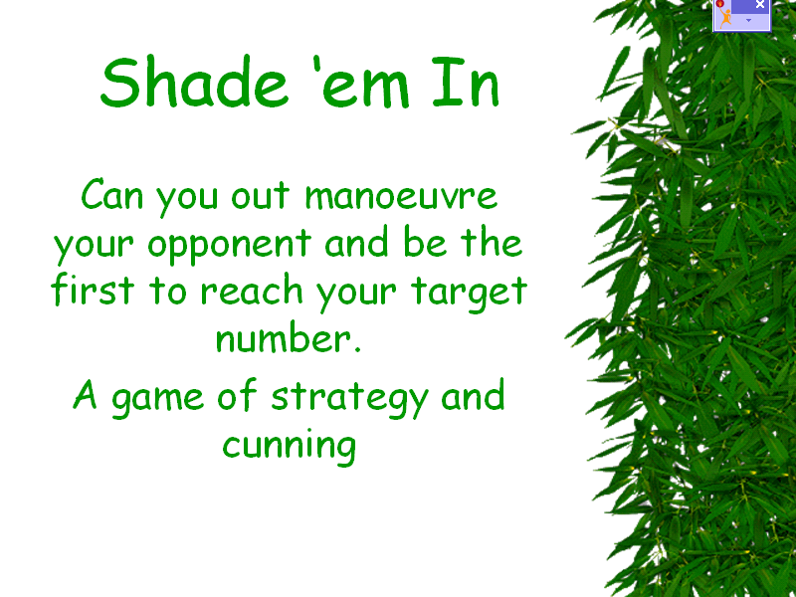 | Introduction to the activity.  Click through until this page is complete.  What do the children understand by the words ‘manoeuvre’ and ‘strategy’?  Which other games do they use a strategy for?  Why do we sometimes need to think ahead beyond the next move?
Page 2  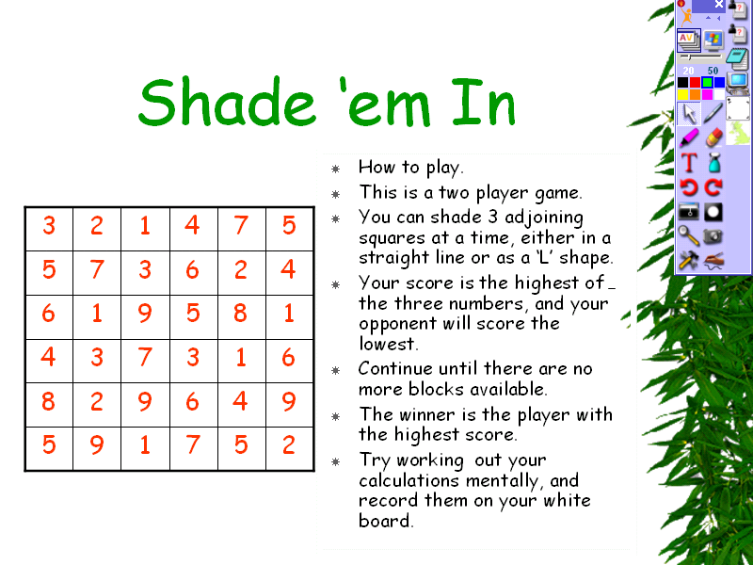 | Instruction on playing the game.  Click through all the bullet points to bring up the rules of the game.  Click on the ‘computer icon’ in the Active Studio window to run Active studio.  Select the highlighter pen and any colour other than red as the marker colour.  Demonstrate how the numbers will be shaded in.  You will have to leave Active Studio by clicking on the ‘computer’ icon to get back into Power Point.  Move onto the next page.
Page 3  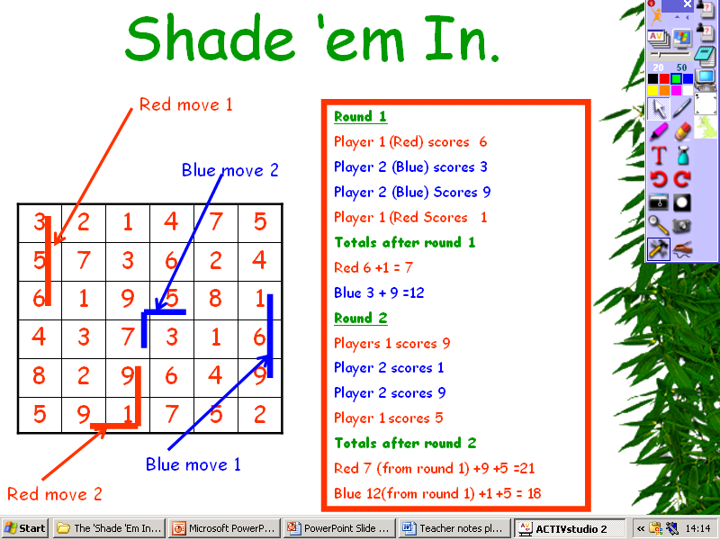 | Explanation of scoring system.  By running Active studio again you can highlight some more combination of numbers to give more examples.  Discuss any particular numbers that might be worth targeting.  Can you spot any three adjoining numbers that have the greatest differences.  You can add an element of time by selecting the countdown timer from the tools box if you wish to add a further element to the activity.
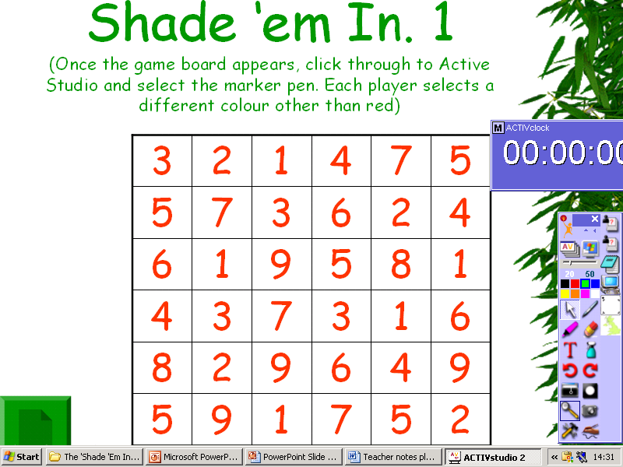 | The Game  The game can now be played interactively by clicking into Active Studio and using the whiteboard pens, or if there are not sufficient computers available a copy of the game board is available by clicking on the ‘page’ icon and printing out a sufficient number of sheets. These could be laminated as a pack containing games 1 and 2 on one side of an A4 page and games 3 on the reverse. The children can then use wipe-off marker pens so that they can replay the game.  The timer can be brought up to bring a timed element into the game for differentiation.
Page 5  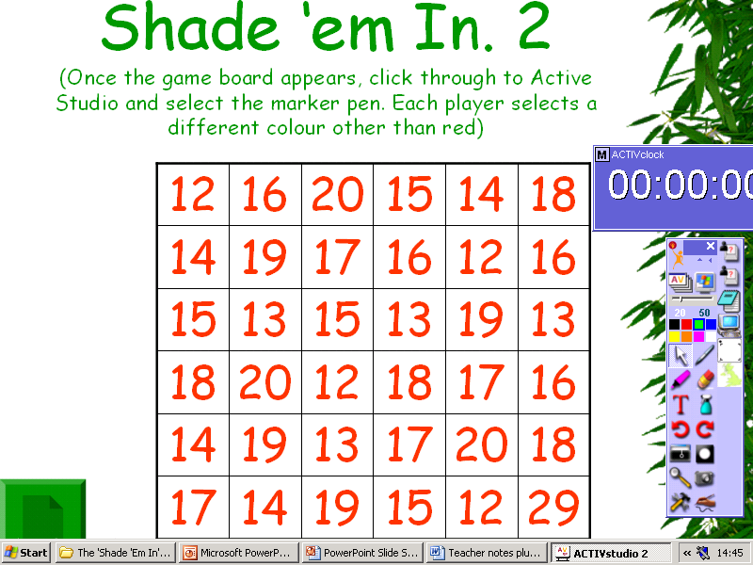 | A second game to play but with slightly larger numbers but all between 11 and 30.  You will have noticed from the first game that some of the numbers are unable to be used because they become ‘blocked’. An added rule here might be to deduct any numbers which become blocked from that players score
Page 6  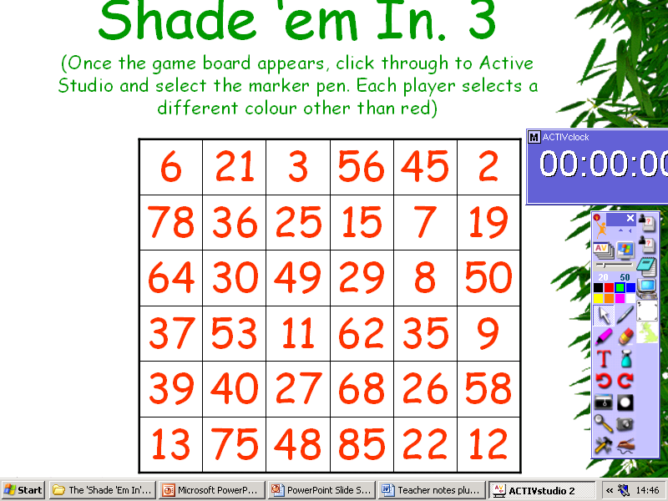 | Game 3 contains a wider range of 2 digit numbers.
Page 7  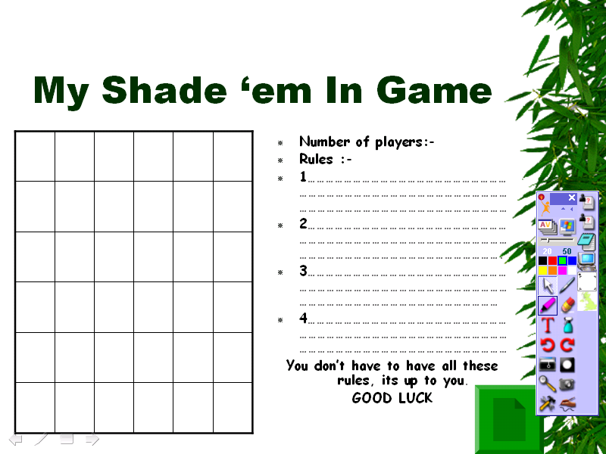 | A game board for pupils to plan out their own set of rules and to add numbers of their choice.  Suggestions might be:-  - Fractions  - Multiply your score by the middle number  - Dividing score by middle number and using the remainder as your score  - Adding/subtracting the middle number to the difference of the two outside numbers  - Overlapping groups of numbers
Page 8  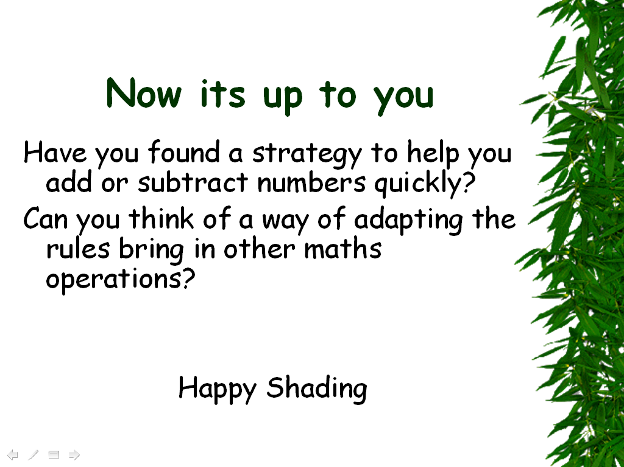 | A plenary session for the children to discuss strategies they have been using.  A time to share views on the games and an opportunity for the children to explain the games that they have developed for themselves.

