Teacher’s Notes
Symbols
Objectives:- To use symbols correctly, including less than (<), more than, (>), equals to (=) etc.
Year group:- 4
A series of activities designed in Power Point to allow children to become more familiar with the use of the symbols for more than/less than etc. plus the associated vocabulary.
You will need to run whiteboard software as well so that you can make better use of the IAWB.
All activities are also available as Word documents so the activities can be played away from the computer if required.
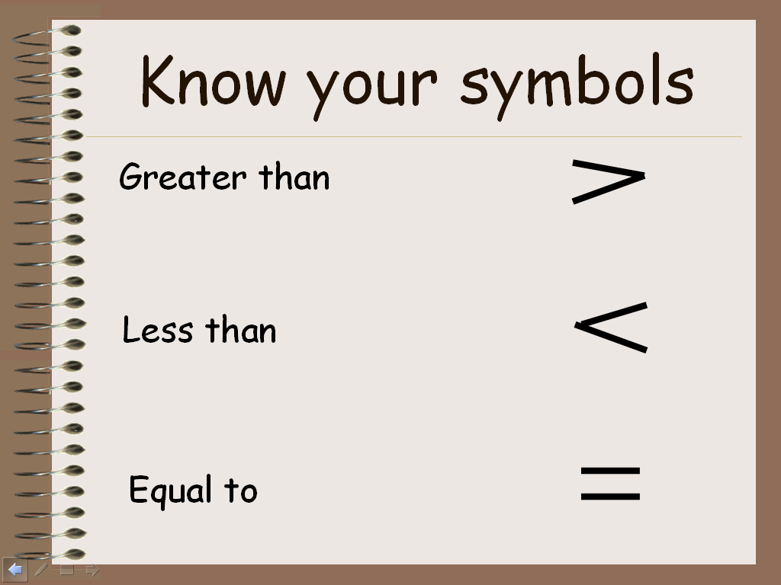 | Page 1.  The activity runs in Power Point but if you also have Whiteboard software installed you can make this page more interactive by getting the children to draw in the symbols as the definitions appear and then check them through by clicking back into Power Point.  Use this page for discussion and get the children to feed back statements based on these symbols.
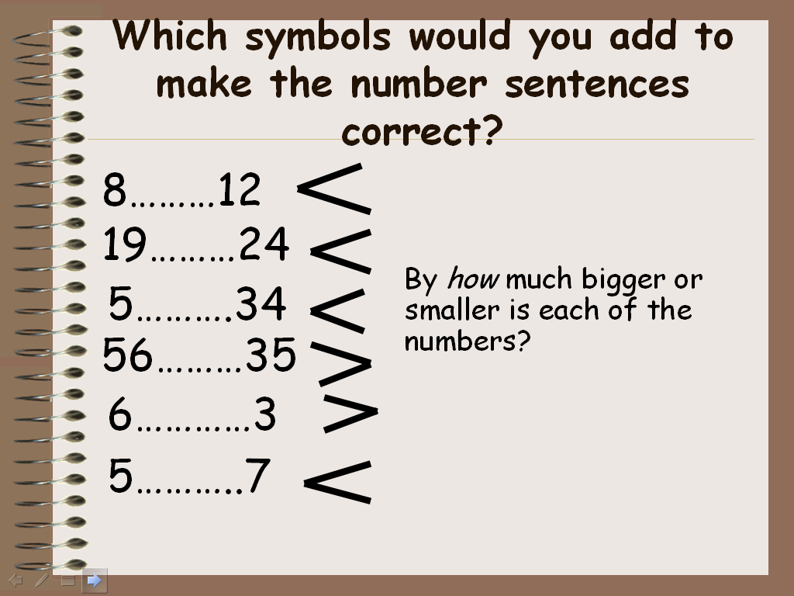 | Page 2.  A few introductory examples for the children to fill in as a whole class activity and then checking through their answers.
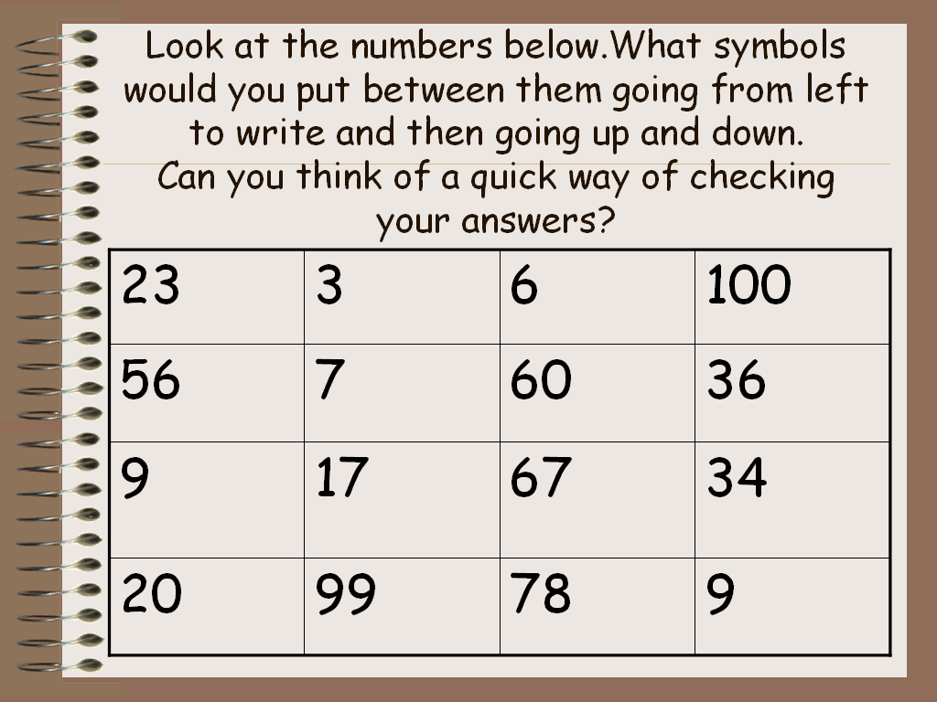 | Page 3.  This activity is also available as a ‘Word’ document so if you want to print some copies of this out the children can work off the computer on their own or in pairs.  Again it can be used on the interactive whiteboard so you can do this as a whole class activity or run it on individual machines.  Can the symbols be put in both horizontally and vertically?
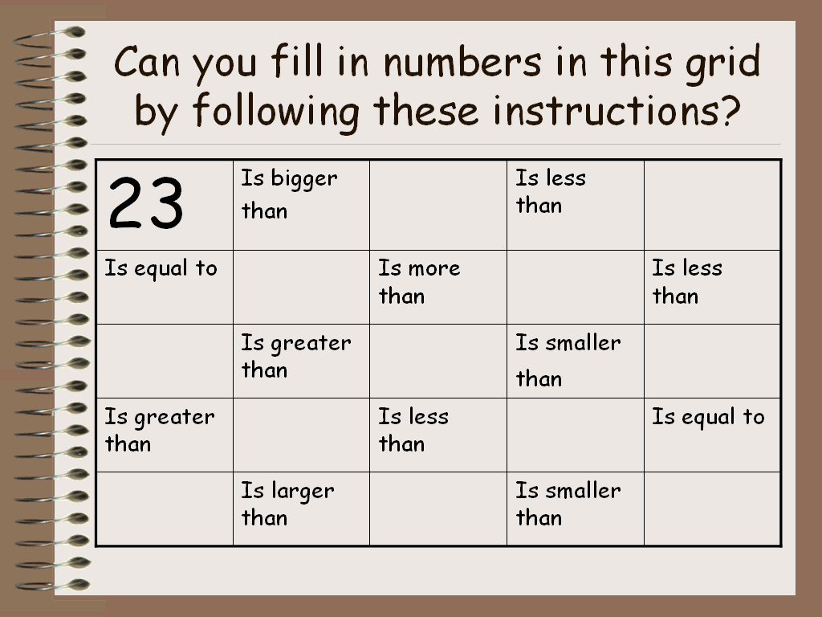 | Page 4.  This page is again available as a ‘Word’ doc.  A time to reflect on the symbols and look at the different ways they might be represented.  Can the children think of any other ways they might be represented?
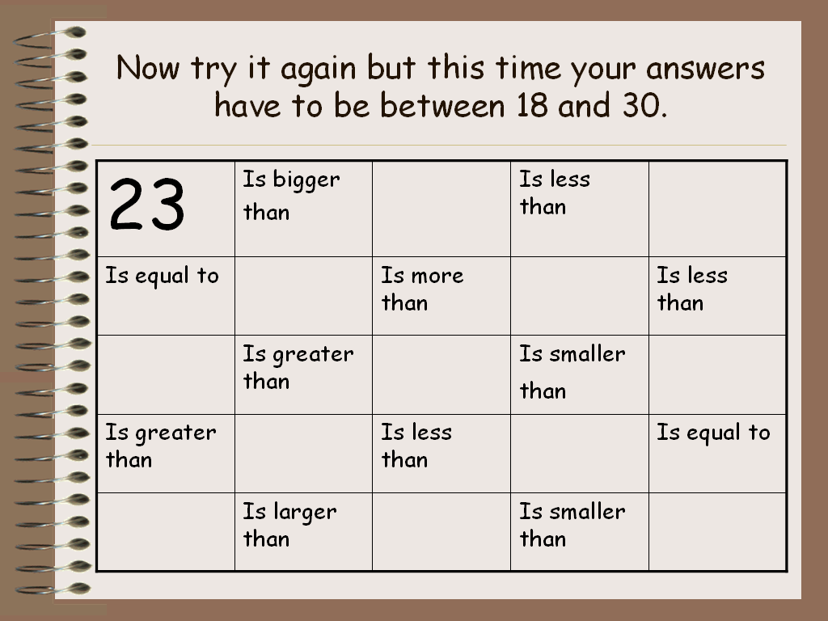 | Page 5  Similar activity to the previous page but this time limitations are in place restricting the choice of numbers that might be used. Discuss with the children what problems might occur because of these limitations. Is it possible to complete the board using only whole numbers or will fractions have to be used?
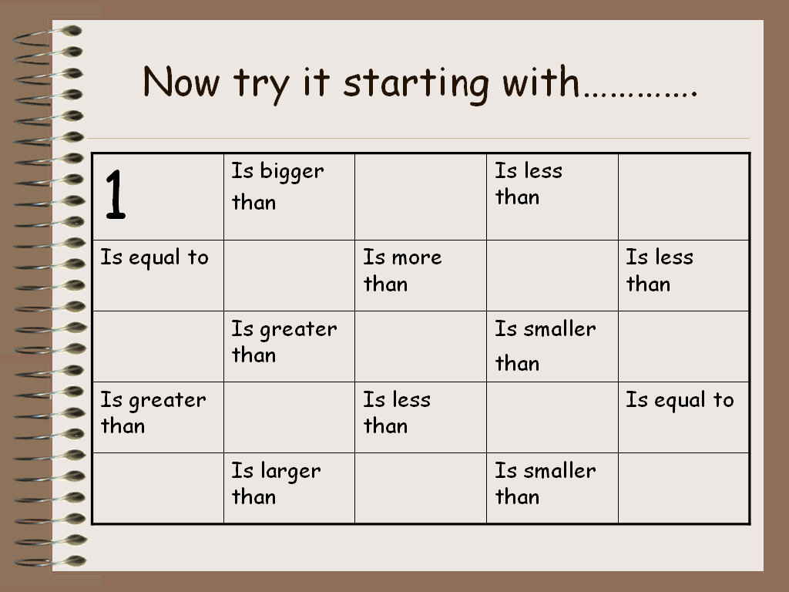 | Page 6.  Word doc available.  A particular starting number is already given. This can be altered if necessary and other numbers inserted into the grid randomly
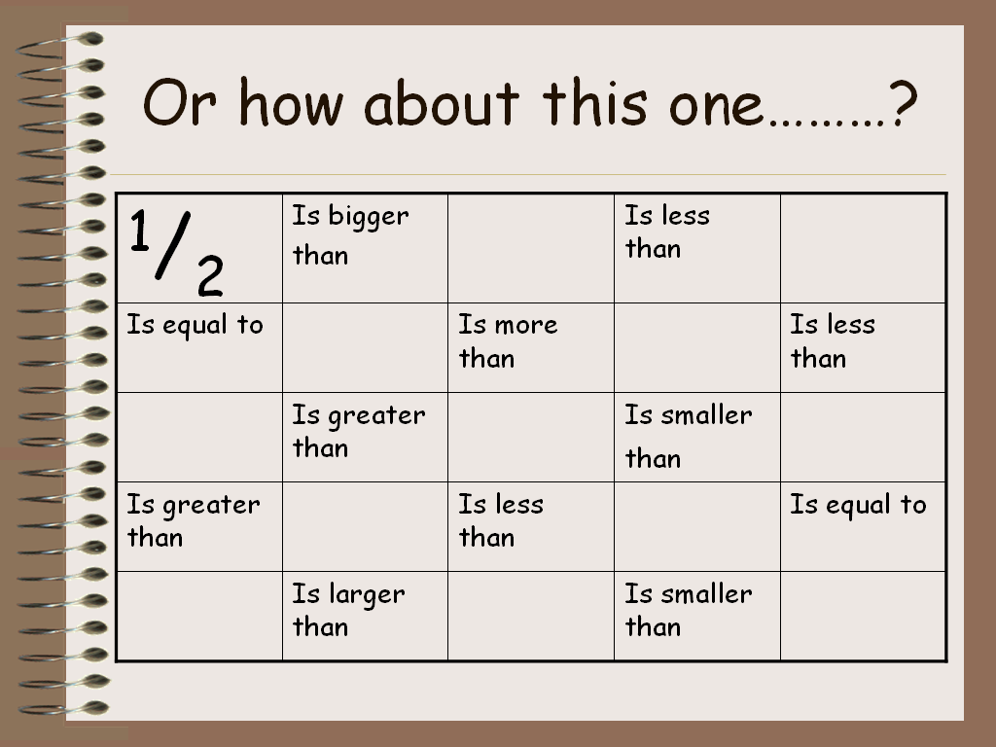 | Page 7  Re-visiting fractions.  Depending on previous work on fractions this grid can be restricted to the family of fractions the children are familiar with
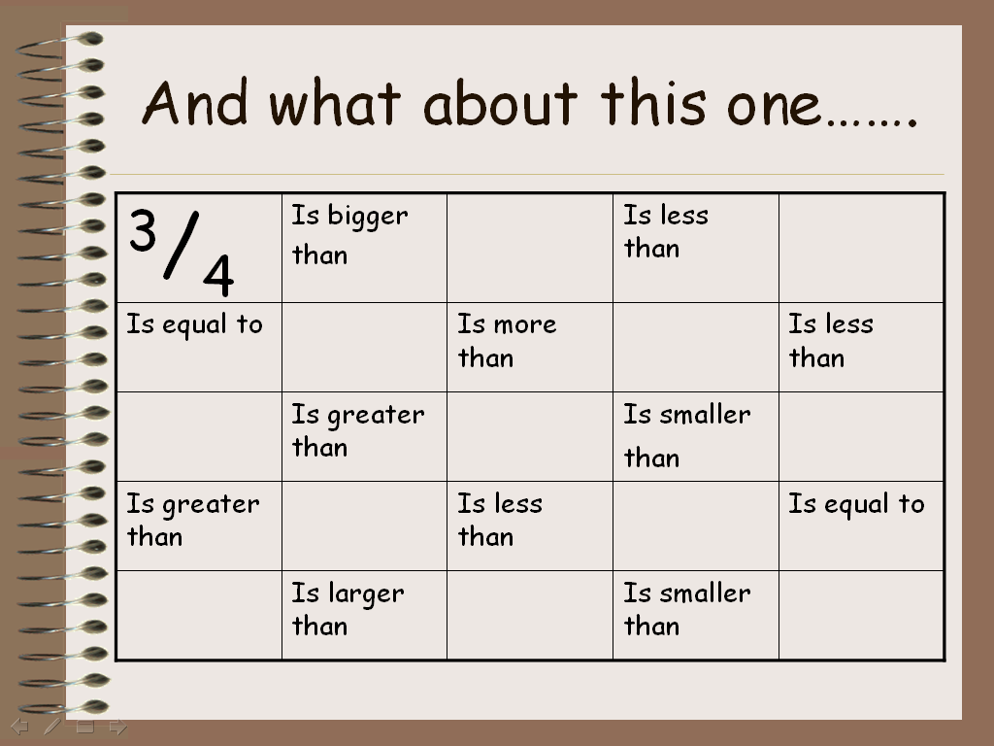 | Page 8.  The same as above.
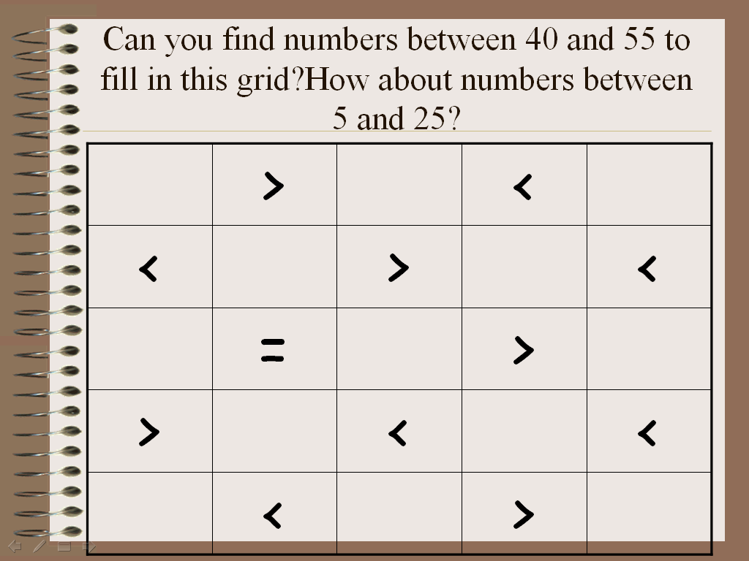 | Page 9.  Fill in the missing numbers. The range of numbers can be agreed before the activity.
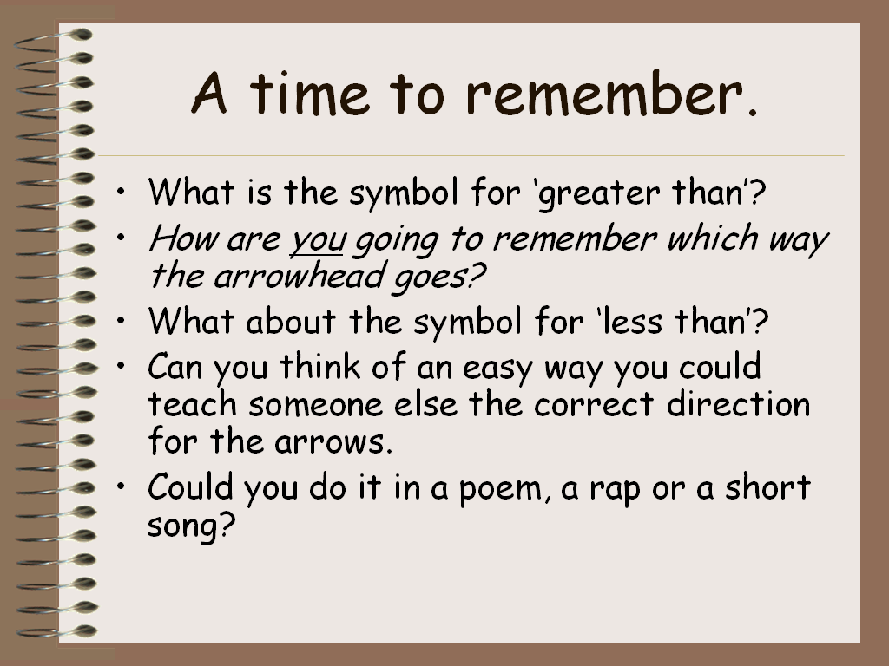 | Page 10  Plenary session.  Time to discuss what the children have learnt and how they are going to remember which way the symbols point. Are there any particular ways which make it easier for the children to remember.  Can these ideas be put into limericks, raps, poems, songs.

