Multiplication Tables.
Key Objective: Know by heart facts for the 2, 3, 4, 5 and 10 multiplication tables
Year 5.
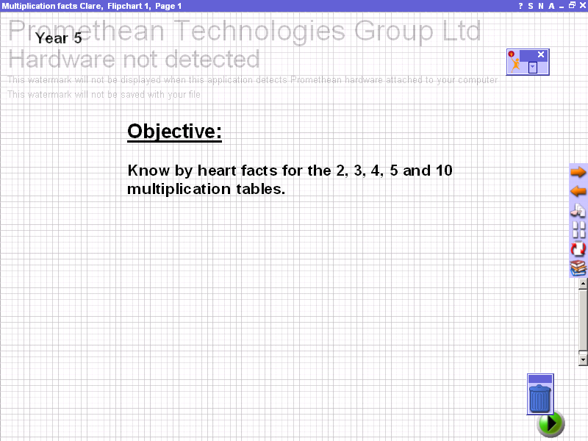 | Page 1: Title page and objective.
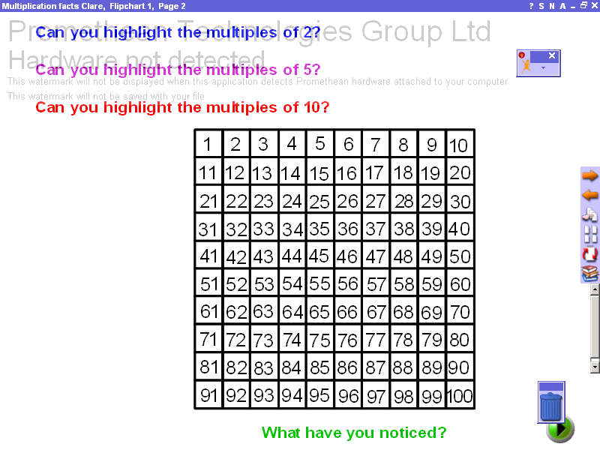 | Page 2: Highlight the multiples of 2, 5 and 10.  Click the highlighter tool for this page, but a different size and colour to highlight the different multiples, try to use the following:  2 = size 51 and yellow  5 = size 39 and orange  10 = size 31 and green
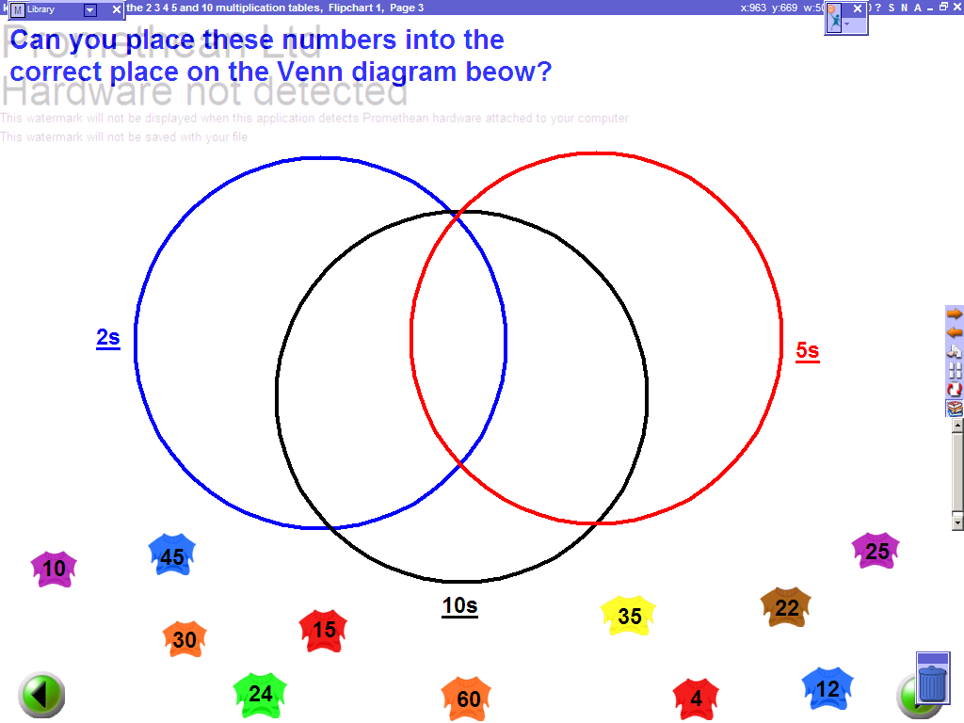 | Page 3: Sort the multiples of 2, 5 and 10 using a Venn diagram.  Click the marquee select tool for this page. Click, drag and drop the numbers into the correct section of the Venn diagram.
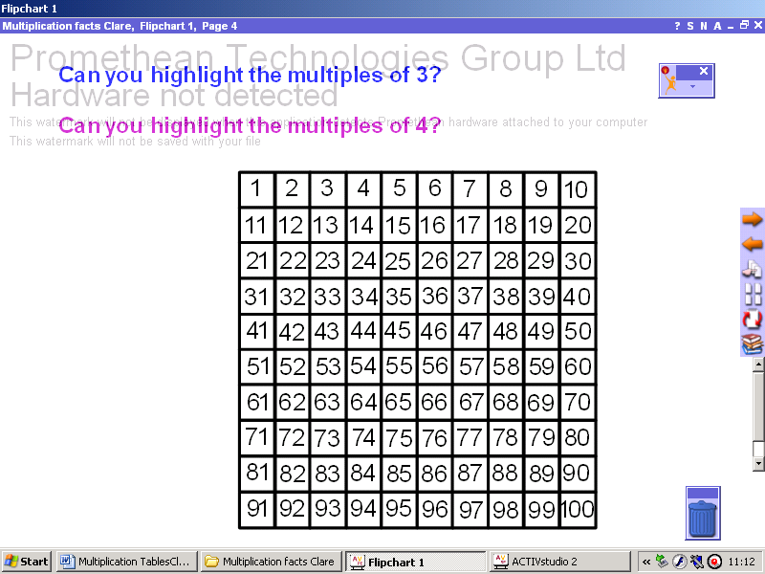 | Page 4: Highlight the multiples of 3 and 4.  Click the highlighter tool for this page, but a different size and colour to highlight the different multiples, try to use the following:  3 = size 51 and yellow  4 = size 39 and orange
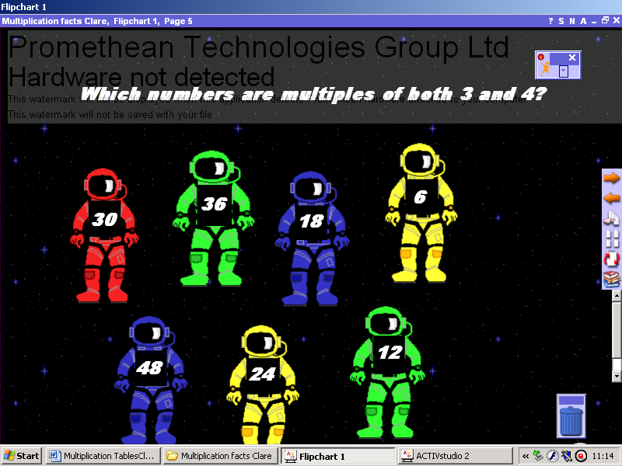 | Page 5: ‘Spaceman Quiz’. Identify numbers that are multiples of both 3 and 4.  Click the marquee select tool for this page. Click onto a number, if correct it will take you to a page saying correct, if incorrect it will take you to a page saying incorrect; both pages have an arrow button on the page to return to ‘Spaceman Quiz’.
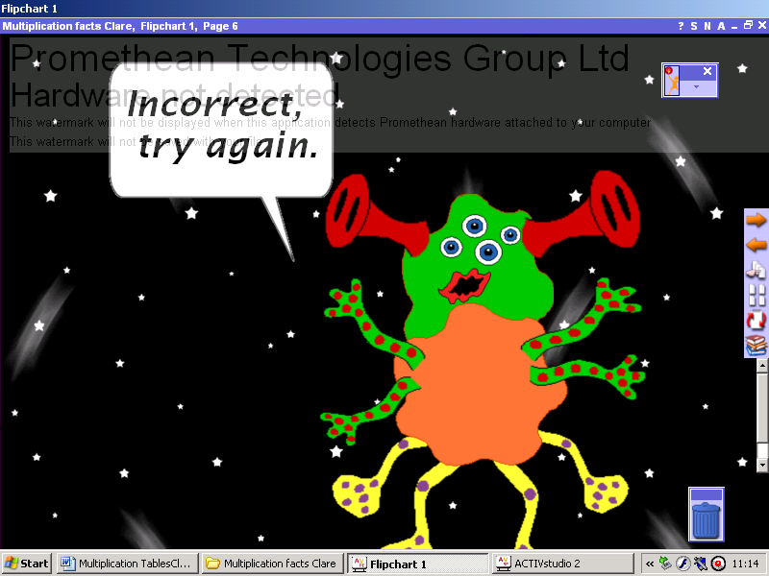 | Page 6: ‘Spaceman Quiz’ Incorrect page.  Only use this page with the ‘Spaceman Quiz’
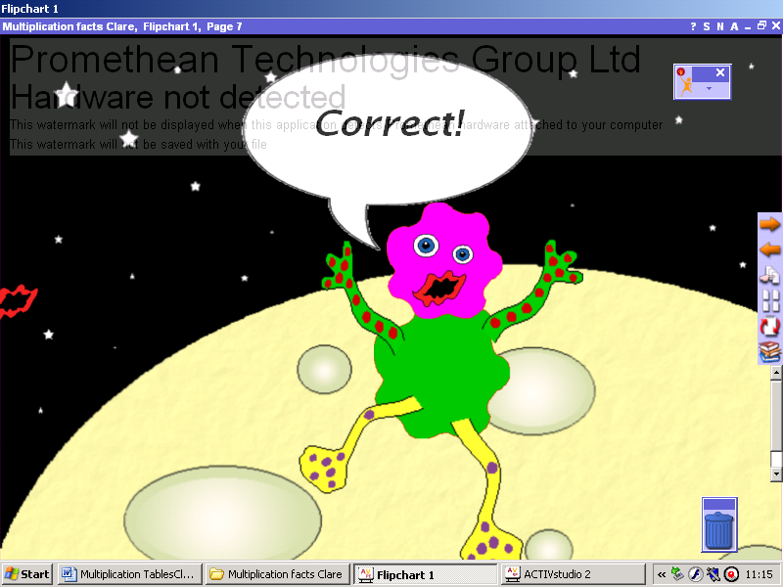 | Page 7: ‘Spaceman Quiz’ Correct page.  Only use this page with the ‘Spaceman Quiz’
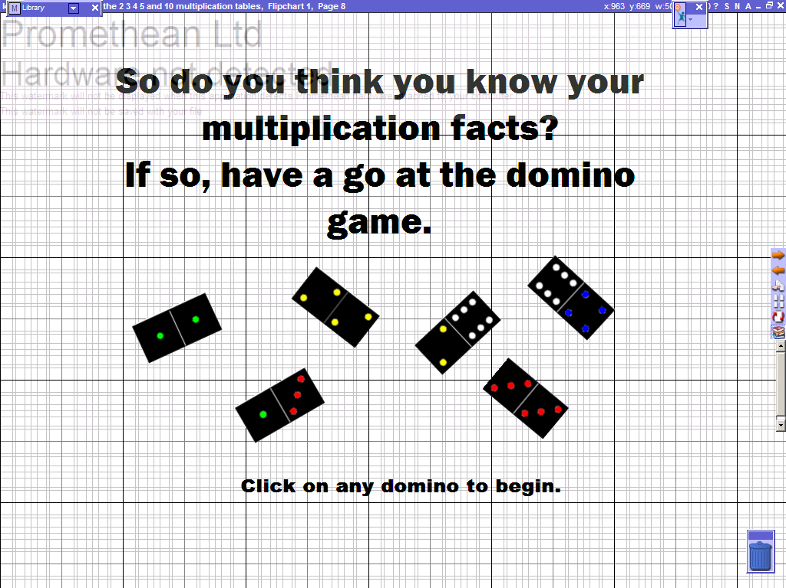 | Page 8: Dominoes, to identify multiplication facts of 2, 3, 4, 5 and 10.  Click on any of the dominoes to begin the game. Click and drag dominoes to position them. Don’t worry if you can’t complete the game, just exit and then start a new game, but this time beginning with a different domino.

