Teacher Notes -Rounding
Objective:
Y4: Round any positive integer less than 1000 to the nearest 10 or 100.
Overview of the lesson:
To enable the children to see rounding to the nearest 10, 100, integer using whole numbers. The children get a chance to see it visually, to practice and then to play interactive quiz games to reinforce and consolidate.
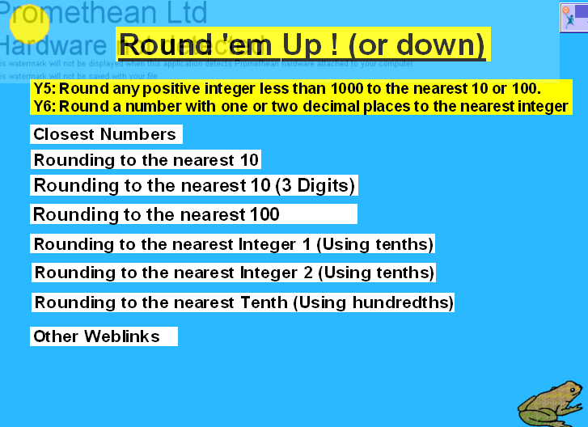 | The Home page has links to all the other pages. Each page is hyperlinked:  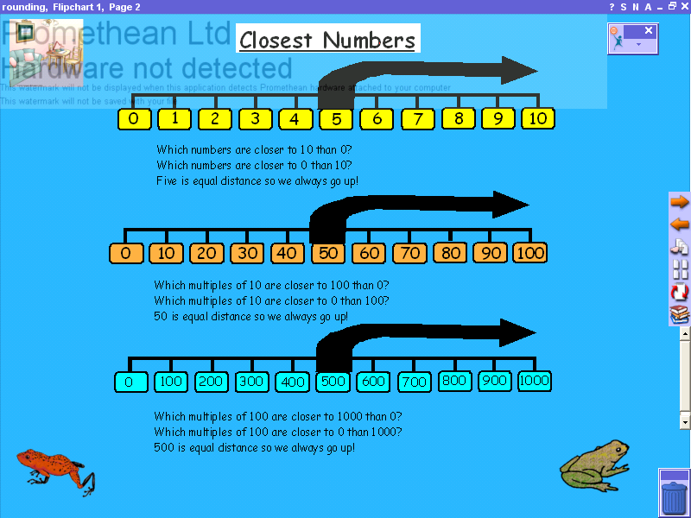  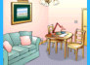  Forward to the next page  To the Home page.  Back to the previous page
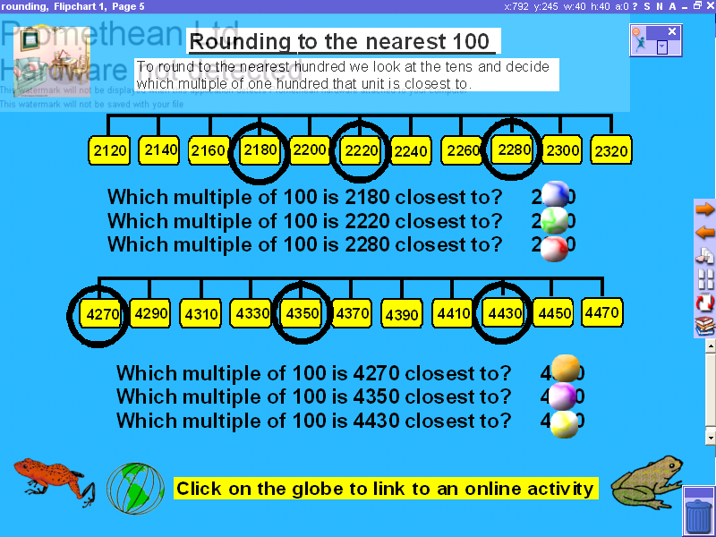 | Pages 2 to 5 Rouning using Whole Numbers.  Work through the questions on screen, explaining the working out. Then drag the balls away to reveal the answers to the example questions.  Once the concept has been explained and practiced, the children can attempt a spreadsheet activity that can downloaded from http://www.numeracysoftware.com/Roundit.XLS
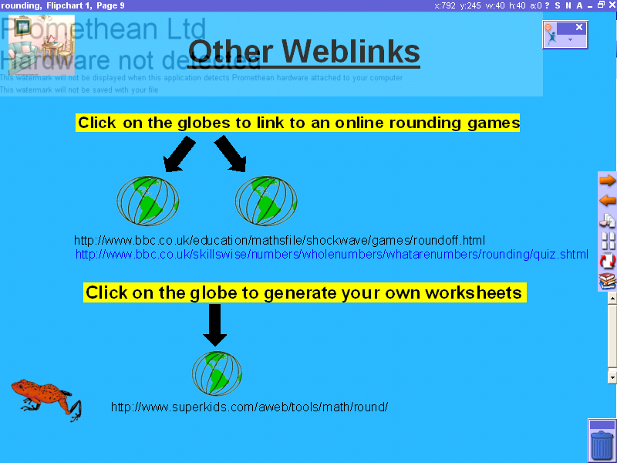  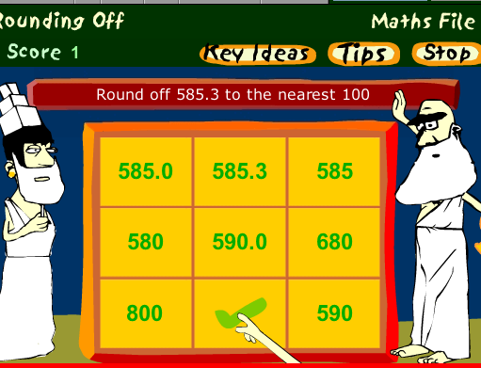 | Page 9 Other Weblinks.  Type these addresses to get to the pages if the hyperlinks don’t work.  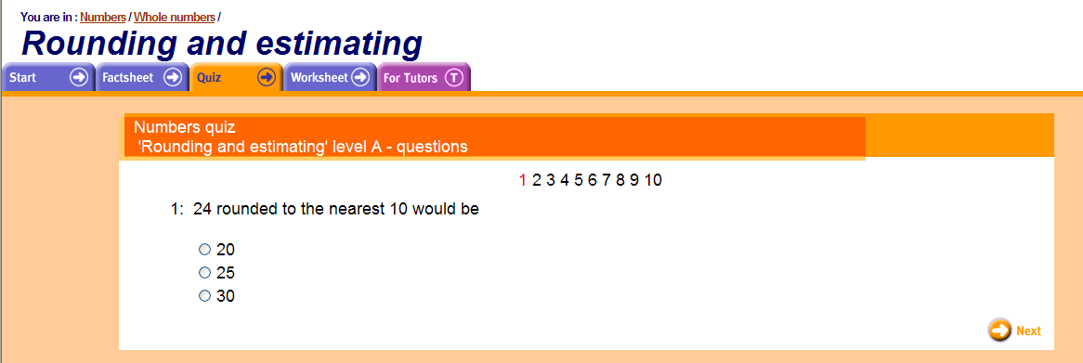  www.bbc.co.uk/skillswise/numbers/wholenumbers/whatarenumbers/rounding/quiz.shtml  www.bbc.co.uk/education/mathsfile/shockwave/games/roundoff.html  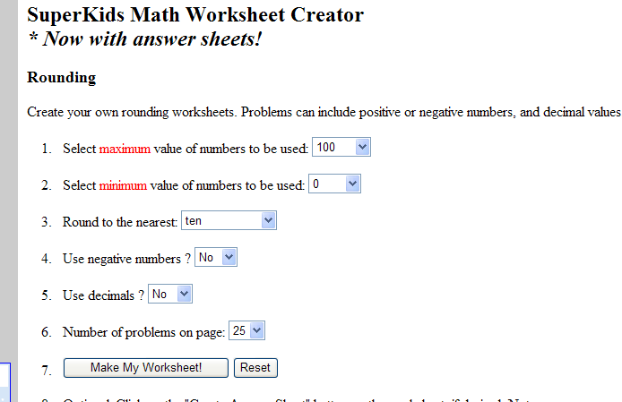  This website produces worksheets for you:  www.superkids.com/aweb/tools/math/round/

