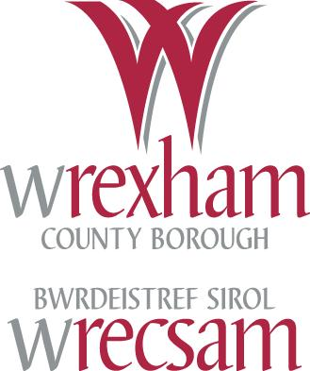
SUMS UP!

Year 5 KO Reference j

Classify polygons, using criteria such as number of right angles, whether or not they are regular, symmetry properties.

10. Tick the shapes that have the same number of lines of symmetry.

22. Which of these shapes is NOT a regular figure?

Key Words
Polygons, Shape/s, right angles, symmetrical, symmetry, regular, irregular, properties, sides, edges, faces, corners, triangle, quadrilateral, pentagon, hexagon, octagon.

Key Questions
Show me a regular polygon. How do you know it is regular? What do you look for?

Practical Activities
- Practical activities relating to shape/classifying etc.
- Use of pictures of polygons. Discuss the: name of the polygon, number of sides, number of angles, number of corners etc.
- Sorting shapes, for example Triangle Sort (sort the triangles into Equilaterals, Isosceles, Right or Other)
- Have a shape quiz, with questions such as; What is the name of a five-sided polygon? What is special about regular polygons? Which triangle has 2 equal sides and 2 equal angles?
- Revise – symmetry and angles. Introduce a protractor (angle measurer) – practice drawing angles of different sizes.
- Use of Roamer to turn angles.
- Challenge – draw shapes to given sizes, for example a square with sides of 2cm or an equilateral triangle with sides of 3cm or a right-angled triangle with two sides of 4cm.
- Using geoboards/plasticboards: to make 2D shapes/pictures.

Written Activities Quadrilaterals Not quadrilaterals
Worksheet to name/describe different shapes.
Regular
Not regular
Worksheet to practice drawing angles.
Worksheet on symmetry.
2-way table
Worksheet on Carroll Diagrams/2-way tables or Venn Diagrams.
Shapes need to be provided
(e.g. square, rectangle, semi-circle, triangles, hexagon, pentagon, octagon etc).
Regular
Quadrilateral
Venn Diagram

Optional Assessment Material (2006)

Activity 7 : ‘Windows and doors’

Pupil Sheets 1-4

IT
http://www.bbc.co.uk/schools/revisewise/maths/shape/
http://www.primarygames.co.uk/
Maths Pack 1: Reflect Primary Games Vol 4: Reflect-a-Sketch & Symmetrical Patterns
Maths Pack 3: Sketch and Reflect (Polygon)/ (Line) (Quadrants), Create a Tile & Polygon
Maths Pack 2 Geo Boards etc
http://www.tlfe.org.uk/promethean/ks2/flipchartsks2numeracy.htm
http://www.primaryresources.co.uk/maths/mathsE3.htm
http://www.primaryresources.co.uk/online/symmetry.swf
http://www.crick.northants.sch.uk/assets/Flash%20Studio/cfsmaths/quad/quad.html
http://www.crick.northants.sch.uk/assets/Flash%20Studio/cfsmaths/Symm/Symm.html
http://www.crick.northants.sch.uk/assets/Flash%20Studio/cfsmaths/Triangles/triangles.swf

DfES Progression Map
http://www.standards.dfes.gov.uk/progressionmaps/maths/shape_and_space/sec_ma_prgrsn_sas_sas_s2.htm

NNS ITP : ‘Area’ and ‘Polygon’

Games
Shape Snap, Shape Dominoes, Shape Bingo.
‘Shape up’ & ‘Up the Ladder’ from the Wrexham “Games & Activities to Enhance Maths” pack.

Home activities/Homework
Everyday activities to develop knowledge about shape.

