Teacher Notes -Powerlines
Objective: Year: 5 Choose and use appropriate number operations and ways of calculating (mental, mental with jottings, pencil and paper) to solve problems.

Overview of the lesson:
To enable the children to use and apply their mathematical knowledge and find different ways of making a whole number. The numbers overlap so the children will have to think hard to find numbers that work together to make the total whilst looking for the linking numbers which will appear in 2 or more lines. Looks easy but it isn’t!
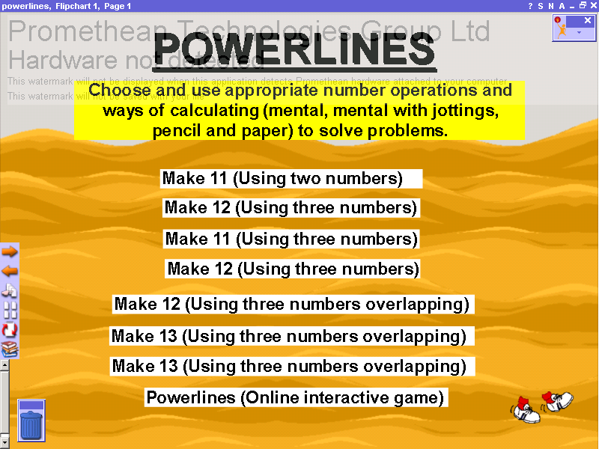 | The Home page has links to all the other pages. Each page is hyperlinked:  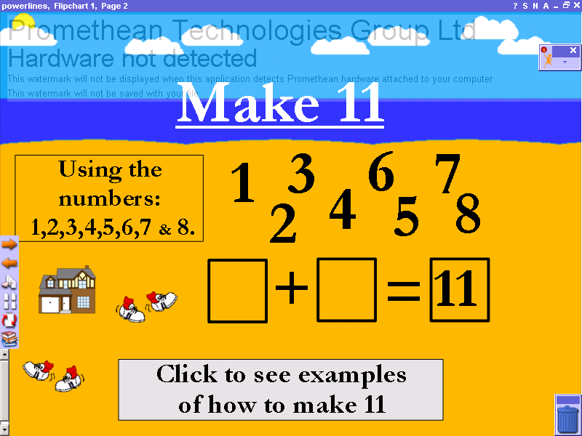  Forward to the next page  To the Home page.  Back to the previous page
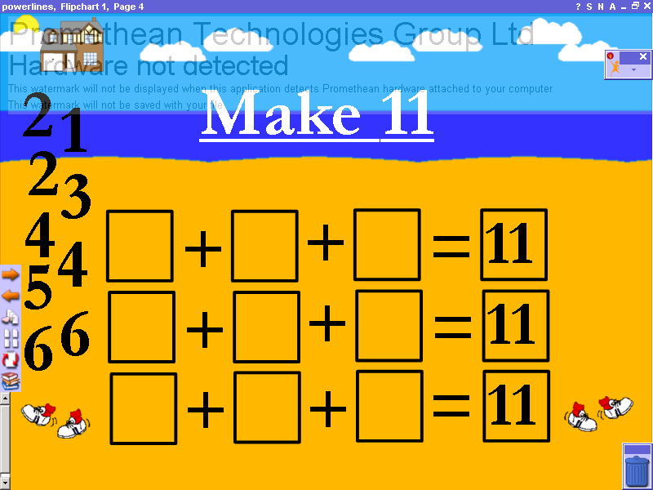  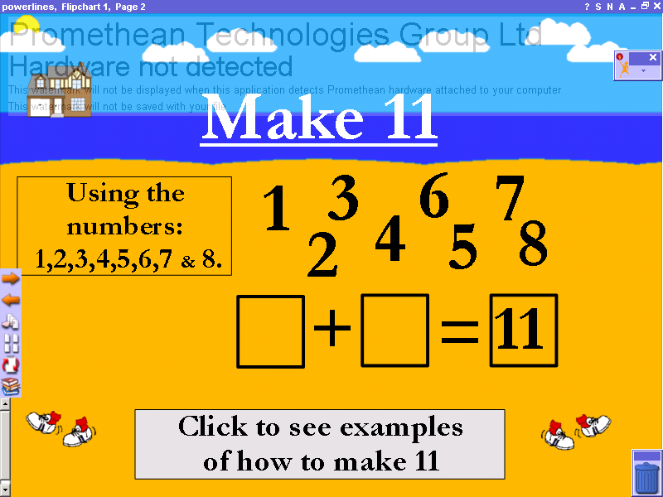 | Pages 2 to 5 allow the children to use two and three different number combinations to make a total of 11 and 12.  The children can work out their answers, giving all possible ways on their individual whiteboards and then a child can drag in the numbers on the interactive board to explain to the class how they worked it out.  When there are three rows of questions the children must use all the numbers on the left hand side to fill in the boxes.  On page 2 there is a hyperlink to a PowerPoint presentation ‘What Makes 11?’ which shows different ways to make 11 (This is a visual aid to reinforce number bonds).  See below
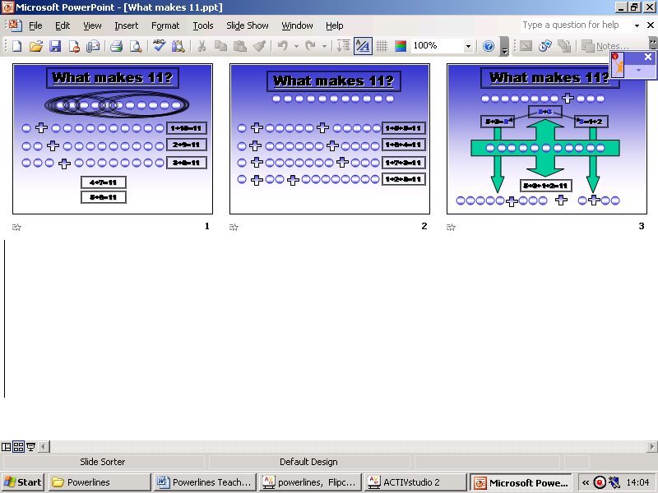 | PowerPoint presentation ‘What Makes 11?’-  Press F5 button on your keyboard or click on the toolbar ‘Slide Show’ then ‘View Show’.  The pages will progress through the slides automatically. A click on the advance button is needed to go from slide to slide.  To exit the slide show press Esc button on keyboard.
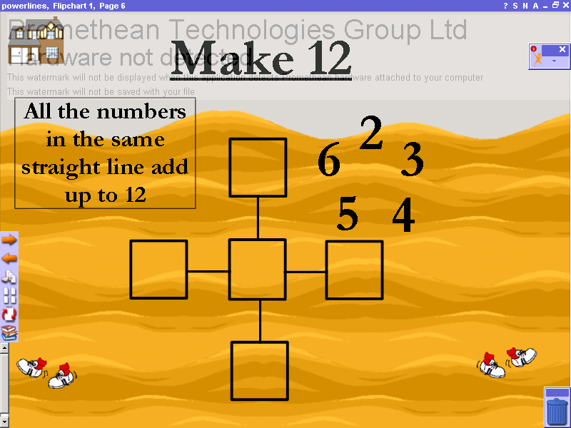 | Pages 6-8 are designed to introduce the children to linking sets of numbers, which make a total together using a common ‘link number’. The totals of each line must add up to the specified total.  Again the children can attempt the problem on their individual whiteboards and then a child can drag in the numbers on the interactive board to explain to the class how they worked it out.
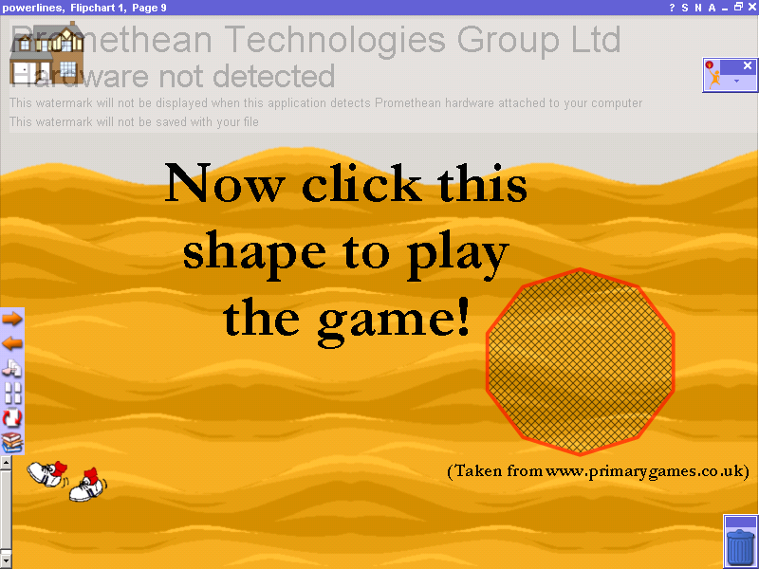  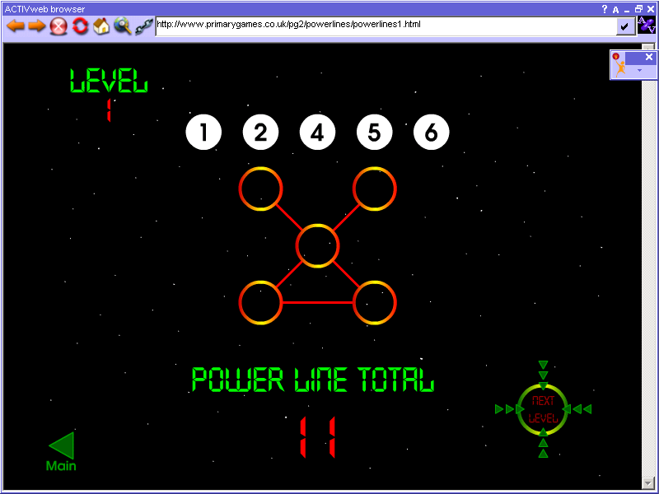 | Page 9 is a hyperlink to Phase One of an online interactive game of ‘Powerlines’ on the www.primarygames.co.uk website.  Use interactive board software/individual whiteboards for the children to explain and show their working as they play the game.

