Teacher Notes –Treasure Trail
Objective: Year: 6
Identify and use appropriate operations (including multiple operations) to solve simple word problems.

Overview of the lesson:
To answer a variety of questions correctly and progress through the game getting closer and closer to the treasure. If 10 consecutive questions are answered correctly the treasure is won. You may well want to offer a reward to go along with the games treasure of ‘solving problems brilliantly and improving your Maths brain!’
The game runs in PowerPoint and you can also run ACTIVstudio/SMART software alongside to allow teacher/children to work out and show their strategies (as requested in the game and the objective).
The game is also designed so that the children can work out their answers on paper/individual whiteboards to play along and to aid them in ‘explaining methods and reasoning.’
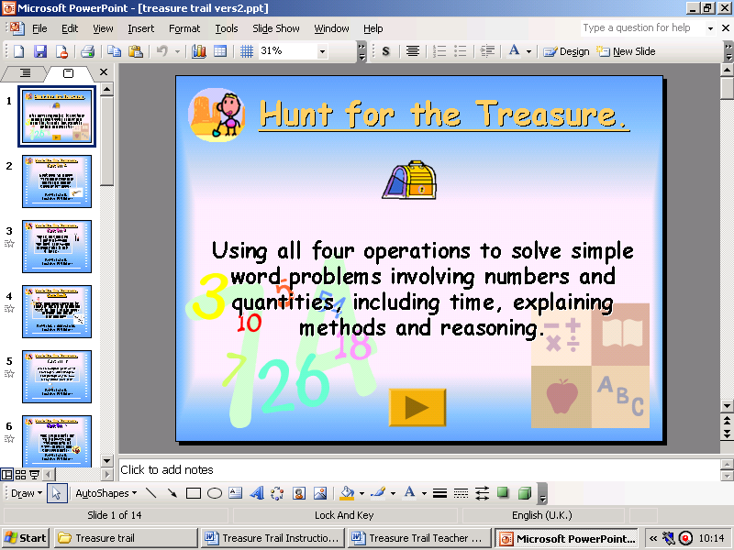 | The Home page The game begins with a welcome screen with the lesson objective. It also ends with the same slide to remind the children what they have been doing.  Click advance forward arrow on screen to progress to next slide.
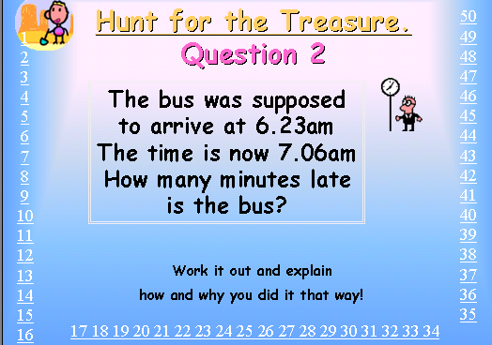 | The question slides will appear after a short time and the children are then encouraged to think and work out and explain their answer. After a designated time (teacher led) a child/teacher can then click on the number they think represents the answer.  The numbers around the edge of the slide are hyperlinked to either the ‘wrong answer’ slide or, if correct, will progress the game to the next question
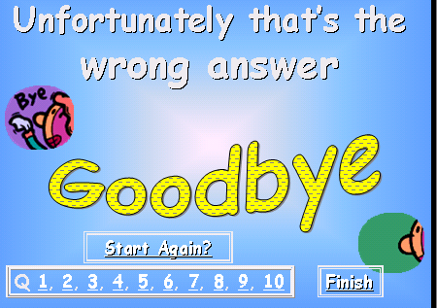 | On the wrong answer slide their is an option to go back to any of the questions by clicking on the hyperlinked numbers at the bottom of the slide which represent the question numbers.  ‘Start again’ will start the game back at the opening slide.  ‘Finish’ will take you to the end slide.
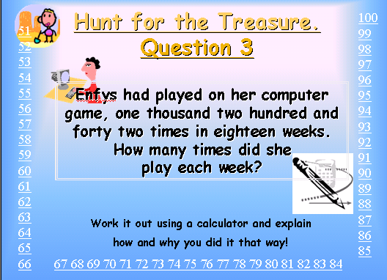 | Using a calculator:  On questions 3, and 6 using a calculator is encouraged.  Of course this is optional, especially if you are attempting to improve their long division skills for example.
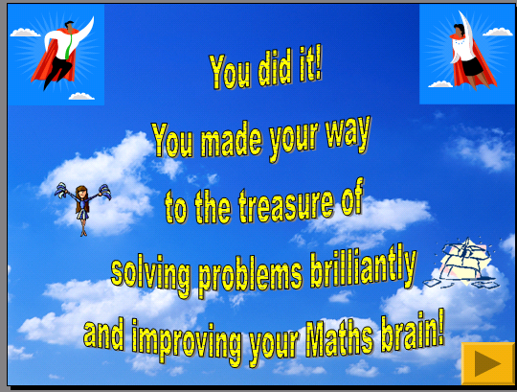 | If all questions are answered correctly the congratulations slide appears.  To end with the original objective slide click advance forward button. | Answers:  Q1) 50p x 8 = £4.  Q2) 6.23am to 7.06am = 43 mins.  Q3) 1242 ÷ 18 = 69.  Q4) 150 – 87 – 25 = 38 or 150 – (87+25) = 38 envelopes.  Q5) 13:47 to 14.32 = 45 mins.  Q6) 1053 ÷ 27 = 39.  Q7) 10.20am + 23mins for assembly = 10.43am when playtime starts.  10.43am to 11.08am = 25 mins.  Q8) ¼ litre = 3tomatoes therefore 1 litre = 12tomatoes. 36 ÷ 12 = 4 litres.  Q9) 414 ÷ 18 = 23 mins.  Q10) 138 – 3 = 135. 135 – 87 = 48 more lambs.

