Teacher Notes -Rounding
Objective:
Y5: Round a number with one or two decimal places to the nearest integer.

Overview of the lesson:
To enable the children to see rounding to the nearest integer using decimals. The children get a chance to see it visually, to practice and then to play interactive quiz games to reinforce and consolidate.
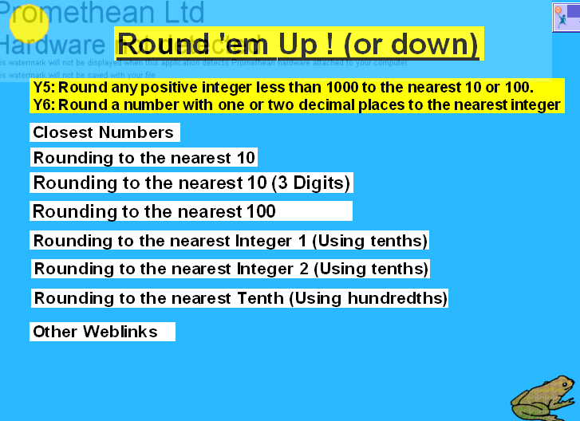 | The Home page has links to all the other pages. Each page is hyperlinked:  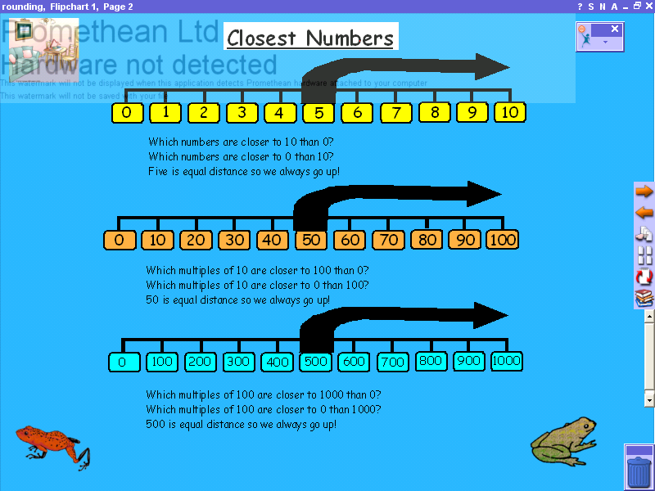  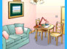  Forward to the next page  To the Home page.  Back to the previous page
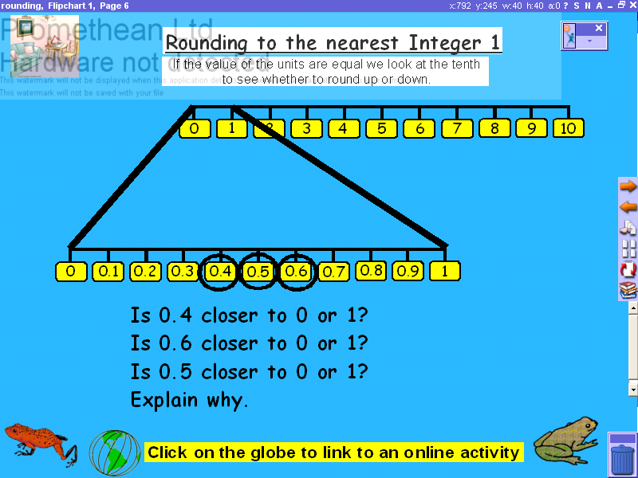 | Pages 2 to 4 Rounding Using Decimals.  Rounding to the nearest integer. To show the decimal fractions between the whole numbers. Children can practise their knowledge using online activities at http://www.quia.com/jg/66061.html
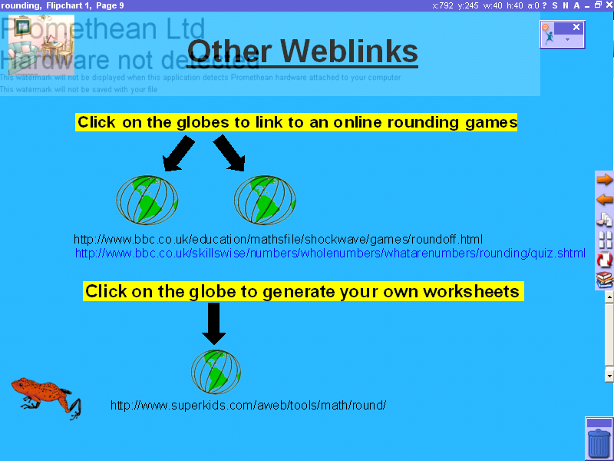  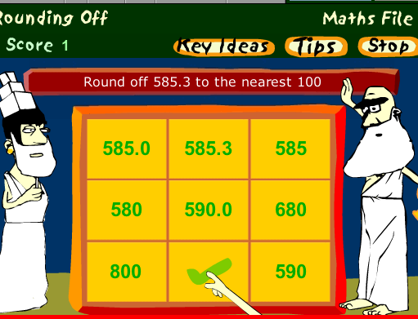 | Page 5 Other Weblinks.  Type these addresses to get to the pages if the hyperlinks don’t work.  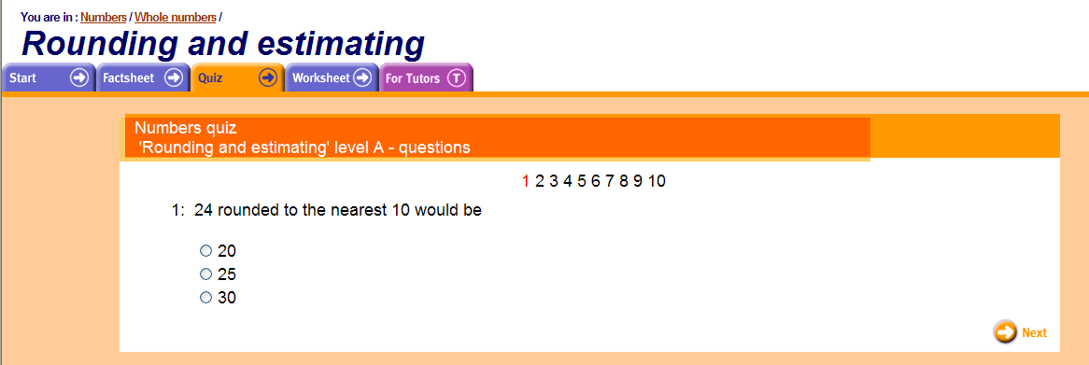  www.bbc.co.uk/skillswise/numbers/wholenumbers/whatarenumbers/rounding/quiz.shtml  www.bbc.co.uk/education/mathsfile/shockwave/games/roundoff.html  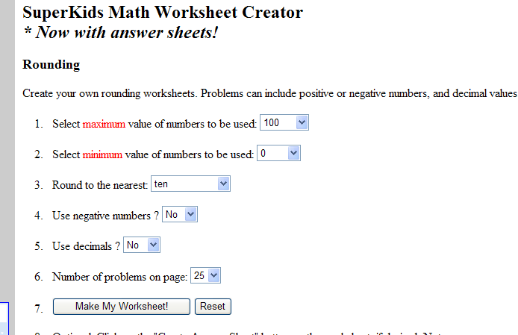  This website produces worksheets for you:  www.superkids.com/aweb/tools/math/round/

