Year 5: To order a given set of positive and negative integers.
Objective: To order a given set of positive and negative integers. There is the opportunity for differentiation by both activity and outcome.
 | Page 1:Title page and objectives.
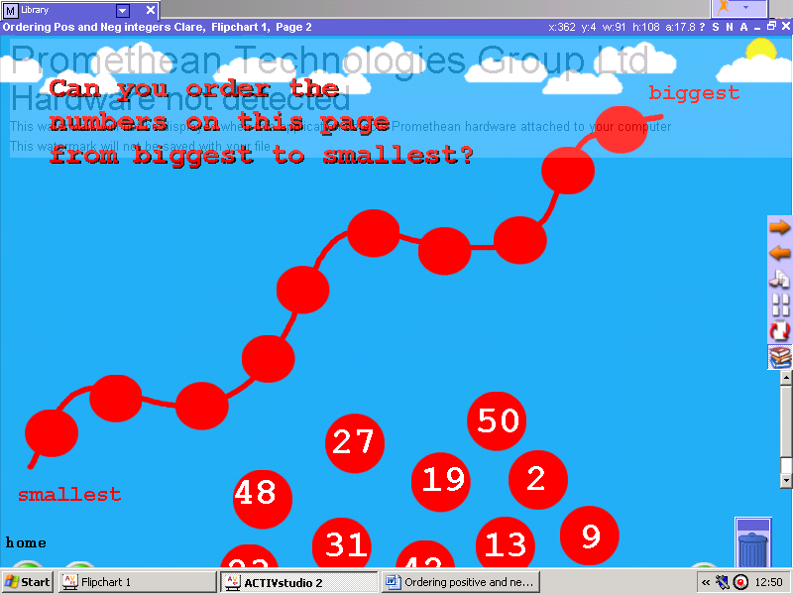 | Page 2: To order positive whole numbers from biggest to smallest. Click the marquee select tool for this page. Click, drag and drop the numbers into the correct place on the number line.
 | Page 3: To order positive whole numbers from biggest to smallest. Click the marquee select tool for this page. Uncover the numbers behind the faces by clicking and dragging. Then click, drag and drop the numbers in the correct place on the number line. Opportunity for discussion about the careful placement of numbers as all the numbers are not in view at the beginning.
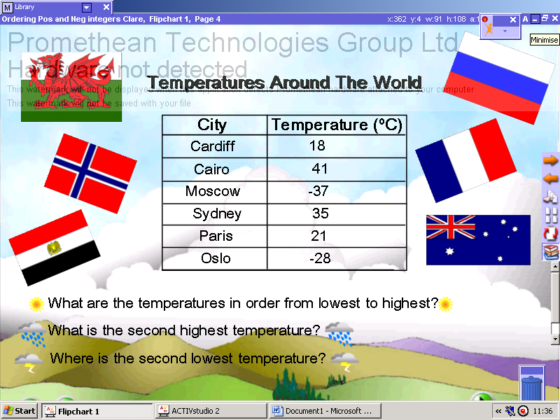 | Page 4: Ordering positive and negative whole numbers in reference to temperatures. Discuss the different temperatures around the world, highlighting the hottest and coldest places.
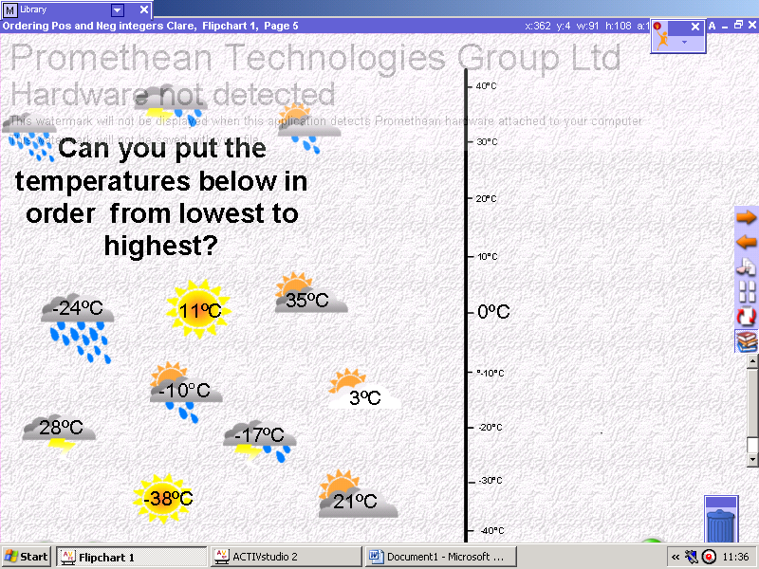 | Page 5: Ordering positive and negative whole numbers in reference to temperatures. Discuss the number line. Click the marquee select tool for this page. Click, drag and drop the numbers into the correct position on the number line.
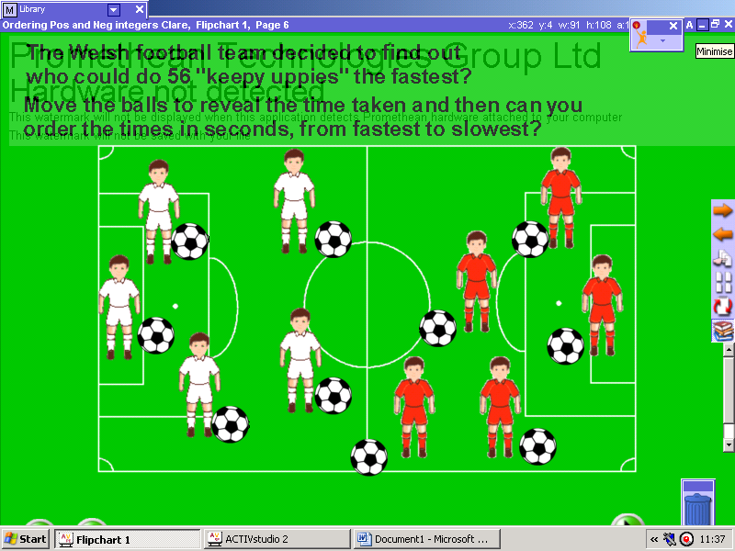 | Page 6: Ordering positive numbers with reference to time. Click the marquee select tool for this page. Click and drag the footballers so that they are ordered across the bottom of the page from slowest to fastest.

