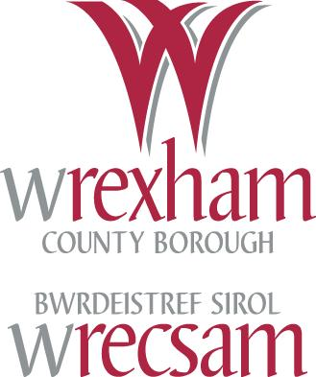
SUMS UP!

Year 6 KO Reference Sheet d

Round a number with one or two decimal places to the nearest integer.

4. What is the nearest whole number to 8.6?

19. Write 36.74 the nearest whole number.

Key Words
Round, number, rounding up/down, one/two decimal places, tenths, hundredths, nearest whole number.

Key Questions
What numbers, to one decimal place, could round to 6? What is the largest such number? What is the smallest?
What instructions would you give someone to help them to round amounts of money to the nearest pound?

Practical Activities
- Use of whiteboards, number fans and digit cards to respond to questions such as 4. and 19. above.
- Round lengths to the nearest metre & money to the nearest pound.
- Use of number lines to assist with rounding numbers.
9 is the nearest whole number to 8.6

The nearest whole number to 36.74 is 37
8 8.6 9
36 36.7 37
36.74

Encourage pupils to say the decimal part correctly. For example, 7.86 should read as “seven point eight six” and not as “seven point eighty six.”
Rounding to the nearest whole number …
Look at the tenths digit.
If it is 5 or more, round up to the next whole number.
If it is less than 5, the units digit stays the same.
7.8 rounds up to 8 8.5 rounds up to 9 78.78 rounds up to 79
7.1 rounds down to 7 13.4 rounds down to 13
56.49 rounds down to 56 … don’t round the 4 because of the 9, then treat the tenths digit as ‘5’

Written Activities

To link with the above activities.
Worksheet with actual data can be used. For example, ‘The Planets’ :
Distance from Sun Exactly To the nearest whole number
Earth 149.6 million km
Jupiter 778.33 million km
Mars 227.94 million km
Mercury 57.93 million km

Worksheet to answer the following :
Round these to the nearest whole number: 9.7 25.6 148.3 80.5
Round these lengths to the nearest metre: 1.5m 6.7m 4.1m 8.9m
Round these coins to the nearest £: £4.27 £12.60 £14.05 £6.50

IT
www.mathszone.co.uk
http://www.freewebtown.com/weddell/mw/rounding/nearest1.swf
http://www.wmnet.org.uk/resources/gordon/Bingo%20-%20rounding%20v2.swf
http://www.primarygames.co.uk/ : Maths Pack 3: Round it

DfES Progression Map
http://www.standards.dfes.gov.uk/progressionmaps/maths/number/sec_ma_prgrsn_n_pv_s3_1.htm

Games
Put the pupils into pairs. Write a number on the whiteboard (e.g. 774.7). The pairs have to say ‘round up’ or ‘round down.’ They have one point for a correct answer. The winning pair has the highest number of points.
(e.g. 774.7 : round up 117.9 : round up 40.2 : round down 324.03 : round down).
‘Snail Race’ from the Wrexham “Games & Activities to Enhance Maths” pack.

Home activities;
Activities/worksheets to develop skills in rounding numbers (with one or two decimal places) to the nearest whole number. Activity – ask the pupils to collect some prices of food items – round them up or down to the nearest pound (e.g. £2.47 - £2 to the nearest pound, £4.99 - £5 to the nearest pound).

